ROSKOVEC MUNICIPAL NEWSLETTER  SPECIAL EDITION • STUDY VISIT TO LEZHË | JULY 2026

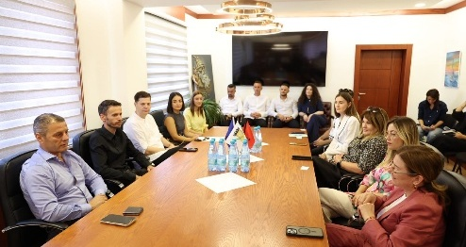
ROSKOVEC AND LEZHË MUNICIPALITIES
Strengthening Cooperation for Good Governance and Better Public Services
 | The Municipality of Roskovec, under the leadership of Mayor Ms Majlinda Bufi, successfully concluded a two-day study visit to the Municipality of Lezhë, held on 12–13 July 2026 within the framework of the Good Governance Programme.  The 14-member delegation was welcomed by the Mayor of Lezhë, Mr Pjerin Ndreu. The visit combined official meetings, professional presentations, peer exchange and field visits, creating a practical platform for institutional learning and cooperation. |  | AT A GLANCE  • 2-day study visit  • 14 municipal representatives  • Good Governance Programme  • Peer learning and field visits
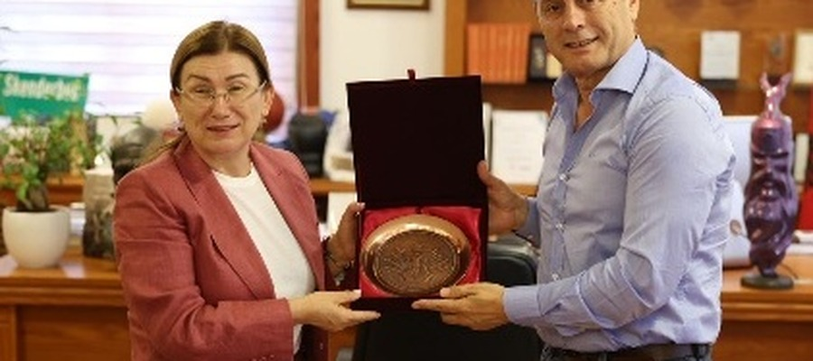 |  | 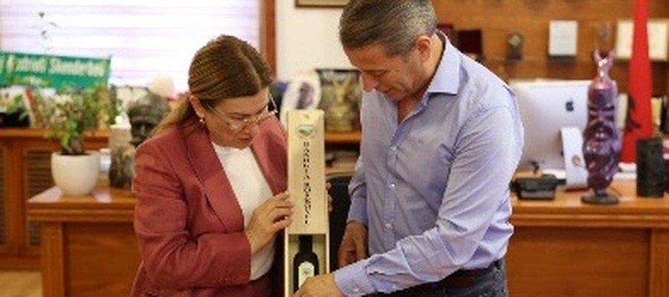 | 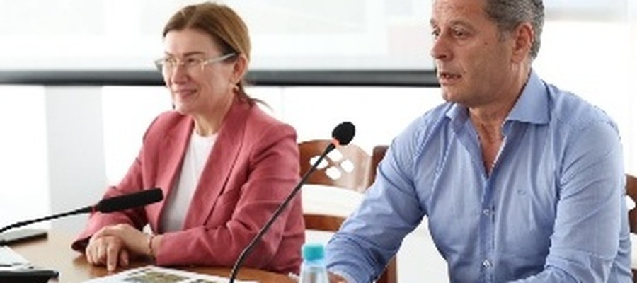
INSTITUTIONAL EXCHANGE
From Dialogue to Practical Cooperation
The visit began with an official meeting in the office of the Mayor of Lezhë and continued with a working session near the City Library. In their welcoming remarks, both mayors underlined the importance of exchanging good practices between local self-government units, strengthening inter-institutional cooperation, and sharing practical solutions that improve the quality of public services for citizens.
Mayor Pjerin Ndreu thanked Mayor Majlinda Bufi for launching this valuable initiative to strengthen good governance through study visits among Albanian municipalities. He emphasised that municipalities across the country have much to share and learn from one another, particularly through the exchange of practical approaches and the replication of successful models, including the co-financing mechanism recently applied in Roskovec within the framework of the Good Governance Programme.
“  This study visit represents a valuable opportunity to learn from the experience of the Municipality of Lezhë and to discuss concrete ways of adapting successful practices within the Municipality of Roskovec.  MAJLINDA BUFI • MAYOR OF ROSKOVEC | 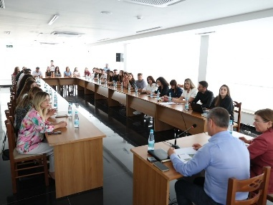
Areas of Learning and Exchange
LOCAL GOVERNANCE  Administrative practices and institutional capacity | PUBLIC SERVICES  Citizen-oriented delivery and service quality | TERRITORIAL DEVELOPMENT  Planning, tourism and local potential
ENVIRONMENT  Sustainable management and shared challenges | COMMUNICATION  Transparency, public information and outreach | PROJECTS  Strategic initiatives and project management

The Municipality of Lezhë presented its practices and initiatives through the municipal staff responsible for each thematic area. Mayor Pjerin Ndreu complemented the presentations by highlighting the municipality’s key achievements, lessons learned, and the most relevant features of each good practice. The discussions enabled participants to compare administrative approaches, identify shared challenges, and explore practical opportunities for future cooperation.
Mayor Ndreu also guided the delegation through the renovated Palace of Culture and its modern facilities, highlighting the dedicated spaces that support Lezhë’s artists, singers, dancers, writers, painters, and the wider creative community. The delegation also visited the newly renovated Municipal Council Chamber, which offers a modern and functional setting for council meetings, institutional dialogue, and transparent local decision-making.
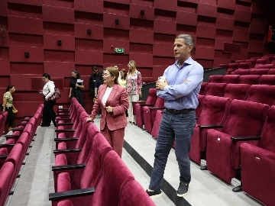 | 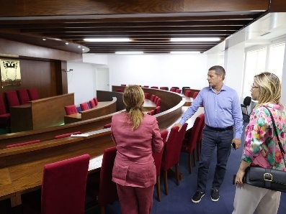 | 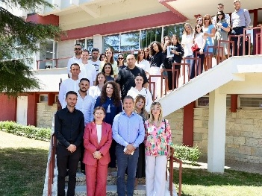
LEARNING ON SITE
Culture, Heritage and Local Development in Practice
As part of the cultural programme, Deputy Mayor of Lezhë Mr Fatjon Zefi and Mr Paulin Zefi, the municipal official responsible for cultural monuments, accompanied the delegation to several of Lezhë’s most significant heritage and natural sites. The programme included visits to the Skanderbeg Memorial, the newly established Ethnographic Museum, and the scenic lagoon areas, offering valuable insight into the municipality’s history, cultural identity, and natural landscape.
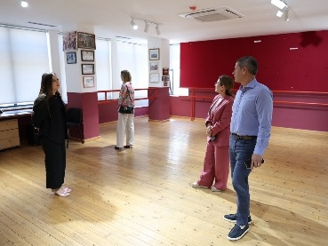 | 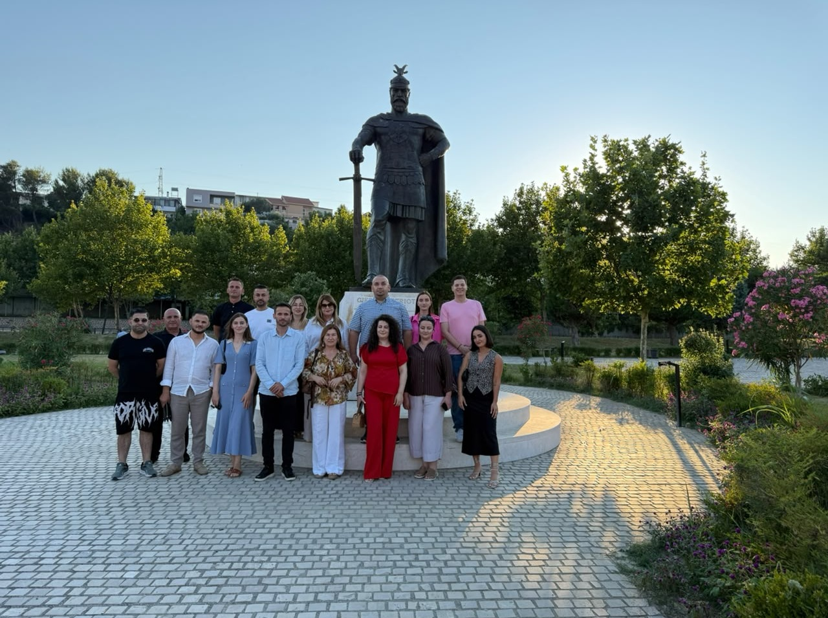
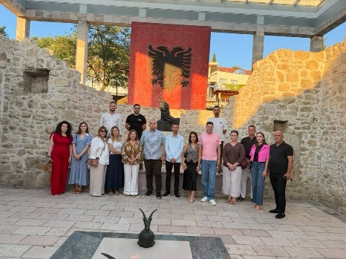 | 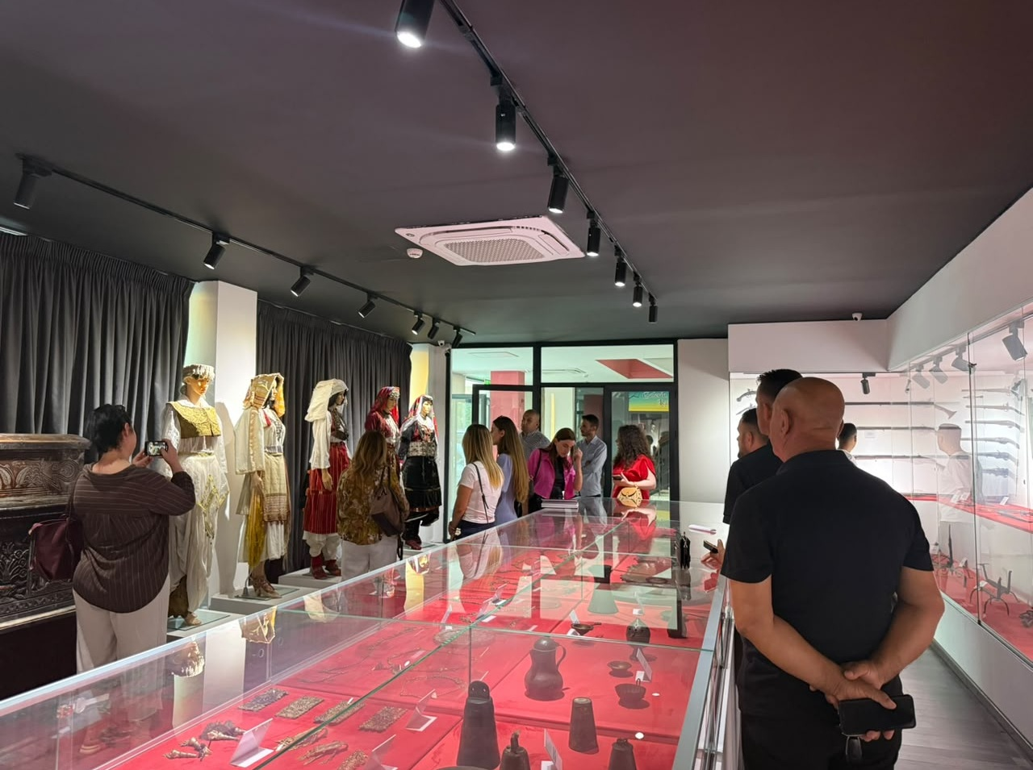
Key Outcomes
01  KNOWLEDGE EXCHANGE  A stronger understanding of workable municipal solutions and transferable practices. | 02  INSTITUTIONAL CAPACITY  New ideas for improving governance, public services and project implementation. | 03  FUTURE COOPERATION  A reinforced basis for continued inter-municipal dialogue and joint initiatives.
A Platform for Continued Partnership
The study visit served as an effective platform for exchanging knowledge and experience between the two municipalities. It contributed to stronger institutional capacities and closer inter-municipal cooperation, in line with the principles of good governance and European standards of public administration.
Activity Visibility and Media Coverage
Online media: Official website • Hana Press • News Albania • Ministria e Lajmeve • Spektri TV • Alb-Spirit|Social media and TV: FB 1 • FB 2 • FB 3 • FB 4 • FB 5 • FB 6 • TV Apollon • FB 7

