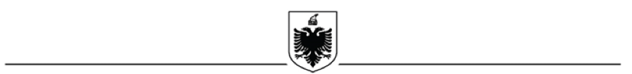
REPUBLIC OF ALBANIA
MUNICIPALITY OF ROSKOVEC

Annex C: Self-Declaration Form
I, the undersigned ________________ in the capacity of business representative/applicant of the project, hereby declare that:
- I declare that I have read and understood the instructions of the Call for Expression of Interest for co-financing in the project.

- I acknowledge and accept the application criteria as well as the legal restrictions and obligations that I must implement and respect during the implementation of the project;

- I declare that the information included in this application, together with any express declarations, is, to the best of my knowledge, true, accurate and complete.
- I acknowledge that knowingly providing false or inaccurate information will lead to the rejection of this application.

- The applicant's business is not in liquidation or bankruptcy proceedings;

- I am not under investigation, criminal proceedings or convicted of any criminal offense by the justice institutions in Albania.

Name Surname:
Applicant's Signature:
Date:

