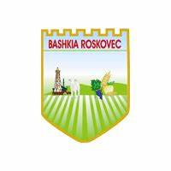
Këshilli i Bashkisë
Kryetari i Bashkisë
Roskovec
SESION INFORMIMI PËR KOMUNITETIN
RENDI I DITËS
Date 21/10/2025 Time 11:30,
Place Council Hall Roskovec
11:00 – 11:30 | Welcome of the participants
Open of the Session
11:30 – 11:40 | - Welcoming the participants  - Open the Session | Arlinda Hajdini  MC Secretary
11:40 – 12:40 | - Presentation of MC achievements and activity | Afrim Plaka  MC Chairman
12:40 – 13:00 | - Questions by participants | Participants
13:00 - 14:00 | - Open discussions by the participant | Afrim Plaka  MC Chairman
Close of the Session - conclusions

This activity was supported by "Strong Municipalities" Project, a project of the Swiss Agency for Development and Cooperation SDC, and the Government of Sweden, implemented by Helvetas.

