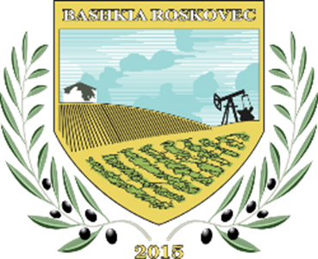

LOCAL ACTION PLAN FOR ENERGY AND CLIMATE (LAPEC)
ROSKOVEC MUNICIPALITY
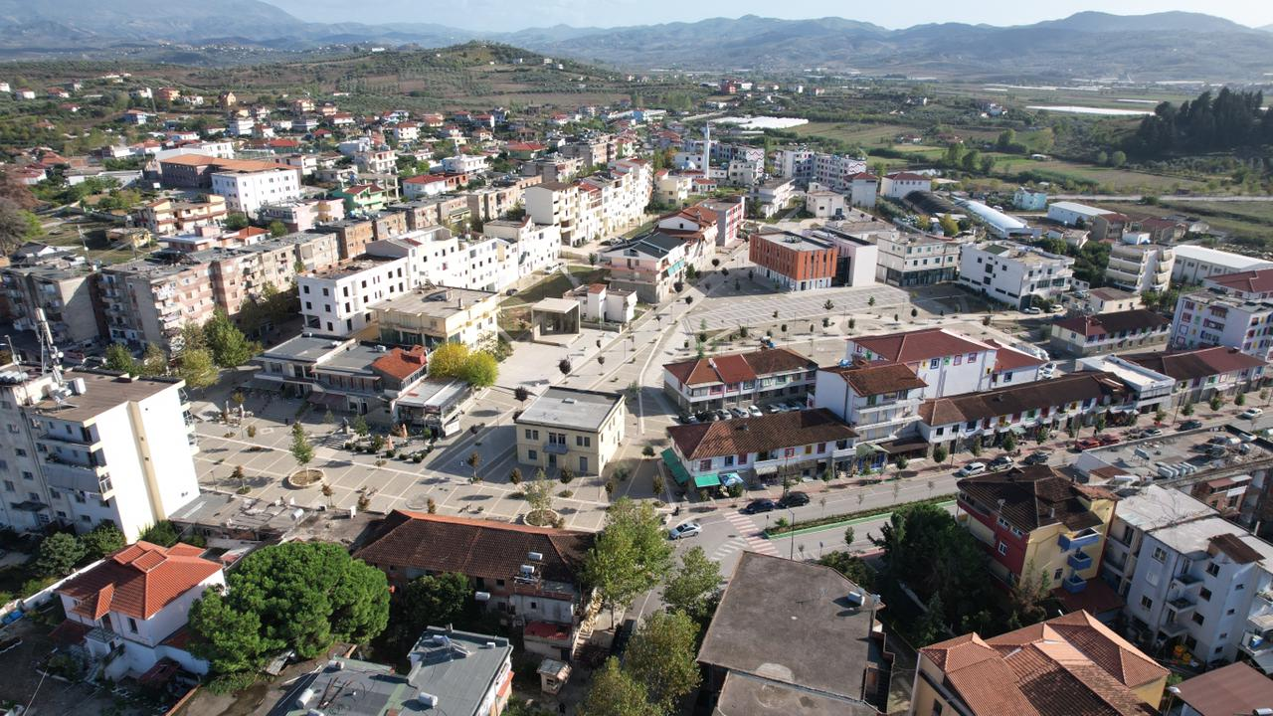

October , 2023

CONTRIBUTORS TO THE PREPARATION OF THE PLAN

STAFF OF ROSKOVEC MUNICIPALITY
Name and Surname | Function and Department | E-mail
Eva Hatia | Responsibe of the Planning and Construction Permits Sector | Eva.Hatia@bashkiaroskovec.gov.al
Ermir Hajdini | Drector, Maintenance Services Enterprise | Ermir.Hajdini@bashkiaroskovec.gov.al
Miranda Cepele | Drector, Cemetery Cleaning, Greening and Maintenance Enterprise | Miranda.Çepele@bashkiaroskovec.gov.al
Arben Dukaj | Responsible of the Investment Enforcement Sector | Arben.Dukaj@bashkiaroskovec.gov.al
Enirjeta Shehu | Director, Directorate of Culture and European Unit Integration | Enirjeta.Shehu@bashkiaRoskovec.gov.al
Orgesa Goga | Responsible for business sector | orgesa_goga@gmail.com
Edlira Toro | Responsible of finance | toroedlira@gmail.com

EXTERNAL CONSULTANTS

INSTITUTE FOR ENVIRONMENT AND TERRITORY MANAGEMENT
Adress: Avni Rustemi Square , Pal.Teuta Konstruksion, Tiranë
Website: www.etmi-al.org

Name and Surname | Position | E-mail
Meivis Struga | Climate and Energy Consultant | mstruga@etmi-al.org
Kledisa Çela | Specialist (junior) for Energy | kledisa.cela@hotmail.com

MAYORS‘ FOREWARD

Climate, energy, carbon are not just the key words of an implementation plan, but are our everyday life, the way of life that has inevitably led to finding alternative energy sources and using them efficiently, improving the environment where we live.
Aligning our objectives with the global agenda, with the goals of sustainable development, is today more than ever a vital obligation that we have to the generations to come.

Majlinda Bufi

TABLE OF THE CONTENT
CONTRIBUTORS TO THE PREPARATION OF THE PLAN 2
MAYORS‘ FOREWARD 3
LISTA E FIGURAVE 6
LISTA E TABELAVE 7
ABBREVIATIONS 9
1. INTRODUCTION 13
1.1. Part of the obligation to join the Convention of Chairs is the preparation, implementation and reporting of the Local Energy and Climate Action Plan (LEAP). The Local Action Plan for Energy and Climate for the Municipality of Roskovec was drawn up by the working group approved by Order No. 186 dated 22.09.2023, of the mayor. The working group, led by the mayor, consists of specialists from the directorate and various sectors in the municipality, who have ensured the collection of all the necessary information/data for PLVEK. 13
1.2. Content and structure of the plan 13
PROFILE OF ROSKOVEC MUNICIPALITY 18
Pozicioni Gjeografik 18
1.3. Relievi 19
1.4. Climatic conditions 19
1.6. Economic profile 21
2.5.1. Industrial sector 21
2.5.2. Sector of energy 21
2.5.3. Agricultural sector 23
1.7. 1.7. The annual municipal budget (Year 2022) 24
2. METHODOLOGY 24
2.2. Mitigation (Reduction) 25
3.2.2. Base year 26
3.2.3. Field of action 26
• Defining context and scope: Time frame, climate variables and risk framework. 28
• Collection of data on weather, climate and climate indicators as well as climate projections. 28
• Risk and vulnerability assessment taking into account the main climate risks and determining the possible impacts for each sector. Information on historical events and climate projections will also be used to understand how risks may change over different time periods. 28
• Determination of adaptation opportunities that can be implemented by the municipality of Roskovec, including stakeholders. 28
In this chapter, a summary of information on the historical context of climate risks in Roskovec municipality, past events, climate projections and how climate change is expected to affect physical and social characteristics will be provided. The main risks are described according to the group defined in point 3.4.3 of this plan. A summary of the assessment of risk and vulnerability to climate change is also presented. 32
3.5.1. 32
Periudha të nxehta të shpeshta, të gjata dhe të thata 32
3.5.2. Rritje e intensitetit dhe shpeshtësisë së ngjarjeve ekstreme të reshjeve 37
Figure 17 Risk Maps according to Exposure Categories 43
5. Risk evaluation 45
The second step in this process was the risk assessment for each of the sectors defined for the risks that may be caused by climate change. 46
4.1.2.1. 46
Sektori i ndërtesave 46
4.1.2.2. Transportation sector 46
4.1.2.3. Energy sector 46
4.1.2.4. Water sector 47
4.1.2.8. HEALTH 49
4.1.2.10. Economy 50
4.1.3. Vulnerability evaluation 50
1. 6. DESCRIPTION OF THE CURRENT SITUATION (REDUCTION) 51
6.1. 51
6.2. Building sector 51
6.1.1. Municipal building 51
From the collected data, it can be observed that the consumption of electricity from individual dwellings is many times higher than that of apartments. This is because in apartments, part of the living spaces are shared and the energy losses are at smaller values. Electricity from the residential sector is mainly used for heating/cooling the premises, lighting and cooking. The heating of the dwellings is mainly carried out with electricity and a small part of them with firewood. Regarding electricity consumption rates, the price of energy for household consumers is 11 Lek/kWh. Electricity losses in the residential sector are considered high because most of the stock of residential buildings are not thermally insulated, the equipment they use is not efficient, the heating/cooling systems are not efficient, etc. 53
6.1.4. Public lightning 54
6.3. Transportation sector 56
6.4. Other sectors 57
Based on the data of the Roskovec municipality, the total revenue from the collection of cleaning fees (households, public institutions and businesses) for the year 2022 was ALL 15,298,527. 59
7.1.1. 7.1. Scenario I (without measures) and Scenario II (with measures) for energy demand 64
7.1.3. 7.2. Building sector 65
7.1.6. Graph 10 Projections of energy consumption (2022-2040) for municipal buildingsNdërtesat rezidenciale 67
7.2. Graph 12 Projections of energy consumption (2022-2040) for public lighting 68
7.3. Transport 68
7.4. Other sector 69
7.5. 7.4.1. Solid waste management 69
7.6. As explained in the paragraph above, in the evaluation of the demand for energy, the fuel, oil, was taken from the transportation of waste. From the performed calculations, the level of energy consumption in 2022 is at 0.18 GWh. 69
7.6.2. Chart 15 Energy consumption projections (2022-2040) for FUK 70
7.6.4. 7.7. Summary 71
1. 6. PLAN OF MEASURES FOR CARBON REDUCTION (REDUCTION) 74
8.1. 74
8.2. Municipal, residential and commercial buildings 74
8.3. 8.3. Commercial buildings and residential buildings 79
8.4. Transport 79
8.5. Residues 81
8.6. Agriculture (irrigation) 84
9.1. Sektori i ujit 86
9.2. 9.2. Agriculture and forestry sector 88
9.3. Environment and biodiversity 89
9.4. Health 90
11.1. 9.5. Civil protection and emergencies 91
10.1 7. MONITORING AND REPORTING 91
10.2 Mitigation (Reduction ) 92

LIST OF FIGURES
Figure 1 Steps for preparation o PLVEK 14
Figure 2 Geographical position of Roskovec Municipality 19
Figure 3 Population during the last 5 years in Roskovec Municipality 2018-2022 21
Figure 4 The number of families in Roskovec Municipality during the last 5 years 21
Figure 5 The extent of the electricity infrastructure 22
Figure 6 The main departments for the implementation of PLVEK 24
Figure 7 Steps for the preparation of PLVEK 25
Figure 8 Steps for risk assessment and adaptation 28
Figure 9 Consultation meetings with different stakeholders 32
Figure 10 Average temperature and precipitation anomalies 33
Figure 11 Annual distribution of the number of days with a maximum temperature of 35°C 33
Figure 12 Expected annual temperature by the year 2050 and 2100 34
Figure 13 Number of fires by year in forest and non-forest lands owned by Roskovec Municipality 35
Figure 14 Annual rainfall distribution (mm) 37
Figure 15 Annual precipitation projections (mm) without and with climate change……………………………….38
Figure 16 Expected annual precipitation by year 2050 and 2100 39
Figure 17 Risk Maps by Exposure Categories 43
Figure 18 Areas expected to be flooded by 2050 (sea, left) and rivers 44
Figure 19 Organization of the Public Works Sector in Roskovec Municipality 58

LIST OF TABLES

Table 1: A summary of "high" level risks………………………………………………………………………………………………..12
Table 2 Targets on CO2 reduction and final energy consumption ………………………………………………………….16
Table 3 Summary of national energy and climate policy documents …………………………………………………….17
Table 4 Administrative Units of Roskovec Municipality ………………………………………………………………………...19
Table 5 Demographic data for Roskovec Municipality …………………………………………………………………………..20
Table 6 Fuel trading stations that also have LPG for vehicles …………………………………………………………………23
Table 7 Roskovec Municipality Budget for 2022 ……………………………………………………………………………………24
Table 8 Annual expenses, year 2022 …………………………………………………………………………………………………….24
Table 9 Categories of GHG emissions (GHG Protocol) ……………………………………………………………………………26
Table 10 Key assumptions for climate risk assessment ………………………………………………………………………….28
Table 11 Risk Assessment Matrix …………………………………………………………………………………………………………..30
Table 12 Projections of temperature change (°C) ………………………………………………………………………………….34
Table 13 Expected number of days with Tmax>35°C …………………………………………………………………………….35
Table 14 Classification of areas according to the level of risk of forest fires ………………………………………….36
Table 15 Projections for the risk of forest fires as a result of climate change……………………………………….. 36
Table 16 Projections of precipitation change (%) ………………………………………………………………………………….38
Table 17 Flood damage with certainty 1 time in 100 Years …………………………………………………………………..39
Table 18 Bull caused by the possible destruction of dams ……………………………………………………………………40
Table 19 Slide inventory for each administrative unit …………………………………………………………………………..41
Table 20 Vulnerability map expressed in value of affected surface in hectare ………………………………………42
Table 21 Data on vulnerability, expressed in value of affected surface per hectare………………………. 42
Table 22 Risk values in units (Ha) of the surface according to classes …………………………………………….42
Table 23 Risk values in percentage of the surface according to classes (Recurrence time 100 years) 42
Table 24 Expected number of days with Tmin < 0°C……………………………………………………………………….. 44
Table 25 Main climate risks and current level of risk………………………………………………………………………. 45
Table 26 Risk assessment for the transport sector ………………………………………………………………………….46
Table 27 Risk assessment for the transport sector ………………………………………………………………………….47
Table 28 Risk assessment for the energy sector ……………………………………………………………………………...47
Table 29 Risk assessment for the water sector ………………………………………………………………………………..48
Table 30 Risk assessment for the waste sector ………………………………………………………………………………..48
Table 31 Risk assessment for the agriculture and forestry sector …………………………………………………….48
Table 32 Risk assessment for land use …………………………………………………………………………………………….49
Table 33 Risk assessment for the environment and biodiversity ……………………………………………………..49
Table 34 Health risk assessment…………………………………………………………………………………………………….. 50
Table 35 Risk assessment for civil defense and emergencies …………………………………………………………..50
Table 36 Risk assessment for the economy ……………………………………………………………………………………..50
Table 37 The most vulnerable sectors ……………………………………………………………………………………………..51
Table 38 Public buildings in Roskovec Municipality…………………………………………………………………………. 51
Table 39 Electricity consumption by public buildings………………………………………………………………………. 52
Table 40 Energy consumption (diesel) by public buildings………………………………………………………………. 52
Table 41 Energy consumption (wood) from public buildings ……………………………………………………………53
Table 42 Distribution of buildings by construction period for each administrative unit…………………… 53
Table 43 Electricity consumption by the residential sector ………………………………………………………………53
Table 44 Energy consumption (firewood) from the residential sector ……………………………………………..53
Table 45 Electricity consumption by the commercial and service sector …………………………………………54
Table 46 Number of lighting poles………………………………………………………………………………………………….. 54
Table 47 Types of public lighting lamps ……………………………………………………………………………………………55
Table 48 Electricity consumption for street lighting …………………………………………………………………………55
Table 49 Total costs for street lighting ……………………………………………………………………………………………..56
Table 50 Public lighting tariff according to customer categories ………………………………………………………56
Table 51 Fuel consumption by the public transport sector……………………………………………………………… 56
Table 52 Infrastructure for waste collection in Roskovec Municipality ……………………………………………..58
Table 53 Fleet of waste transport vehicles ……………………………………………………………………………………….59
Table 54 Fuel consumption for waste management service …………………………………………………………….59
Table 55 Street and square cleaning service …………………………………………………………………………………….59
Table 56 Cleaning fee according to the fiscal package approved in 2022 ………………………………………….60
Table 57 Location of warehouses/reservoirs for water supply ………………………………………………………….61
Table 58 Water stations and reservoirs for water supply in Roskovec ……………………………………………….62
Table 59 Performance indicators for the water supply system ………………………………………………………….63
Table 60 Water supply rates in Roskovec Municipality ……………………………………………………………………..63
Table 61 Performance indicators for wastewater ……………………………………………………………………………..64
Table 62 Information on the level of energy consumption and carbon emissions …………………………….65
Table 63 Level of energy demand and carbon emissions in 2040…………………………………………………….. 73
Table 64 Indicators related to the impact of climate change……………………………………………………………. 93
Table 65 Data monitoring 94

LIST OF GRAPHICS

Graph 1 Projections of carbon emissions 2022-2040 (without measures) ……………………………….11
Graph 2 Projections of carbon emissions 2022-2040 (with measures) …………………………………...12
Chart 3 Number of adaptive measures by sector (the number in the chart indicates the number of actions)----------------13
Chart 4 Population affected by flood with certainty 1% …………………………………………………40
Graph 5 Economic damage ………………………………………………………………………………40
Chart 6 Economic damage from flooding from the possible destruction of dams ……………………….41
Chart 7 Types of public lighting lamps …………………………………………………………………..55
Chart 8 Categorization according to consumption for each category ……………………………………65
Chart 9 Energy consumption projections (2022-2040) for municipal buildings………………………… 67
Chart 10 Energy consumption projections (2022-2040) for municipal buildings ………………………..67
Chart 11 Energy consumption projections (2022-2040) for residential buildings ………………………..68
Chart 12 Energy consumption projections (2022-2040) for public lighting…………………………....... 69
Chart 13 Projections of energy consumption (2022-2040) for transport …………………………………69
Chart 14 Energy consumption projections (2022-2040) for transport ……………………………………70
Chart 15 Energy consumption projections (2022-2040) for FUK ………………………………………..71
Chart 16 Energy consumption projections (2022-2040) for irrigation …………………………………...72
Chart 17 Level of energy demand and carbon emissions in 2040 ………………………………………..73
Chart 18 Level of energy demand and carbon emissions in 2040 without measures …………………….74

ABBREVIATIONS
EEA | Energy Efficiency Agency
BUR | Biennial Update Report
BTR | Biennial Transparency Report
CoM | Convention of Mayors
CO2 | Carbon dioxide
GHS | Greenhouse Gases
GHG | Greenhouse gases
LPG | Liquefied Petroleum Gas
GWh | Gigawatt hours
GWP | Global Warming Potentials
WRA | Water Regulatory Authority
IPCC | The Intergovernmental Panel on Climate Change (IPCC)
WTP | Wastewater Treatment Plant
IFN | International financial institutions
INSTAT | Institute of Statistics
UNFCCC | United Nations Framework Convention on Climate Change
BWS | Black Water Sewers
MIE | Ministry of Infrastructure and Energy
MTE | Ministry of Tourism and Environment
DNC | Defined National Contribution
NECP | National Energy and Climate Plan
PKEK | Administrative unit
JSC UK | National Energy and Climate Plan
WRI | Anonymous Society of Water Supply and Sewerage
WBCSD | World Resources Institute
WBCSD | World Business Council for Sustainable Development

EXECUTIVE OVERVIEW
The Convention of Mayors (CoM) on Climate and Energy brings together thousands of local governments voluntarily committed to implementing climate and energy objectives. By joining the Convention of Mayors, the Municipality of Roskovec has pledged to achieve the following objectives: To reduce CO2 emissions by at least 40% (per capita) by 2030 referring to the base year 2022, To increase climate resilience (drafting of climate action plan); Ensure access to sustainable and affordable energy, integrated with mitigation and adaptation plans. The municipality of Roskovec has expressed interest in being part of the convention of mayors and for this purpose has taken the initiative in cooperation with external consultants to prepare the Local Energy and Climate Plan for the period 2023-2040. PLVEK consists in the assessment of carbon emissions and the addressing of measures for its reduction and adaptation to climate change. The assessment of carbon emissions has been carried out for the sectors of i) Buildings which include public, residential and commercial (commercial) buildings, ii) Transport which includes private, public and municipality-administered transport and iii) Other sectors which include waste, supply with water and irrigation from the agricultural sector. From the assessments carried out, the carbon emissions from the building sectors in 2022 turn out to be 45.5 GWh translated into 6,063-tons of CO2, the transport sector turns out to be 51 GWh and 13,825 tons-CO2 and the level of energy consumption from other sectors about 2 GWh and 570 tons-CO2. The following graph shows the projections of carbon emissions for the period 2022-2040 without considering the measures.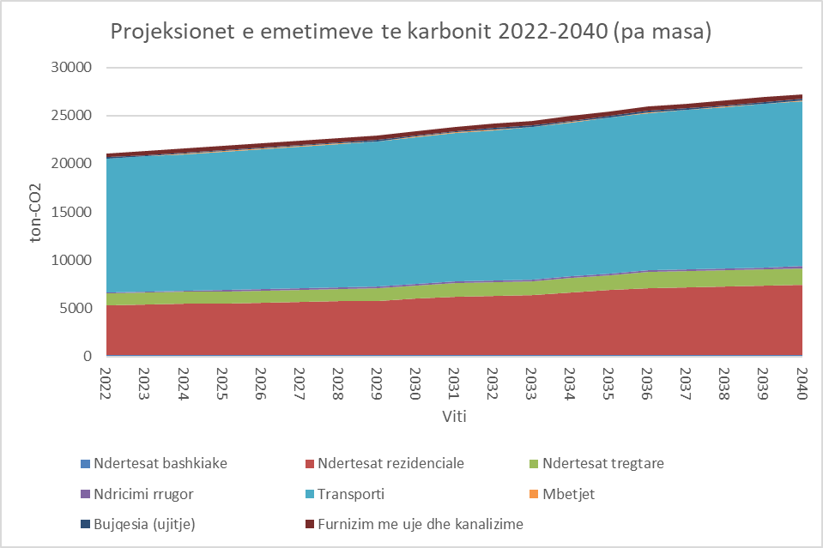
Graph 1 Projections of carbon emissions 2022-2040 (without measures)
In order to reduce energy consumption (GWh) and the carbon level, a number of measures/projects are foreseen (chapter 8). As a consequence of the proposed measures, the demand for energy in the construction sector until 2040 is expected to be 22 GWh, the transport sector is expected to be 33 GWh and from other sectors 1.02 GWh. The CO2 level will be 4407 ton-CO2 from the buildings sector, about 9115 ton-CO2 from the transport sector and the transport sector 376 ton-CO2.
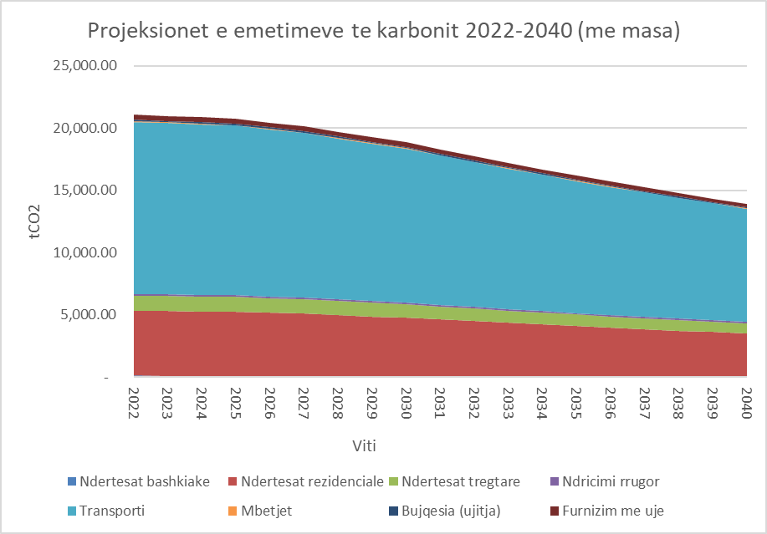
Graph 2 Projections of carbon emissions 2022-2040 (with measures)
The climate change risk assessment was carried out for the 11 sectors defined in relation to the main risks identified. The main sectors for which the risk assessment was carried out are: Buildings, Transport, Energy, Water, Waste, Land use planning, Agriculture and Forestry, Environment and Biodiversity, Health, Civil Defense and Emergency, Economy. The hazards defined by the Convention of Presidents that are assumed in this plan are: Heat, Extreme cold, Extreme precipitation, Floods (luvial/urban), Drought, Storms (strong winds), Landslides (erosion), Fires in forests, Sea level rise. The risk assessment was done taking into consideration the historical context of the climate for Roskovec Municipality, future climate projections as well as the impact these risks have on each of the sectors. In the table below, you give a summary of the risk assessment, which is considered "High", for each of the analyzed sectors.

Tabela 1 : Një përmbledhje e risqeve të nivelit "të lartë"
Sector | Main risk | Impact/Consequences | Time span
Building | Extreme heat | Extreme heat causes overheating in buildings increasing demand for cooling, leading to increased costs for building repair and maintenance. | Short-term
Water | Extreme heat | The increase in temperatures and the lack of rainfall would cause droughts. This would cause disruption and lack of water supply, affecting daily life and industrial activity. | Short-term
 | Droughts
 | Extreme precipitation | Extreme rainfall and flooding can cause damage to urban wastewater management infrastructure. | Short-term
 | The floods
Agriculture and forestry | Extreme heat/ Extreme cold | Degradation of the quality of agricultural land; Reduction of productivity and yield of crops; Changing periods/seasons of agricultural products. | Short-term
 | Droughts
 | Forest fires | Loss of forest area | Short-term
Land use planning | Extreme heat/droughts | Change in land use | Short-term
Environment and Biodiversity | Extreme heat | Destruction of the natural environment. | Short-term
 | Droughts | Lowering the level of water bodies, eutrophication of waters and loss of habitats;
 | Forest fires | Biodiversity loss, species migration;
Health | Extreme heat/ Extreme cold | Increase in diseases and the level of mortality; | Short-term
 | Droughts | Lack of water or water of poor quality which leads to dehydration and ill health.

Based on the risk assessment carried out for each of the sectors, adaptive measures have been proposed which can be implemented by Roskovec Municipality as a response to climate change. The number of adaptation measures by sector is given in chart no. 3. A detailed analysis of them is described in chapter 9 of this plan.

Chart 3 Number of adaptation measures by sector (the number in the chart indicates the number of actions)

INTRODUCTION
Overview and purpose of PLVEK
The Convention of Mayors (CoM) on Climate and Energy brings together thousands of local governments voluntarily committed to implementing climate and energy objectives. By joining the Convention of Mayors, the Municipality of Roskovec is committed to achieving the following objectives:

- To reduce CO2 emissions by at least 40% (per capita) by 2030 with reference to the base year 2022.
- Increase climate resilience (designing an energy and climate action plan);
- Ensure access to sustainable and affordable energy, integrated with mitigation and adaptation plans.

Part of the obligation to join the Convention of Chairs is the preparation, implementation and reporting of the Local Energy and Climate Action Plan (LEAP). The Local Action Plan for Energy and Climate for the Municipality of Roskovec was drawn up by the working group approved by Order No. 186 dated 22.09.2023, of the mayor. The working group, led by the mayor, consists of specialists from the directorate and various sectors in the municipality, who have ensured the collection of all the necessary information/data for PLVEK.

Content and structure of the plan
The Local Energy and Climate Action Plan (PLVEK) consists of the following chapters:

Figure 1 Steps for the preparation of PLVEK

1.3 National Policies on Energy and Climate
Albania joined the United Nations Framework Convention on Climate Change (UNFCCC) in January 1995 and the Kyoto Protocol in January 2005. Albania has developed three National Communications on Climate Change, supported by the UNFCCC and the Kyoto Protocol.
In 2002, the First National Communication of Albania was realized as a response to the commitments towards the KKKBNK. The Second National Communication was carried out in 2009 and the third in 2016. As an obligation to the KKKBNK, in 2019, work has begun on the drafting of the Fourth National Communication. As part of the Convention, Albania has the obligation to carry out the inventory of greenhouse gases for each sector (energy, agriculture, industry, transport) according to a defined methodology/protocol.
Albania is also one of the countries that joined the Paris Agreement, signed on April 22, 2016. As a member of this agreement, Albania is obliged to promote the reduction of greenhouse gases and the development of technologies, local and national plans for the reduction of gases. greenhouse.
Within the framework of the agreement, Albania has adopted the document on "Nationally Determined Contribution (NDC)" which is an obligation of the country defined in article two of the United Nations Framework Convention on Climate Change. The National Determined Contribution of Albania is the determination of the objective to reduce carbon emissions (CO2) by 11.5% until 2030.
Albania is involved in the process of creating a supportive internal market in the field of energy and in guaranteeing energy security, energy efficiency and environmental protection, including the reduction of GHG emissions carried out and presented in a series of measures planned and identified investments in various political documents. National Energy Strategy, Second and Third Energy Efficiency Action Plans, Consolidated Renewable Energy Action Plan, National Greenhouse Gas Mitigation Plan and Transport Strategy have defined objectives and targets for increasing the security of supply through investments in the electricity sector, the penetration of gas in the Albanian market and the increase in the percentage of RES and EE, followed by a reduction in GHG emissions.
In 2018, Albania approved the National Energy Strategy for the period 2018-2030.
The National Energy Strategy 2018–2030 is the main strategic document for the country's energy sector. It is in line with national efforts to support economic development and fulfill commitments under the Energy Community Treaty, the EU integration process and other international agreements, increasing security of energy supply and minimizing environmental impacts with affordable costs for Albanian citizens and all sectors of the economy.
The five dimensions supported by the energy strategy are:
1. Energy security, based on the diversification of energy sources;
2. Full integration in the regional market and then in the European one;
3. Energy efficiency that contributes to the moderation of the demand;
4. Decarbonization of the economy;
5. Research, innovation and competition.

The energy strategy has very well defined the country's energy targets to make possible the European integration of Albania in the entire European energy infrastructure:
- The continuation of the reduction of losses in the electricity distribution network from 26.4% in 2017 to 10% in 2030 – this level is compared with all European countries;
• The continuation of the increase in electricity revenues from 90% in 2018 to 98% in 2030 – this level is compared with all European countries;
• Increasing the contribution of primary energy sources against the total supply of primary energy sources to the level of 52.5% in 2030; ¬
• The opening rate of the electricity market to reach 100% in 2025 while simultaneously building a simple and applicable scheme for the protection of low-income family consumers.
• The Albanian economy and society to achieve a level of energy savings against total consumption of 15% in 2030; ¬
• The target of renewable energies against total consumption to reach the level of 42% in 2030;
• Reduction of GHG emissions against the total to reach 11.5% in 2030; ¬
• The penetration of natural gas against the total supply of primary energy sources to reach the level of 20% in 2030.
In December 2021, Albania adopted the "National Plan of the Republic of Albania for Energy and Climate 2021-2030 (PKEK)". According to PKEK, the goals that must be achieved within the year 2030 are presented in the following table.
Table 2 Targets on CO2 reduction and final energy consumption
Target (2030) | Contribution according to sectors
Reduction of carbon emissions: - 18.7% (only for the energy sector. |  |  | 18.70%
Targets for greenhouse gas emissions (kt CO2 equivalent): | Greenhouse Gas Emissions (kt CO2 equivalent) predicted with additional measures until 2030
 | Power consumption/demand | 4833
 | The transformation | 250.8
 | Industry, waste | 5139
Energy Efficiency (Reduction of final energy consumption):- 8.4% |  |  | 8.40%
Final energy consumption (ktoe) target: | Final energy consumption (ktoe) projected with additional measures for 2030.
 | Residential | 348.9
 | services | 195.2
 | industry | 542.4
 | Transportation | 1003.4
 | Agriculture and forestry | 110.5
 | Fishing | 56
 | Not Energy | 70.6
Use of renewable energy in final energy demand: 54.4% |  |  | 54.40%
Target of coverage with renewable energy | The coverage ratio of energy demand from renewable sources (percentage) in the projection with additional measures until 2030.
 | RES - Electricity | 178.1 %*
 | BRE - Transport | 34.60%
 | RES- heating, cooling | 16.60%
The analytical basis of the PKEK explains that the targets are mainly influenced by the way renewable energy plants are operated, the reduction of the use of fossil fuels in transport and industry through fuel substitution and energy efficiency measures aimed at the building sector . The following table shows the summary of the national political documents developed for energy and climate in Albania in the las 4 years
Table 3 Summary of national policy documents on energy and climate
Before 2019 |  | National Action Plan for Renewable Energy Sources | National Action Plan for Energy Efficiency |  | National Strategy of Energy
 |  | The period: 2018-2020 | The period: 2017-2020 |  | The period: 2018-2030
 |  | Director : MIE | Director : MIE |  | Director : MIE
2019 |  | National Strategy for Climate Change |  | Law no. 155/2020 "On climate change"
 |  | The period : 2019-2020 |  | The period : N/A
 |  | Director : MTE |  | Director : MTE
2020 |  | Update of NDCs to KKKBNK |  | Biennial Update Report (BUR)  Biennial Transparency Report (BTR)
 |  | Period : 2020-2025 |  | Period: 2020-2022
 |  | Director : MTE |  | Director : MTE
2021 |  | National Energy and Climate Plan (NECP) |  | Fourth National Communication to KKKBNK
 |  | Period : 2021-2030 |  | Period : 2020-2024
 |  | Director : MIE |  | Director : MTE

For the implementation and full implementation of energy and climate policies, relevant secondary legislation has been drawn up, which is aligned with the European Union directives on energy and climate.
Local level policies for Energy and Climate
According to Law 124/2015 "On Energy Efficiency" (revised in March 2021), it is clearly stated that all municipalities must prepare Local Action Plans for Energy and Climate to be in convergence with the National Action Plan for Energy and Climate (PKVE) including clear energy savings at the local level.
Contribution of renewable energy sources and CO2 reduction targets for each of the direct sectors including public buildings, public lighting, solid waste collection and management, water supply, sewage treatment plants, public transport and all other municipal services as well as other sectors such as residential, commercial, etc.
Starting on February 28, 2022, every three (3) years, municipalities will prepare and submit to the Energy Efficiency Agency (EEE) draft municipal energy and climate action plans which will include proposed policies and measures for improving energy efficiency and climate, which cover all sectors operating at the municipal level.
Prior to the approval of the Local Energy and Climate Action Plan by the City Council, the AEE shall assess its compatibility with national energy efficiency policies, objectives and related plans and shall provide its opinion with recommendations within sixty (60) days from the date of submission of the draft plan. The approval of Local Action Plans for Energy Efficiency and Climate by the City Council must be done before April 30 of the respective year and must cover the following three (3) years.
The plan will, among other things, provide for the establishment and operation of local energy management and monitoring systems, as appropriate, individual energy management systems, including energy audits for buildings that consume a lot of energy and for the renovation of public buildings for meet the minimum energy performance standards defined by the Law on Energy Performance in Buildings and other energy efficiency measures taken in facilities controlled by municipalities. Municipalities required to implement a local energy management system will need to have at least one or two energy managers.
Legal framework for energy and climate adaptation
Listed below are the main laws targeting energy efficiency and climate adaptation:

- Law on Energy Efficiency (Law no. 124/2015 amended by law no. 28/2021).
- Law on Energy Performance in Buildings (Law no. 116/2016).
- Law on renewable energy sources (Law no. 7/2017).
- National Energy and Climate Plan (approved in December 2021).
- Law no. 155/2020 on climate change.
- Revised Target National Contribution (NTC) for Albania.
- The Third National Communication of the Republic of Albania addressed to the United Nations Framework Convention on Climate Change.

PROFILE OF ROSKOVEC MUNICIPALITY

Pozicioni Gjeografik
The municipality of Roskovec is part of the district of Fier and is bordered to the north by the Municipality of Lushnje, to the east by the Municipality of Ura Vajgurore, to the southeast by the Municipality of Berat, to the west by the Municipalities of Patos and Fier, while to the south by the Municipality of Mallakastër. The city of Roskovec, the center of the Municipality, is located 42 km southwest of the city of Fier.
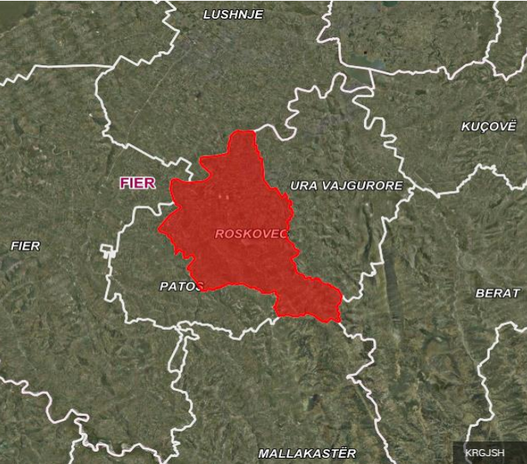

Figure 2 Geographical position of Roskovec Municipality
The municipality of Roskovec covers an area of 118 km2 and consists of four administrative units - Roskovec, Kuman, Kurjan and Strum. Currently, Roskovec Municipality has 1 (one) city and 14 (fourteen) villages.
Table 4 Administrative Units of Roskovec Municipality
Administrative unit | km² | Village | km²
Kurjan | 34 | Kurjan | 17.1
 |  | Ngjeqar | 10.2
 |  | Vlosh | 5.7
 |  | Mbers | 4
Strum | 35 | Strum | 12
 |  | Suk-1 | 7.4
 |  | Suk-2 | 5.9
 |  | Arapaj | 4.9
 |  | Velmish | 5
Roskovec | 19 | Roskovec | 15
 |  | Jagodine | 4
Kuman | 30 | Kuman | 5.6
 |  | Marinez | 9.6
 |  | Vidhisht | 5.5
 |  | Luar | 11.3

Relievi
The relief of Roskovec Municipality can be divided into two geomorphological units; hilly areas and plain areas. According to the data provided by the Roskovec Municipality, the field area mainly includes the field of Sheqishte and Kuman, which also includes the fields of Marinez and Vidhishte, as well as its northern part parallel to Roskovec. The height varies from 10-15 m above sea level, while the field of Marinza does not exceed the height of 13.5 m. A range of hills in a southwest-northeast direction spread from the village of Zharrëz to Marînez with a height greater than 79 m.

Climatic conditions
Based on the map of climatic zones of Albania, the municipality of Roskovec is part of the area with a Mediterranean hilly climate. The presence of the Seman River plays an important role in shaping the climate of this municipality. The municipality of Roskovec has a mild climate with hot and partly dry summers and cold and wet winters. The average amount of precipitation is 1012 mm. The average annual temperature is 15-16oC. The driest month is July with 29 mm of rain per month and November is the wettest month with 150 mm of rain. Winds are present for most of the year (5.5 months) and have a speed of 3 m/s. Winds blow mainly from the south, east and west.
  - Demographic data
There are two official sources for population data, namely INSTAT (Census) and Civil Registry data.
Based on the Civil Registry, the number of inhabitants in January 2020 was 32,763 inhabitants. The following table shows detailed demographic data provided by Fier Prefecture for Roskovec Municipality over the last 5 years, which show a slight increase in the population and number of families according to the civil status register:
Tabela 5 Të dhënat demografike për Bashkinë Roskovec
A.Unit | 2018 2019 2020 2021 2022
 | No. pop | No. fam | No. pop | No. fam | Nr. pop | No. fam | No. pop | No. fam | No. pop | No. fam
Roskovec | 8,859 | 2,92 | 9,154 | 2,91 | 9,139 | 2,94 | 9,081 | 2,94 | 9,062 | 2,94
Strumë | 9,345 | 2,5 | 9,559 | 2,61 | 9,622 | 2,66 | 9,628 | 2,68 | 9,654 | 2,73
Kuman | 8,519 | 2,39 | 8,627 | 2,43 | 8,619 | 2,49 | 8,558 | 2,51 | 8,499 | 2,54
Kurjan | 5,318 | 1,47 | 5,377 | 1,50 | 5,383 | 1,54 | 5,318 | 1,54 | 5,293 | 1,56
Total | 32,041 | 9,340 | 32,717 | 9,472 | 32,763 | 9,649 | 32,585 | 9,686 | 32,508 | 9,787

As we can understand from the graph below, the population in Roskovec Municipality has increased until 2020 and then in the last two years there has been a decrease in population and at the end of 5 years, it can be seen that the population from 2018 to 2022 has increased with 1.44%. Strum County has the largest population over the past 5 years, followed by Roskovec County.
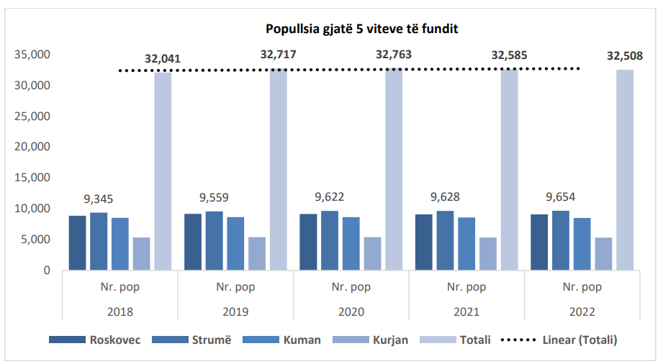
Figura 3 Popullsia gjatë 5 viteve të fundit në Bashkinë Roskovec 2018-2022
Almost the same situation is also reflected with the number of families, that over the past 5 years their number has increased by 4.57%, where the largest number of families is registered in Roskovec A.Unit 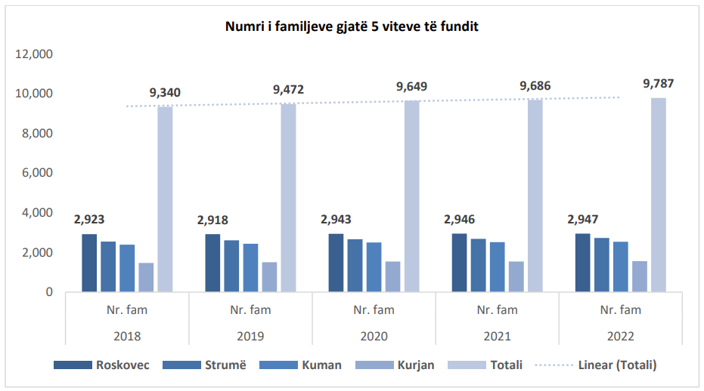
Figura 4 Numri i familjeve në Bashkinë Roskovec gjatë 5 viteve të fundit

Economic profile

Industrial sector

The hydrocarbon extraction industry in the Marinza oil field is one of the main economic activities that take place in the territory of Roskovec Municipality. The activity of oil extraction in this territory started in the 30s and has continued inseparably until today, making it one of the main sources of economic income for the residents of the area who are employed in this industry. Conditioned by geological construction, it is not noted for a variety of mineral resources, but without a doubt its greatest asset is the oil deposit.
Agricultural land turns out to be excessively fragmented by the infrastructure of wells used for oil extraction. In the territory administered by the Municipality of Roskovec, a number of subjects belonging to the technological/industrial sector perform their activities, such as the hydrocarbon research and production company, ALBPETROL sh.a and Bankers Petroleum Albania Ltd., some subjects whose activities have transportation, storage and trading of oil, gas and their by-products. Moreover, in the territory of this municipality, the Patos Marinez oil field, as well as the transport infrastructures and technological installations of the groups of wells and the Central Oil Treatment Plant (CTF) of Bankers Petroleum Albania Ltd.

Sector of energy

Electricity continues to be a major source of energy not only for household consumers, but also for businesses, industries and institutions. Alternative energy sources such as solar, wind and geothermal energy are used very little, but the potential that this area has to use these energies is great.
The energy infrastructure: Roskovec is supplied with electricity from Matkë and Jagodinë substations. Matkë substation has the following feeders: Feeder F2 U Drize (S330), (10KV), Feeder Ngjeqar, NGJ (5331) (10KV), Feeder Strum, STR (5333) (10KV). Feeder Roskovec, ROS (5332). (10 KV) 14 In the territory of Roskovec Municipality, the 110KV high voltage lines extend for a length of 5.5 km. The 220 KV high voltage lines extend over a length of 7.7 km.
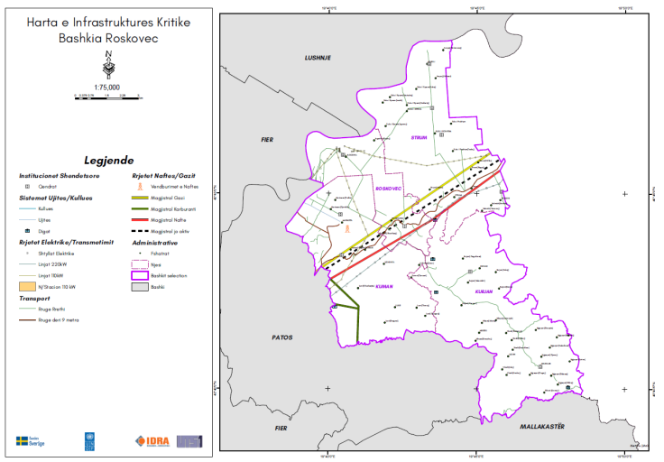
Figure 5 Extent of electricity infrastructure
Fuel supply (fuels and Liquefied Petroleum Gas - LPG) is one of the important energy sources that meets the needs of various consumers in the municipality of Roskovec, as for use in means of transport, in the means used for purposes of agricultural activity, but also for use for heating and cooking in services (hotels, restaurants) and in the residential sector.
The fuel supply network (fuels and LPG) is made mainly through fuel trading stations (for retail trade) and storage parks (for wholesale trade), which represent technological installations for the storage and trading of oil by-products , including LNG whose storage is done in pressurized equipment. Referring to the Administrative Units in the Municipality of Roskovec, the disposition of technological plants consisting of Storage and wholesale plants for oil by-products, fuel and LPG sales stations, as well as Pressure Installations according to these units in the Municipality of Roskovec, is as in the following tables:
Table 6 Fuel trading stations that also have LPG for vehicles
Name of the subject | A.Unit | Type | Capacity (Litra)
AUS OIL | Kuman | Oil & Gas | 54,000 liter & 5,000 GLN
Burhan Petrol | Kurjan | oil | 47,400 liter
Cepele sh.p.k | Roskovec | oil | 60,000 liter & 5,000 GLN
Xhei 11 | Roskovec | oil | 48,000 liter & 4,900 GLN
Das Oil | Roskovec | oil | 13,000 liter
Special Gas | Strum | gas | 470,000
Ysenj Agaci | Strum | gas | 21,500
Ledio 2020 | Strum | Oil & Gas | 81,000 liter & 5,000 GLN
Edi T | Strum | oil | 40,000 litet & 4,900 GLN

Agricultural sector
The agricultural system covers a space that extends over almost the entire surface of Roskovec Municipality. The entire area has high quality land, offering a large production of agricultural products and becoming one of the main economic elements of the municipality. Olives, fruits and vineyards are the most cultivated crops, relying mainly on the farmer's labor and personal instruments. Weather conditions in Roskovec are generally good for the production of a wide range of agricultural crops. Agricultural areas can be used twice a year on average. The amount of water reserves created by Lake Kurjan makes the Roskovec area one of the best agricultural locations in the country. The development of agriculture, the creation and implementation of irrigation schemes, the creation of access to the hills, will bring an increase in the planting of fruit trees, olive trees and the creation of vineyards. The low level of technology and agrotechnics used, the insufficient and non-standardized number of points of supply, processing, collection, trading, sanitary and quality control do not provide the suitable ground for a competitive and contemporary production efficiency in the domestic and international markets. foreign. The lack of agro-food industries aligned and connected with local products deprives producers of a higher added value. The agricultural sector currently faces many problems such as: high fragmentation of land, lack of production lines, weak infrastructure, technique and technology not yet developed, lack of standardization and marketing of products, difficulties in financing, etc. The fact that the agricultural sector plays an important role in the family economy, has ranked the solution of the high problems mentioned as a national priority.

Organization chart of Roskovec Municipality
Figure 6 The main departments for the implementation of PLVEK
Above are identified the main departments responsible for energy and climate management at the local level. The energy manager is the main coordinator who leads energy and climate monitoring.

1.7. The annual municipal budget (Year 2022)

For the year 2022, the total budget realized by Roskovec Municipality was 811,217,191 Lek, of which 507,382,751 Lek were revenues from the central state budget and 303,834,440 were total revenues from local taxes. The following data were provided by the Finance Department in the municipality.

Table 7 Roskovec Municipality Budget for 2022
Annual income (year 2022) | Value (Lekë)
The annual budget of the municipality (realized) | 811,217,191
Total income (central budget) | 507,382,751
Total income (local taxes) | 303,834,440
Regarding the expenses incurred, the following table provides data for the year 2022:
Table 8 Annual expenses, year 2022
Annual expenses (year 2022) | Value (Lekë)
Total expenditure on investments | 345,534,235
Total expenditure on municipal services | 102,499,250
Street lighting | 19,860,220
Municipal solid waste collection and municipal cleaning | 32,153,570
Supply of drinking water and waste water | 31,970,870
Other municipal services not included above (cemeteries, parks, flower gardens, playgrounds, etc.) | 18,514,590

METHODOLOGY

  - About the methodology for the development of PLVEK
The process of drafting PLVEK follows a defined methodology which is followed by all municipalities that are signatories of the Convention of Mayors (CoM). This methodology was developed by the Convention of Mayors and serves as a guide for local authorities (municipalities) in developing an effective energy and climate plan, including the main steps as described in the figure below.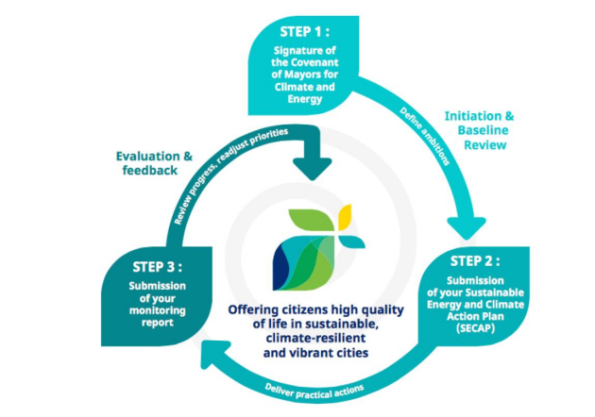
Figure 7 Steps for the preparation of PLVEK
- 1. Step I is the signing of the Convention of Presidents on Energy and Climate. The municipality of Roskovec has issued the Decision of the Municipal Council no. 39, on March 30, 2023 for "Granting the authorization of the mayor to join and sign the agreement of mayors on Climate and Energy for the Western Balkans and Turkey", taking in consideration of all obligations arising from the signing of this agreement. After agreeing on the realization of the plan, the municipality sets up the working group from each sector and begins the preparation of the climate and energy plan. Initially, it becomes possible to set up the database through the study of the current situation in the form of quantitative and qualitative data. After collecting the data, they are processed and the preliminary version of the energy and climate report is created. At this stage, it is also agreed on the monitoring report that must be done every 2 years by the team established within the municipality.
- Step II is the delivery of the Local Action Plan for Energy and Climate (PLVEK). The plan was drawn up by the working group established by the Roskovec municipality and was approved by the Municipal Council.
- Step III is the submission of monitoring reports. PLVEK should be monitored and revised every 2 years when necessary. Monitoring reports are prepared by the energy and climate team in collaboration with external consultants.

Mitigation (Reduction)

    - Followed process
The Covenant of Mayors initiative allows local authorities (municipalities) to develop climate change mitigation action plans, which should be adapted to their local context. Considering this principle, the Convention of Mayors has devised a methodology, which includes the selection of the base year (the year for which the data will be collected), the method used for the greenhouse gas inventory, the emission factors and the determination of greenhouse gas reduction targets.

Base year

The base year is the reference year against which the emission reduction targets will be compared, in order to monitor the results of the proposed actions. For the municipality of Roskovec, the reference year was determined to be 2022, as this was the most suitable year for which all the necessary data for the design of the plan were provided. In order to reach the 40% reductions target for 2030, it is very important that the monitoring starts from the last year, which would reflect the current situation of the city.

Field of action

The selected sectors within the boundaries of Roskovec municipality are the construction sector (public, residential, commercial and service), public lighting, waste management, water supply, waste water removal and treatment and the transport sector. The municipality of Roskovec has no control over the residential sector, the commercial and service sector as well as the industrial sector, sectors which are classified as private sectors.
3.2.4. Methodology for the calculation of carbon emissions assessment
The methodology for calculating greenhouse gas emissions for the baseline emissions inventory is developed according to the Greenhouse Gas Protocol (GHG Protocol) developed by the World Resources Institute (WRI) and the World Business Council for Sustainable Development (WBCSD). In the GHG Protocol, the emission categories are classified as follows:
Table 9 Categories of GHG emissions (GHG Protocol)
 | At the level of the municipality | At the level of the urban area
Category I | Direct emissions (e.g. from municipal vehicle fleet, consumption of fossil fuels for heating in buildings) | Direct emissions (eg from vehicles in the city)
Category II | Indirect emissions (eg electricity consumed in municipal buildings) | Indirect emissions (eg electricity consumed in the city)
Category III | Consumption-based emissions (eg emissions due to the purchase and receipt of production and transport products/services) | Consumption-based emissions (eg products and services consumed in the city, due to production and transport in another country or region)

Direct and indirect greenhouse gas emissions are calculated for each energy carrier by multiplying the final energy consumption by the relevant emission factor. CH4 and N2O emissions from waste, wastewater treatment, agriculture and livestock have also been calculated and converted to CO2e. In the calculation of the Basic Emissions Inventory, all CO2e (or GHG) emissions that occur due to energy consumption within the territory of the municipality of Roskovec, either directly (through the burning of fuels) or indirectly (through the consumption of electricity) are included. . The majority of GHG emissions are CO2 emissions, while CH4 and N2O emissions are of secondary importance for combustion processes in the residential and transport sectors. All CO2, CH4 and N2O emissions are calculated for all fuel types along with global warming potentials (GWP) using IPCC Fifth Assessment Report (AR5) emission factors. The IPCC methodology is used as a basis for greenhouse gas calculations within the defined boundaries of Roskovec Municipality. The following formulas and variables are used in the calculations by Category I, Category II, and Category III greenhouse gas source types.

    - Followed process
The methodology of the Convention of Presidents includes 6 (six) main phases for the climate adaptation cycle, which describe the necessary processes that must be followed to improve resilience to climate change. The stages to be followed are:
1. Preparation (data collection)
2. Assessment of risk and vulnerability
3. Identification of climate adaptation opportunities
4. Selection of adaptation options
5. Implementation of adaptation actions
6. Monitoring and evaluation

Phases 2, 3 and 4 of this cycle are an integral part of the document of the Local Action Plan for Energy and Climate, while the other phases of this process, implementation, monitoring and evaluation are included in the reporting format that the municipality of Roskovec will submit to the Convention of the Mayors .
Figure 8 The steps for risk assessment and adaptation

The assessment of Risk and Vulnerability to climate change for the municipality of Roskovec constitutes the basis for understanding and minimizing the impacts faced by the municipality as well as for identifying adaptation opportunities. To address phases 2, 3 and 4 of the adaptation cycle, the following steps were followed:

• Defining context and scope: Time frame, climate variables and risk framework.

• Collection of data on weather, climate and climate indicators as well as climate projections.

• Risk and vulnerability assessment taking into account the main climate risks and determining the possible impacts for each sector. Information on historical events and climate projections will also be used to understand how risks may change over different time periods.

• Determination of adaptation opportunities that can be implemented by the municipality of Roskovec, including stakeholders.

    - Defining context and purpose
The main step for any climate risk assessment is to define some assumptions made during the analysis.

Table 10 Main assumptions for climate risk assessment
Field of action | Followed approach
Time frame | Current climate conditions were assessed using national and regional climate change projections, in accordance with the report of the Third National Communication of Albania for the KKKBNK. Regarding climate effects in the future, the time frames for the climate projections to be used were defined with reference to the PLVEK example: Current, Short Term (<2040), Medium Term (2041 - 2070), Long Term (2071-2100) , Unknown
Climate risks | The hazards defined by the Convention of Mayors that are assumed in this plan are: Heat, Extreme cold, Extreme precipitation, Floods (luvial/urban), Drought, Storms (strong winds), Landslides (erosion), Fires in forests, Sea level rise.
Main Sectors | The sectors defined by the Convention of Mayers considered in this plan are:  • Buildings  • Transportation  • Energy  • Water  • Waste  • Land use planning  • Agriculture and Forestry  • Environment and Biodiversity  • Health,  • Civil Defense and Emergency  • The economy
Risk assessment methodology | For the risk assessment, the methodology described in the guide of the Global Convention of Mayors on Energy and Climate was selected.
    - Determining the main risks
- The methodology of the Convention of Mayors foresees 9 (nine) main risks that must be analyzed during the risk assessment. These risks are grouped into 3 main groups, to interpret and how these risks are related. Below are all the risks along with a description of each one.
- 2. Frequent, long and dry hot periods
- Drought: A period of abnormally dry weather, which can cause a serious hydrological imbalance.
- Extrem heat : The temperature is over 90% higher than the daily maximum.
- Forest Fires: Uncontrolled burning of lands fully or partially covered with timber.
- 3. Increase in intensity and frequency of extreme rainfall events
- Extreme precipitation: A large amount of rainfall in a short period of time
- Storms: Atmospheric weather condition that is accompanied by strong winds and that is accompanied by rain, thunder and lightning.
- The floods: This includes those from rivers, sewers and urban ones from high intensity rainfall.
- Landslides: The movement of a mass of material due to gravity, often aided by water when the material is saturated.
- 3. Increase in average global temperatures
Sea Level Rise: The long-term average increase in ocean surfaceI ftohti ekstrem: The temperature is below 10% of the minimum daily temperature.
Collection of data on weather, climate and other climatic indicators
The collection of data on weather and climate is based on the data published by the National Institute of Geosciences, National Communications that Albania has carried out at KKKBNK as well as on the local risk assessment plan for the Roskovec municipality. In cases where data for climate projections are not available at the local level, then regional climate projections will be considered.
Regarding past climate events, information is provided from online sources such as Academic research papers, published reports, etc.
The indicators used for risk and vulnerability assessment were selected according to the PLVEK reporting example.
    - Risk and vulnerability assessment
The risk assessment was carried out for all sectors defined according to the Convention of Mayers . For each of the risks identified in the municipality of Roskovec, the level of risk was assessed in accordance with the risk matrix, which is a function of the probability that each risk may occur and the impact (consequences) it will have.
Risk = Probability x Impact
In order to determine the probability of risks, climatic data, past events and predicted climate projections were taken into consideration. Risk assessment was performed based on the risk assessment matrix which is explained in the table below.
Table 11 Matrix of Risk Assessment
Probability | Impact/Consequences
 | high (4) | Average (3) | low (2) | not defined (1)
High (4) | High | High | Average | Average
Average (3) | High | Average | Average | Low
Low (2) | Average | Average | Low | Low
Unassigned (1) | Average | Low | Low | Not defined

Probability of risks

High (4) - Extremely likely that the risk/impact will occur (eg more than 1 in 20 chance of occurring)
Medium (3) - The risk/impact is likely to occur (eg between 1 in 20 and 1 in 200 chance of occurring)
Low (2) - The risk/impact is unlikely to occur (eg between 1 in 200 and 1 in 2000 chance of occurring)
Undefined (1) - The municipality has not experienced or encountered climate risks in the past/there is no probability that the impact will occur.Pasoja e rreziqeve klimatike
High (4) - The risk represents a high level of impact for the municipality. When it occurs, the risk results in (extremely) serious consequences for the municipality.
Medium (3) - The risk represents an average level of impact for the municipality. When it occurs, the risk results in average consequences for the territory of the municipality.
Low (2) - The risk represents a lower level of impact for the community. When it occurs, the risk results in impacts that are considered of little importance (or insignificant) to the territory of the municipality.
Undefined (1)- The municipality has not experienced or observed climate risks in the past or has no way to accurately report this information based on evidence or data.
The assessment of the probability and consequences of climate risks was carried out taking into consideration the temporal extent of the occurrence as defined in the table of assumptions (Current, Short Term (<2040), Medium Term (2041 - 2070), Long Term (2071-2100), Unknown ).
Vulnerability to the risks of climate change is determined for the main sectors which are analyzed in the Local Action Plan for Energy and Climate PLVEK.

3.4.5. Defining climate adaptation actions
The determination of actions for adaptation to climate change was carried out by considering the following steps:
1. Review of the existing documents of the municipality of Roskovec proposed in the strategic and political documents of the municipality, in particular the Risk Assessment report from natural disasters.
2. Consultations with experts from each of the sectors to determine the possible actions that will be proposed in PLVEK for climate change mitigation and adaptation.
3. Classification of actions into groups according to their prioritization (actions with high, medium and low priority) using economic, social and environmental criteria.
4. Discussion of the proposed actions with the working group and stakeholders.
5. Selection of high priority actions to be included in the Local Energy and Climate Action Plan.

    - Stakeholder engagement
Stakeholder engagement has played a key role in the PLVEK preparation process. The unit set up by order of the mayor for the drafting of PLVEK has contributed to the collection of all the necessary data for the plan. This unit consists of managers of different sectors near the municipality of Roskovec, who have also proposed actions that can be implemented to mitigate and adapt to climate change. The working group has held continuous meetings to discuss the progress of the plan preparation process. During the process of drafting the PLVEK, consultations were held with interest groups (local communities, civil society, etc.) in Roskovec Municipality to discuss the findings of the plan and its implementation.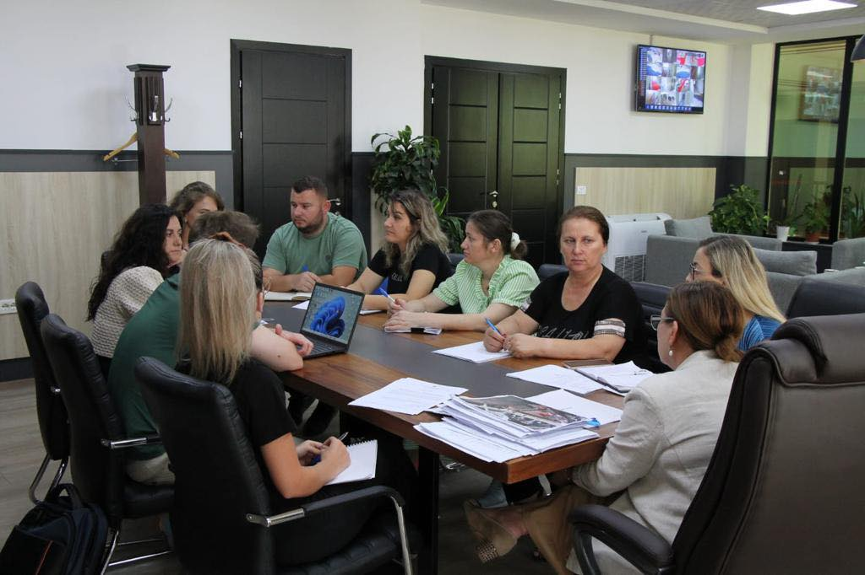 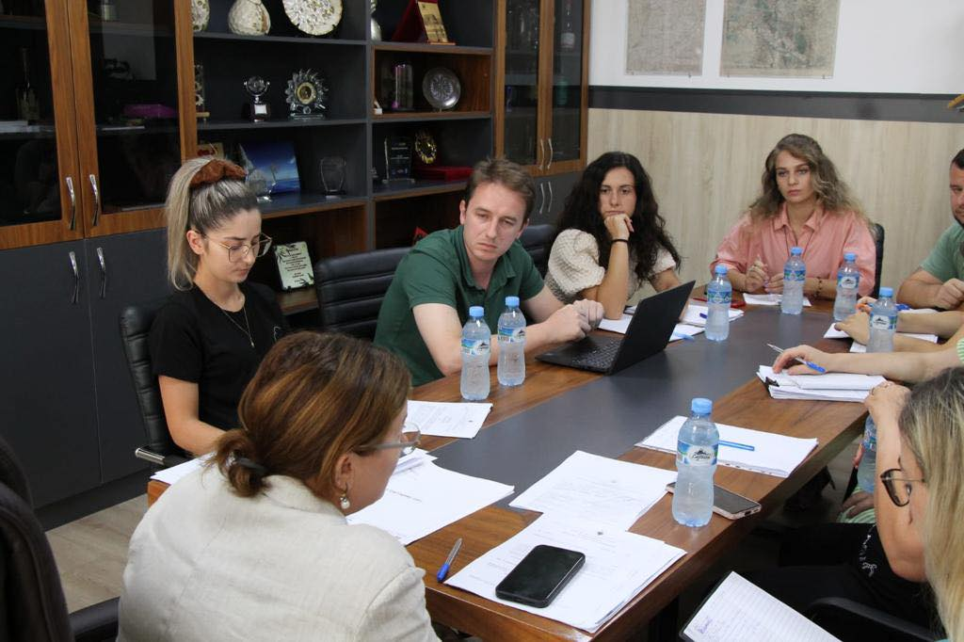
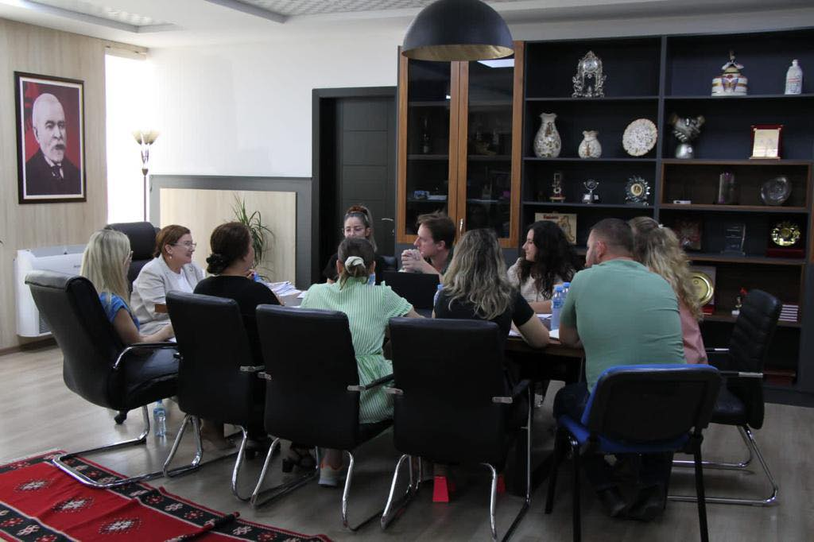
Figure 9 Consultative meetings with different stakeholders

3. DESCRIPTION OF THE CURRENT SITUATION (ADAPTABILITY)

  - Historical context and projections of climate change

In this chapter, a summary of information on the historical context of climate risks in Roskovec municipality, past events, climate projections and how climate change is expected to affect physical and social characteristics will be provided. The main risks are described according to the group defined in point 3.4.3 of this plan. A summary of the assessment of risk and vulnerability to climate change is also presented.

Periudha të nxehta të shpeshta, të gjata dhe të thata
Rreziku kryesor i periudhave të nxehta të shpeshta, të gjata dhe të thata sjell shfaqjen e rreziqeve të lidhura me klimën, si temperaturat ekstreme (I nxehti ekstrem), thatësira dhe zjarret në pyje, të cilat shpesh janë të ndërlidhura.
2.1.1.1 Extreme heat and droughts
The municipality of Roskovec is part of the hilly Mediterranean climate area. The presence of the Seman River plays an important role in shaping the climate of this municipality. The municipality of Roskovec has a mild climate with hot and partly dry summers and cold and wet winters. The average amount of precipitation is 1012 mm. The driest month is July with 29 mm of rain per month and November is the wettest month with 150 mm of rain. Winds are present for most of the year (5.5 months) and have a speed of 3 m/s. Due to the lack of historical data of average annual temperatures for the municipality of Roskovec, the data reported from Albania to the KKKBNK in the Third National Communication in 2016 were taken into consideration. Analysis of the average temperature for the period 1930-2006 against the average 1961- 90 shows that the period 1931-1970 had a positive anomaly followed by a negative anomaly between 1971 and 2000. After 2000 there was a period of positive anomaly from 2001 to the present. This is a consequence of the increase in maximum and minimum daily temperatures, especially in the summer period. The following years after 1990 are characterized by an increasing rate of minimum temperature, higher than that of maximum temperature in summer. Further analysis shows that since the beginning of the century there has been a positive trend of temperature increase for all seasons (winter: from +1.60 to +2.5°C; spring: from +2.00 to +3, 0°C; summer: +3.0°C; and autumn: +2.0°C).
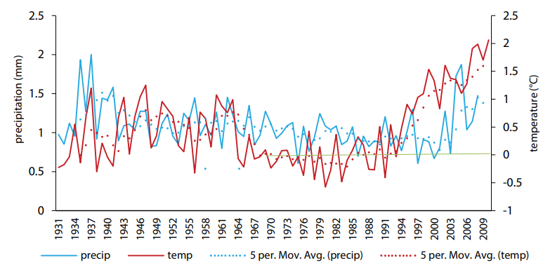
Figure 10 Average temperature and precipitation anomalies
Considering the maximum air temperatures recorded, the highest recorded was 40.4°C accompanied by a general increase in the frequency of days with temperatures above 35°C. Considering the period 1961-2010, this has resulted in an increase in the registration of heat wave days, where previously only two cases before 2001 and 26 days in 2003 were registered in Lezha.
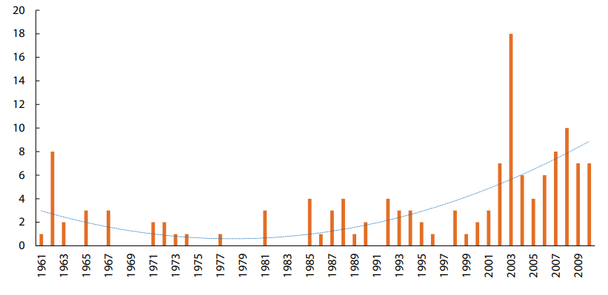
Figure 11 The annual distribution of the number of days with a temperature of Temp.max 35°C
In the last decade there has been an increase of up to 4 times in the number of recorded heat wave days. This finding is supported by an analysis of the probability of days with a maximum temperature greater than 90%, which shows an increase in the number of such days from 20% of the total during 1951-1964 to 30% in the last decade.
Climate projections
The climate scenarios project the lowest temperature increase in winter compared to other seasons and higher increases in spring compared to winter relative to 1990. The average temperature in autumn is likely to increase by 1.6°C to by 2050, 2.8°C by 2080 and 3.5°C by 2100. For summer, mean temperature change projections are likely to reach 5.3°C by 2100. The coastal zone does not is likely to experience average temperatures of less than 25°C by the summer of 2050, and average temperatures of up to 30°C by 2100.
Table 12 Projections of temperature change (°C)
Years | 2030 | 2050 | 2080 | 2100
Annual | 1.0 (0.7 to 1.2) | 1.7 (1.3 to 2.2) | 2.8 (2.0 out of 3.5) | 3.2 (2.4 to 4.1)
Winter | 0.8 (0.7 to 0.9) | 1.2 (1.1 to 1.4) | 2.0 (1.7 to 2.3) | 2.4 (1.9 to 2.7)
Spring | 1.0 (0.8 to 1.12) | 1.5 (1.3 to 1.8) | 2.6 (2.2 out of 3.0) | 3.1 (2.6 to 3.6)
SUMMER | 1.6 (0.5 to 1.8) | 2.5 (2.1 to 2.8 | 4.3 (3.8 to 4.9) | 5.3 (4.6 to 6.0)
Autumn | 1.0 (1.0 to 1.1) | 2.5 (2.1 to 2.8 | 2.8 (2.7 out of 3.0) | 3.5 (3.2 to 3.7
Expected annual increased temperatures are up to 15.9°C (15.6-16.1°C) in the north, 16.8°C (16.5-17.1°C) in the center and 17.9 °C (17.6-18.2°C) in the southern part until 2050. By 2100 the temperature is expected to increase to 17.8°C (17.1-18.5°C) in the north; 18.7 (18.0-19.4°C) in the center and 19.8 (19.1-20.5°C) in the southern regions. 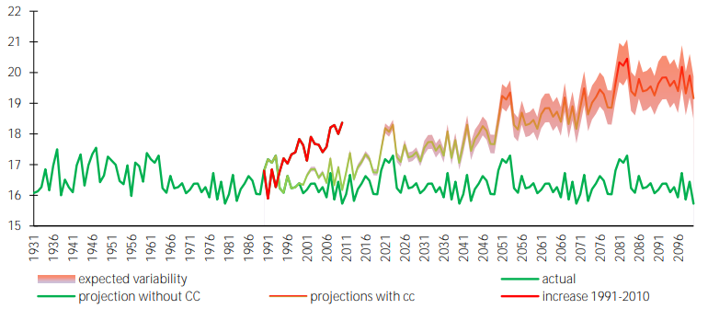
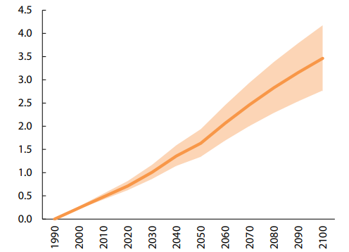
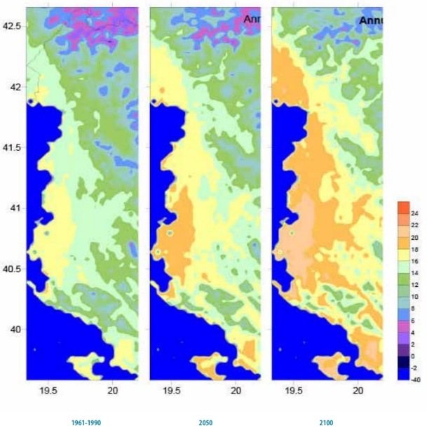

Figure 12 Expected annual temperature by 2050 and 2100
As a result of the predicted changes in temperature and changes in precipitation there will be more hot days and heat waves. More frequent and severe droughts with greater fire risk are expected. Table 13 Expected number of days with Tmax>35°C
 | REGION | 1961-1990 | 2030 | 2050 | 2080 | 2100
Number of days with Tmax >35°C  (average) | Northern | 1.7-5.8 | 5-10 | 7-14 | 8-20 | 10-24
 | Central | 0.6-4.9 | 2-9 | 2-12 | 3-18 | 4-21
 | SOUTHERN | 1.3 | 4 | 5 | 7 | 8

      - Forest fires

The data on the cases of fires in the forest area owned by the municipality of Roskovec are presented in the graph below. From the graphic presentation, we see that in this municipality there is an increase in the number of fire cases in the last two years, where in 2021 the largest number of fire cases was recorded (11 cases), where 10 cases of fires were in non-forest lands and 1 case in the forest, year 2022 (2 cases), and only 1 case of fires in 2011 and 2013. These data show that for the period 2011-2022 the total number of fires was a total of 15, where in the forest fund there was only 1 case and the average number of forest fires was 1 fire in 12 years. The frequency of fires in the forest fund in this municipality is 1 case in over 10 years. Forest fires in this municipality do not have a seasonal trend, but the largest number of fire cases was recorded in the month of September.

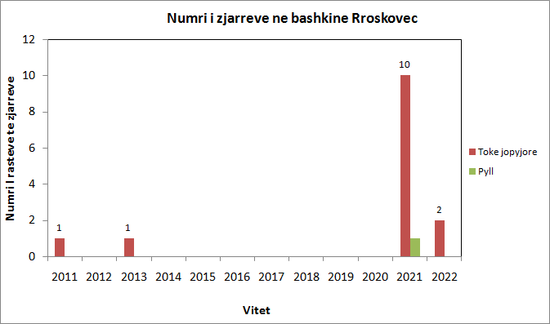

Figure 13 Number of fires by year in forest and non-forest lands owned by Roskovec Municipality
According to the data of DesInventar for the period 2011-2022, the total burned area was 1 ha and the value of the damage calculated only for the timber was about 250,000 ALL.
The combination of urban and forest areas and agricultural and forest areas has increased the risk of fires in the territory of Roskovec municipality. The reason for the severity and escalation of fires is climate change. Climate change is mainly about increased sensitivity as a result of extreme temperature values and lack of precipitation. Roskovec municipality is expected to have consequences from climate change. These changes will make the municipality of Roskovec face drought and intense heat and are expected to increase the number of forest fires. Based on the extent of forest resources, the type of cover and fuel and the location of urban areas near them, the areas with the highest risk in the territory of Roskovec municipality have been identified. The locations where the risk of fire is high are Kurjan, Luar and Marînez, while the areas classified as medium risk are Kuman and Strum. Other areas in the territory of Roskovec municipality are classified as low risk. The data are also presented in the forest fire risk map (Annex 3).

Table 14 Classification of areas according to the level of risk of forest fires
Nr | The location | Administrative unit | Popullsia e ekspozuar ndaj zjarreve në pyje | Fire hazard level
1 | Kurjan | Kurjan | 3618 | High
2 | Luar | Kuman | 5611 | High
3 | Marinëz | Kuman |  | High
4 | Kuman | Kuman |  | Moderate
5 | Strum | Strum | 7538 | Moderate
6 | Roskovec | Roskovec | 4975 | Low

From the exposure analysis, it results that a population of 9229 are more exposed to fires. In the entire territory of Roskovec municipality, a number of objects are also exposed by fires, such as: school (17); public buildings (4); cultural monuments (1); Public (4) and educational institutions (18) and hospitals (10). The most endangered are the objects located in the Kuman and Kurjan administrative units. Climate forecasts show an increase in annual average temperatures from 1ºC (2030) to 3.2ºC (2100). Since the forest fires in this municipality occurred in September, then as a result of climate change in Roskovec municipality the temperature will increase by 1.7 ºC to 3.5 ºC and precipitation will be reduced from ‐3.84% to ‐18.13% until the year 2100, accompanied by changes in their distribution during the year.
These climate changes are expected to affect land use, vegetation types, and biomass moisture that are critical to the expected impacts of wildfires. Thus, fire activity is expected to increase in this municipality due to climate change. Based on climate projections, a 30% increase in the frequency of fires, an increase in burned forest area by the year 2100, and a decrease in population damage as a result of their migration to urban areas are predicted.
Table 15 Projections for the risk of forest fires as a result of climate change
Indicators | Period
 | 2011‐2022 | deri 2100
Forest area burned (ha) | 1.0 Ha | 9.5 Ha
The number of fire cases | 1 | 7
The number of fire cases in 1 year | < 1 | < 1

Despite the forecast for an increase in the population in this municipality, the exposure of people to fires, especially in rural areas, is expected to be lower considering the fact that the majority of the population is expected to live in the urban area.

Rritje e intensitetit dhe shpeshtësisë së ngjarjeve ekstreme të reshjeve

Precipitation and Storms
The analysis of precipitation and anomalies shows that the variation around the normal value (1961-1990) can be divided into three sub-periods, with a wet period between 1951-1980 up to 40% above the normal value, a dry period between 1981-2000 to to 45.3% below normal, and since 2000 a period of increased rainfall.
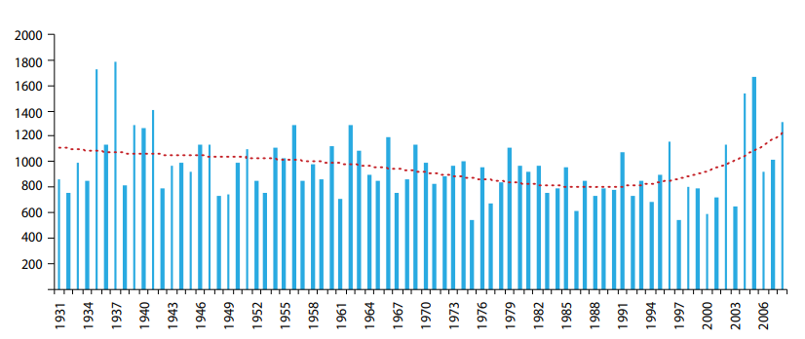
Figure 14 Annual rainfall distribution (mm)
The maximum amount of 24-hour rainfall is the most important parameter in relation to rainfall intensity. The frequency of wet days above the >77 mm threshold is higher in the period 1951-1978 than during the period 1980-2008. Between the years 1951-1978, 75% of years with rainfall amounts above 77 mm could be observed at least once a year. In contrast, during the period 1980-2008, 50% of the cases have one day per year with precipitation over 77 mm.
Climate projections for precipitation
The results of different scenarios lead to the conclusion that annual precipitation is likely to decrease by -8.5% (from 47.4 to -56.0%) by 2050; to -18.1% (from 94.0 to -89.7%) by 2100.
Table 16 Projections of precipitation change (%)
Years | 2030 | 2050 | 2080 | 2100
Annual | -3.84 | -8.46 | -14.37 | -18.13
Winter | -5.96 | -10 | -14.3 | -18.1
Spring | -2.45 | -7.26 | -14.26 | -17.7
Summer | -10.4 | -19.7 | -41.9 | -50.4
Autumn | 0.5 | -2.5 | -6.9 | -9.5

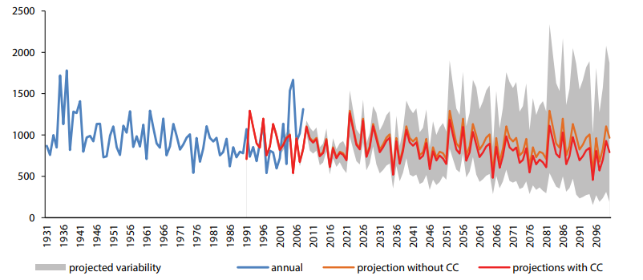
Figure 15 Annual precipitation projections (mm) without and with climate change
There will be a decrease in annual precipitation (-8.5%), ranging from 1500 mm in the north, 965 mm in the center and 1120 mm in the southern part by 2050; the variation from north to south of the entire coastal area is 1400 to 800 mm. By the year 2100, there will be a decrease in total precipitation (-18.1%). In the northern part, the total rainfall is expected to be up to 1300 mm, in the center 860 mm and in the south up to 1000 mm; the variation from north to south is 1600 to 600 mm respectively.

Heavy rainfall events (precipitation above the threshold) are expected to intensify. So it can be expected that by 2030 there will be an increase in dangerous precipitation for the northern part of about 1-2 days in relation to 1990, about 2-3 days by 2050, 3-4 days by 2080 and about 4-5 days. days by 2100. In the central part, an increase of about 1 day of rainy days is expected by 2030, 2 days by 2050, 3 days by 2080 and 4 days by 2100.
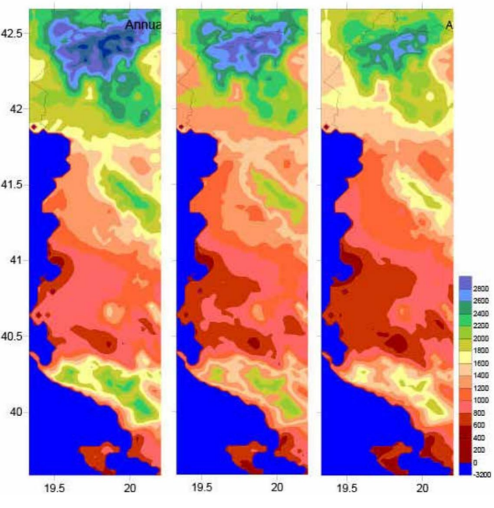

Figure 16 Expected annual precipitation until 2050 and 2100

Përmbytjet

In the Roskovec Municipality area, there are no floods from the Seman River recorded in the last 30 years. Floods occur mainly in agricultural lands during heavy rains, and due to blockage of drains. In the analysis, the risk caused by floods from rivers with a return period of 100 years, or 1% probability, and floods that could be caused by the possible failure of dams were taken into account. Some floods that can bring significant damage from the possible destruction of the dams are: The destruction of the Allambrezi dam, the Kurjan, Strum and Cerven dams which would cause flooding in all four Administrative Units of Roskovec Municipality. Regarding other floods that can be caused by the destruction of dams, we can mention: Slanice, Protoduar and Malthike Dams, but which do not pose a risk since the flow is transported by the streams on which they are built. The biggest risk for floods from the destruction of dams is the destruction of the Banja Dam. In the table below, the risk assessment for floods is given for sure 1 time in 100 years considering the affected population, economic damage, impact on the environment and cultural heritage.
Table 17 Damage from floods probably once in 100 years
Administrative Unit | Risk | Population Census 2011 | Sip. km2 | Affected Population  (residents) | Economic Damage | Environmental impact (km2) | Impact on cultural heritage (picies)
KUMAN | Flooding | 5611 | 32 | 56 | € 884,878 | 0 | 0
KURJAN | Flooding | 3618 | 38 | 5 | € 105,699 | 0 | 0
ROSKOVEC | Flooding | 4975 | 14 | 248 | €1,972,638 | 0 | 0
STRUM | Flooding | 7538 | 33 | 75 | € 910,715 | 0 | 0
Total |  | 21,742 | 118 | 384 | €3,873,931 | 0 | 0
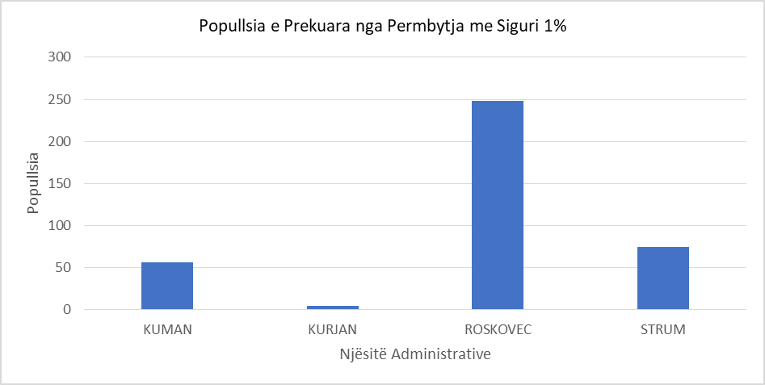

Chart 4 Population affected by the flood with a certainty of 1%
The total economic cost for the municipality of Roskovec is €3,873,931, which is in the range of <0.004 of the GDP of the Fier district. The economic impact of this scenario is "Low". Based on the risk matrix, which combines the likelihood of the risk and the level of impact, the risk level for this scenario is "Low".
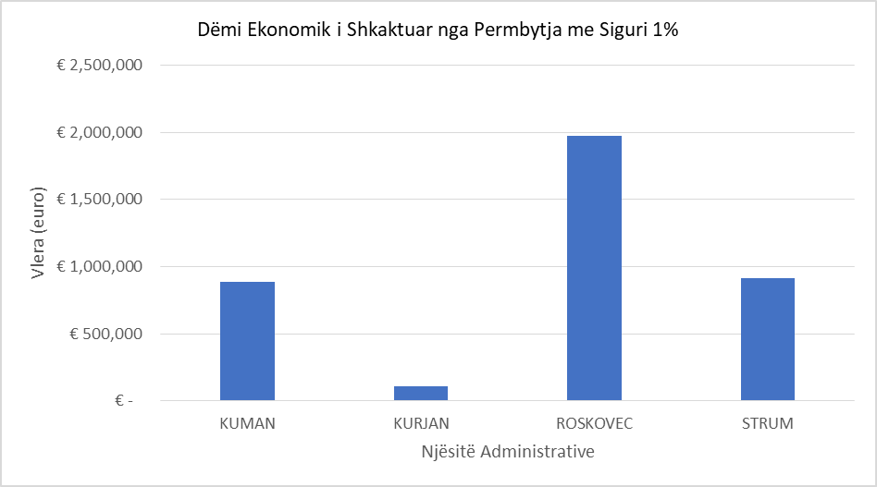
Chart 5 Economic damage
The following table provides the risk assessment for floods caused by the possible destruction of dams considering the affected population, economic damage, environmental impact and cultural heritage.

Table 18 Damage caused by possible failure
Adm.unit | Risk | Pop.  Census 2011 | Surf. km2 | Affected Population  (residents) | Economic Damage (€) | Nd.  in the environment (km2) | iMPACT  in the cultural inheritance  (piece)
KUMAN | Përmbytje | 5611 | 32 | 3928 | 24,133,038 | 0 | 0
KURJAN | Përmbytje | 3618 | 38 | 181 | 1,921,808 | 0 | 0
ROSKOVEC | Përmbytje | 4975 | 14 | 3532 | 10,759,846 | 0 | 0
STRUM | Përmbytje | 7538 | 33 | 4900 | 24,837,671 | 0 | 0
Total Municipality of Roskovec |  | 21,742 | 118 | 12,541 | 61,652,363 | 0 | 0

The total economic cost for the municipality of Roskovec is €61,652,363, which is in the range of 0.04÷0.4% of the GDP of the Fier district. The economic impact of this scenario is "High". Based on the risk matrix, which combines the probability of risk and the level of impact, the risk level for this scenario is "Medium".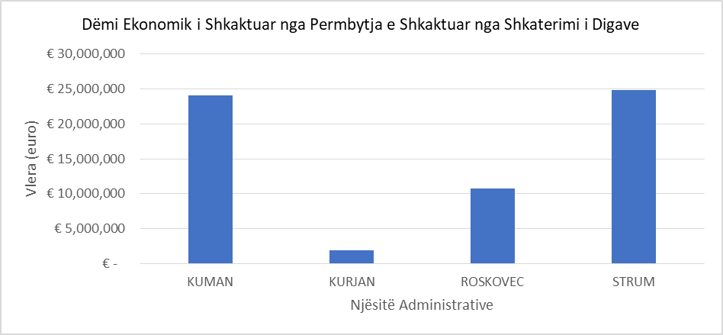

Chart 6 Economic damage from the flood from the possible destruction of the dams
SLIDINGS
The preparation of the landslide inventory map is the first step towards the landslide Hazard assessment pathway.
Table 19 Slide inventory for each administrative unit
No. | Administrative unit | Number of slides | Sliding surface (Ha) | Unit Area (Ha) | Sliding surface %
1 | KUMAN | 93 | 307.3 | 3216 | 9.6
2 | KURJAN | 241 | 702.9 | 3841 | 18.3
3 | ROSKOVEC | 16 | 17.4 | 1436 | 1.2
4 | STRUM | 6 | 24.5 | 3308 | 0.7
ROSKOVEC MUNICIPALITY |  | 356 | 1052.1 | 11801 | 8.9
The total number of landslides for Roskovec municipality is 356 landslides and the area affected by landslides is 8.9%. The assessment of susceptibility to landslides was carried out taking into consideration the following factors: (Height above sea level, Slope, Geological structure, Density of tectonic fractures, Rainfall, Land use, Distance from the hydrographic network, Slope orientation, Slope shape Density of road network Distance from buildings The sensitivity map is obtained by combining all the weight maps for each factor.

Table 20 Vulnerability map expressed in value of affected surface in hectares
ORDINAL NUMBER | Administrative Unit | Its missing | Very low | Low | Medium | HIGH | VERY HIGH
1 | KUMAN | 1317 | 263 | 287 | 350 | 290 | 709
2 | KURJAN | 324 | 227 | 378 | 430 | 767 | 1715
3 | ROSKOVEC | 1125 | 71 | 103 | 74 | 58 | 5
4 | STRUM | 2805 | 118 | 161 | 135 | 85 | 4
ROSKOVEC Municipality |  | 5571 | 679 | 929 | 989 | 1200 | 2433

Table 21 Data on vulnerability, expressed in value of affected surface in hectares
Ordinal number | Administrative  Unit | Its missing | Very low | Low | Medium | High | Very high
1 | KUMAN | 41.0 | 8.2 | 8.9 | 10.9 | 9.0 | 22.0
2 | KURJAN | 8.4 | 5.9 | 9.8 | 11.2 | 20.0 | 44.6
3 | ROSKOVEC | 78.3 | 4.9 | 7.2 | 5.2 | 4.0 | 0.3
4 | STRUM | 84.8 | 3.6 | 4.9 | 4.1 | 2.6 | 0.1
BASHKIA ROSKOVEC |  | 47.2 | 5.8 | 7.9 | 8.4 | 10.2 | 20.6

Based on the results of the sensitivity assessment for the Municipality of Roskovec, it is observed that 47.2% of the territory of this municipality is not sensitive to erosion processes. About 22.1% of the territory is included in sensitivity classes from "Very Low" to "Medium". The rest (30.8%) of the territory is included in the "High" and "Very High" sensitivity classes. The administrative units with high sensitivity to landslides are the Kurjan Administrative Unit with 64.6%, followed by that of Kuman with 31%. For the other two Administrative Units, Roskovec and Strum, the percentages of the territory included in the "High" and "Very High" Sensitivity Classes are respectively 4.3 and 2.7%.
The calculation of the risk of landslides for Roskovec Municipality for a repetition time of 100 years is given in tabular form for each administrative unit, while the Risk Map is built at the level of the Municipality (Annex 2).

Table 22 Risk values in units (Ha) of the surface according to classes
Administrative Unit | Missing | Very low (< 0.2) | Low (0.2 - 0.4) | Medium  (0.4 - 0.6) | High (0.6 -0.8) | Very High (> 0.8)
KUMAN | 1209 | 145 | 291 | 638 | 913 | 20
KURJAN | 77 | 193 | 444 | 873 | 2230 | 25
ROSKOVEC | 1096 | 78 | 67 | 140 | 54 | 0
STRUM | 2781 | 167 | 189 | 172 | 2 | 0
BASHKIA ROSKOVEC | 5163 | 583 | 991 | 1823 | 3199 | 45

Table 23 Risk values in percentage of the surface according to classes (Recurrence time 100 years)
Administrative unit | Missing | Very low (< 0.2) | Low  (0.2 - 0.4) | Medium  (0.4 - 0.6) | High (0.6 -0.8) | Very High (> 0.8)
KUMAN | 37.6 | 4.5 | 9.0 | 19.8 | 28.4 | 0.6
KURJAN | 2.0 | 5.0 | 11.6 | 22.7 | 58.0 | 0.7
ROSKOVEC | 76.4 | 5.4 | 4.7 | 9.8 | 3.8 | 0.0
STRUM | 84.0 | 5.0 | 5.7 | 5.2 | 0.1 | 0.0
ROSKOVEC MUNICIPALITY | 43.7 | 4.9 | 8.4 | 15.4 | 27.1 | 0.4

The results show that 43.7% of the territory of the Municipality of Roskovec is not endangered by forest processes. At the Municipal level, 28.8% of the territory is included in the risk classes from "Very Low" to "Medium" and 27.5% is included in the "High" and "Very High" risk classes. The territories included in the "High" and "Very high" Risk Classes belong to the Kurjan (58.7 %)2, Kuman (29 %), Roskovec (3.8 %) and Strum (0.1 %) Administrative Units.
Elements endangered or exposed to the risk of landslides are grouped into three categories:

A. Infrastructural work: This category includes the national and rural road network and railways;
B. Monuments of cultural heritage: Monuments declared as such (cult objects, archaeological sites, monasteries)
C. Engineering facilities: Residential facilities, Schools, Facilities of public institutions.
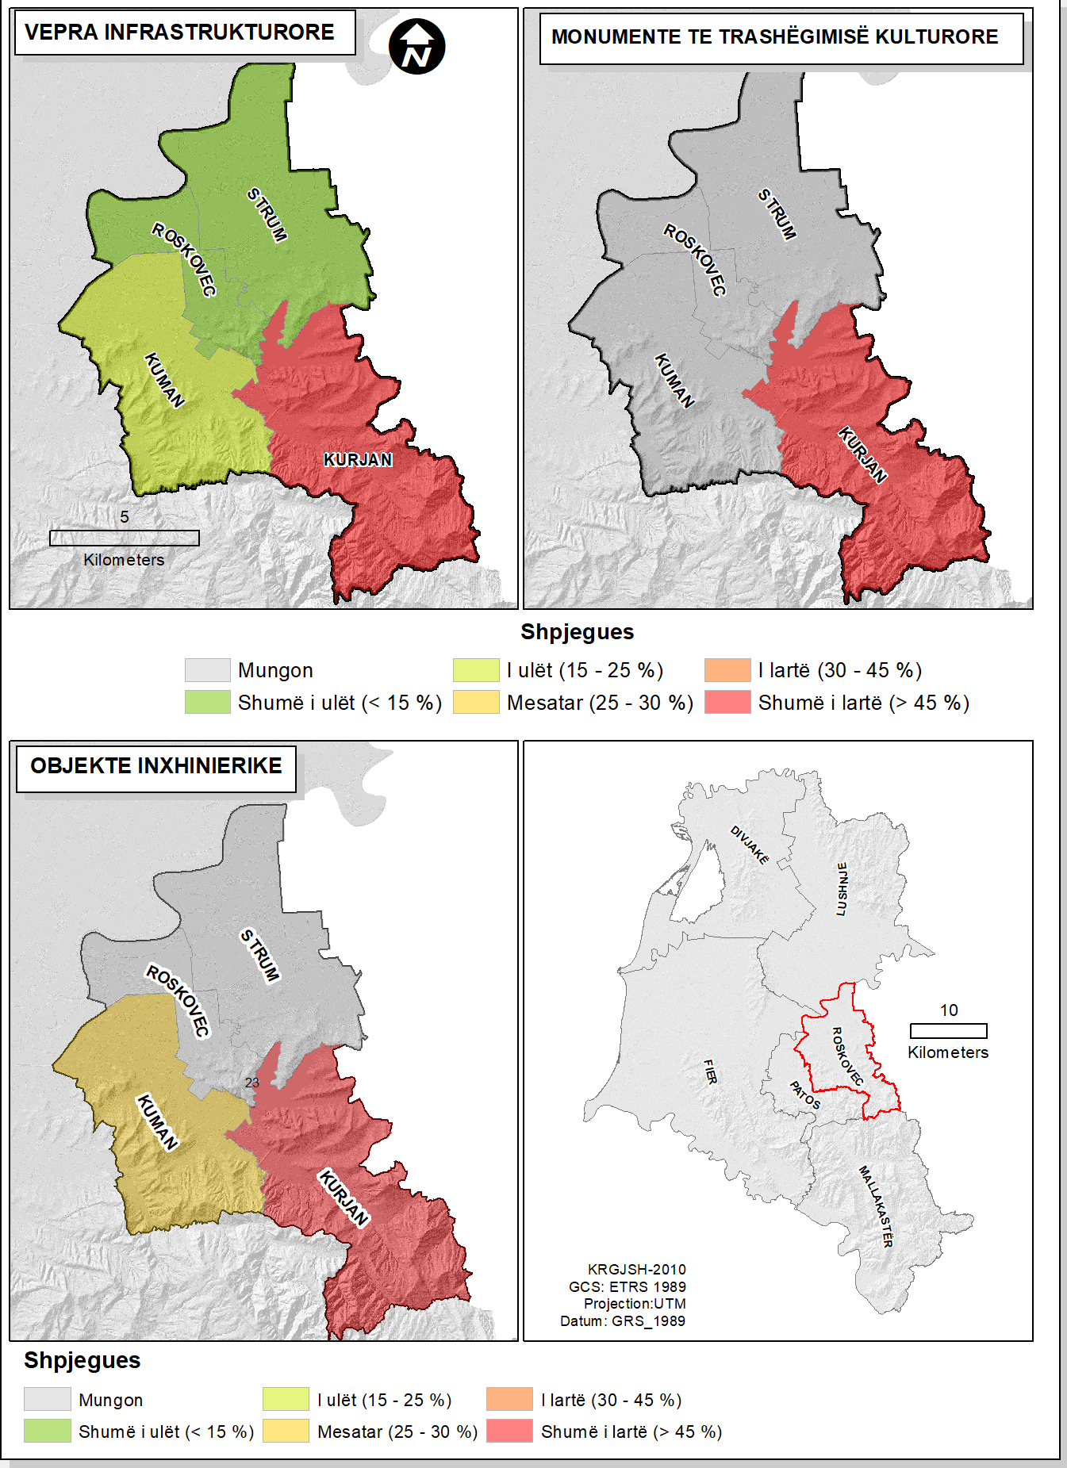

Figure 17 Risk Maps according to Exposure Categories

Increase in global average temperatures
      - The rise of the sea level

Between 1985 and 2011, the Adriatic coast of Albania has changed. By means of satellite images, it was possible to measure that the coastline had an extension of 535 km in 1985 and in 2011 the extension reached 557 km. As a result of sea level rise, river levels are expected to rise in the upper reaches of the basin and flow will slow. In total, by 2050, about 1082.45 km2 (32% of the coastal area or 3.76% of the country's area) will suffer direct consequences from flooding. Most of the existing agricultural and industrial areas will be lost due to sea level rise. Large amounts of agricultural land will be lost or rendered unusable due to flooding and increased salinity. Most coastal habitats, such as sand dunes, freshwater wetlands, marshes and lagoons, will be lost or further degraded.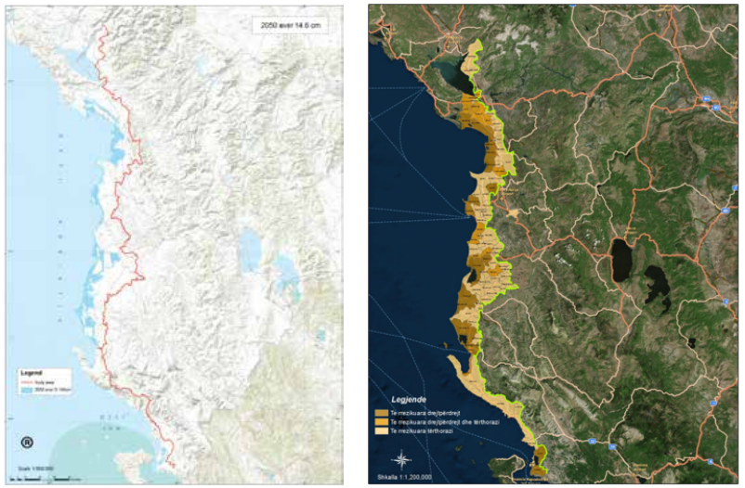

Figure 18 Areas expected to be flooded by 2050 (sea, left) and rivers

Extreme cold
Minimum air temperatures do not show a clear trend, although there is an indication that over the last decade there has been an increase from 0.3 days/year to 0.7 days/year where temperatures ≤-5°C are recorded. The number of days with cold waves (cases when the air temperature for at least six consecutive days is 5°C lower than the long-term average temperature of the corresponding days) does not show an increasing trend.

Table 24 Expected number of days with Tmin < 0°C
 | REGION | 1961-1990 | 2030 | 2050 | 2080 | 2100
Number of days with Tmin <0°C  (average) | Northern | 10-27 | 4-15 | 0-10 | 0-3 | 0
 | Central | 7-32 | 3-18 | 0-11 | 0-5 | 0
 | Southern | 3 | 0 | 0 | 0 | 0

Minimum temperature levels in the coastal area are expected to be higher, so there will be fewer cold days. Frosty days are likely to be a very rare phenomenon for the area near the coastline.

Risk evaluation

    - Risk assessment for climate change

The first step of this risk assessment process was the comprehensive risk assessment of the main risks defined by the Convention of Mayors (CoM) methodology. This assessment was carried out based on the historical context of risks for the municipality of Roskovec. The following table gives the risk assessment for Roskovec Municipality.

Table 25 Main climate risks and current level of risk
Climate risk | Actual risk of risks |  |  | Future risk
 | Propability | Impact | Risk | Expected change in risk intensity | Expected change in risk frequency | Timeline
Extreme heat | High | High | High | Increasing | Increasing | Short-term
Extreme cold | Low | Average | Low | Discreasing | Discreasing | Medium Term
Heavy rain | Average | Average | Average | Increasing | Increasing | Long-term
Heavy snowfall | Low | Low | Low | Discreasing | Discreasing | Long-term
Fog | Low | Low | Low | Discreasing | Discreasing | Long-term
Hail | Average | Average | Average | Increasing | Increasing | Long-term
Drought and lack of water | High | High | High | Increasing | Increasing | Short-term
Flooding from rivers | Low | Low | Low | There's no change | There's no change | Long-term
Flooding from the destruction of dams | Low | High | Average | There's no change | There's no change | Long-term
Sea level rise | Low | Low | Low | There's no change | There's no change | Long-term
Storm | Low | Average | Average | There's no change | There's no change | Long-term
Sliding | I ulët | High | Average | There's no change | There's no change | Long-term
Forest fires | I lartë | High | High | Increasing | Increasing | Short-term

From the table above, it can be seen that the municipality of Roskovec has a high risk in terms of risks such as: extreme heat, drought and lack of water and forest fires. All 3 (three) of these risks are closely related to climate change and rising temperatures. The intensity and frequency of these risks are expected to increase in a short-term period of time (next 20-30 years). The risk from precipitation, floods, storms and landslides is assessed as moderate, where the intensity and frequency of precipitation is expected to increase in the long term, while for floods and storms it will not change in the long term. While the risk of extreme cold, heavy snowfall, flooding from rivers and rising sea levels turns out to be low.

    - Risk assessment for each sector

The second step in this process was the risk assessment for each of the sectors defined for the risks that may be caused by climate change.

Sektori i ndërtesave
The main risks for the building sector are: extreme heat, floods and landslides. The risk from extreme heat for the building sector is estimated to be high, due to the high probability that this risk is expected to occur with reference to climate projections, which show an increase in extreme heat events. Also, the impact of extreme heat will be high for this sector, referring to the current state of comfort of the buildings in this municipality. Floods and landslides are estimated to
have an average risk for this sector.

Table 26 Risk evaluation for the transport sector
Sector | Rreziku kryesor | Impakti/Pasoja | Niveli i riskut | Tmeline
Building | Extreme heat | Extreme heat causes overheating in buildings increasing demand for cooling, leading to increased costs for building repair and maintenance. | High | Short-term
 | Flooding | Flooding from rivers or the possible destruction of dams can cause damage to buildings | Medium | Long-Term
 | SLIDING | Landslides can cause damage to buildings or their total destruction | Medium | Long term

Transportation sector
The transport sector turns out to have an average level of risk in terms of risks such as floods and landslides, this is due to the fact that the probability that these risks affect the municipality of Roskovec is low, while the impact on the transport sector is average.

Table 27 Risk assessment for the transport sector
Sector | Main risk | Impact/Consequences | Risk level | Timeline
Transportation | SLIDING | These risks can affect the damage to the transport infrastructure (road infrastructure). | Medium | Long term
 | Flooding

Energy sector
For the energy sector, the main risks from climate change such as extreme heat, storms and floods are estimated to have an average risk. The following table explains the impact these risks will have on the energy sector.

Table 28 Risk assessment for the energy sector
Sector | Main Risk | Impact/consequences | Risk level | Timeline
Energy  Energy | Extreme heat | Extreme heat can lead to increased energy demand, which puts a high pressure on power generation facilities, causing power outages.  However, the increase in the level of temperatures can create a high potential for the production of electrical energy from photovoltaic panels (renewable energy). | Medium | Short term
 | Storms | Extreme weather events such as storms or floods can damage the infrastructure of generation, transmission and distribution of energy, causing disruption of energy supply throughout the territory of the municipality. | Medium | Midle-term
 | Flood

Water sector

The level of risk for the water sector is estimated to be high for the main risks identified below. Events such as extreme heat, droughts, extreme rainfall, and floods have a high probability of occurring with reference to future climate projections. The consequences for this sector are estimated to be high, where it is worth mentioning the lack of water supply and damage to the water supply system and the management of urban wastewater.
Table 29 Risk evaluation for the water sector
Sector | Main risk | Impact/consequences | Risk level | Timeline
Water | Extreme heat | Rising temperatures and lack of rainfall would cause droughts. This would cause disruption and lack of water supply, affecting daily life and industrial activity. | High | Short-term
 | Droughts
 | Extreme rainfall | Extreme rainfall and flooding can cause damage to urban wastewater management infrastructure. | High | Short-term
 | Flood

4.1.2.5. Residues
The risk assessment from climate change risks is assessed as low.

Table 30 Risk assessment for the waste sector
Sector | Main risk | Impact/consequences | Risk level | Timeline
Mbetjet | SLIDING | The main impact could be damage to waste management infrastructure, treatment/processing plants, increasing maintenance costs.. | Low | Long-term
 | Flood

      - Agriculture and forestry

The agriculture and forestry sector is one of the sectors that can be affected by many risks due to climate change. The risk level is assessed as high for hazards such as extreme heat, droughts, forest fires as the probability of these events is very high based on climate projections and the consequences are great for this sector. Risks such as extreme rainfall, floods, landslides are assessed as medium risk, as their probability of occurrence in this municipality is low. Sea level rise has a low risk for this sector. The following table presents the risk assessment for the agriculture and forestry sector.

Table 31 Risk assessment for the agriculture sector and forests
Sector | Main risk | Impact/consequences | Risk level | Timeline
Agriculture and forestry | Extreme heat/ Extreme cold | Degradation of the quality of agricultural land; Reduction of crop productivity and yield; Change of periods/seasons of agricultural productions. | High | Short term
 | Droughts
 | Heavy rain/Storm | Damage/destruction of crops; | Average | Midterm
 | Flood | Loss of agricultural land; Damage or total destruction of crops; | Average | Long term
 | SLIDING
 | Sea level rise | Loss of agricultural land; Salinization of underground water sources used for irrigation | Low | Long term
 | Forest fires | Loss of forest area | High | Short term

      - Land use planning

The following table provides the risk assessment for land use planning. High risk is assessed by extreme weather events, such as extreme heat, droughts that have a high probability of occurring.

Table 32 Risk assessment for land use
Sector | Main risk | Impact/consewuences | Risk level | Timeline
Land use planning | Slide | Soil erosion causing restrictions on land use | Medium | Midterm
 | Extreme heat/droughts | Change in land use patterns | High | Short-term
 | Flood | Flooding of urban and industrial areas | Medium | Long term
 | Sea level rise | Damage to urban and industrial areas | Low | Long Term

      - Environment and Biodiversity

The level of risk for the environment and biodiversity is assessed as high as the probability of extreme weather events is high and the impact that the risks will cause is high.
Table 33 Risk assessment for the environment and biodiversity

Sector | Main risk | Impact/consequences | Risk level | Timeline
Environment and Biodiversity | Extreme heat | Destruction of the natural environment. | High | Short term
 | Droughts | Decrease in the level of water bodies, eutrophication of waters and habitat loss;
 | Forest fires | Biodiversity loss, species migration;

HEALTH

Some of the main risks from climate change also affect people's health. The high probability of extreme weather events and the impact they have on health makes the risk high. While the risk of floods and landslides is estimated as average, since the probability of these events occurring in this municipality is not high.

Table 34 Health risk assessment
Sector | Main risk | Impact/consequences | Risk level | Timeline
Health | Extreme heat/ Extreme cold | Increase in diseases and mortality rate; | High | Short term
 | Droughts | Lack of water or water of poor quality which leads to dehydration and ill health.
 |  | Damage to health or loss of life. | Medium | Long term
 | flood

      - Civil defense and emergency
The level of risk for civil protection and emergencies is estimated as average.
Table 35 Risk assessment for civil defense and emergencies
Sector | Main risk | Impact/consequences | Risk level | Timeline
Mbrojtja Civile dhe Emergjencat | The hot/ the cold | Increasing pressure on civil defense and emergency agencies;  Economic damage in affected sectors. | Medium | Short term
 | Heavy rain/Storm
 | Flooding
 | Sea level rise
 | SLIDING
 | Forest fires

Economy
The main risks that can cause consequences in the economic sector are landslides and floods, which can affect the economic activity of the municipality of Roskovec. The probability of their occurrence is not high and the risk is estimated to be average.
Table 36 Risk assessment for the economy
Sector | Main risk | Impact/consequences | Risk level | Timeline
Economy | Flood | Damage to economic activity | Medium | Long-term
 | SLIDING

Vulnerability evaluation

      - The most vulnerable sectors
The following table summarizes the most vulnerable sectors for each of the climate risks.
Table 37 The most vulnerable sectors
Rreziqet klimatike | The most vulnerable sectors | Current Level of Vulnerability
Extreme heat | Buildings | Medium
 | POWER | High
 | Water | High
 | Agriculture and Forestry | High
Heavy rain/Storm | Water | High
 | Agriculture and Forestry | High
 | Civil protection and Emergencies | Medium
Droughts and lack of water | Water | High
 | Agriculture and Forestry | High
 | Planning and land use | High
The floods | Building | Medium
 | Water | Medium
 | Agriculture and Forestry | High
 | Planning and land use | Medium
Sliding | Building | High
 | Agriculture and Forestry | High
 | Planning and land use | Mesatar
Forest fires | Agriculture and Forestry | High
- 6. DESCRIPTION OF THE CURRENT SITUATION (REDUCTION)

Building sector

Municipal building

Public buildings of Roskovec municipality are divided into two types according to the funds used from the budget:
• Municipal buildings which belong to the central government.
• Municipal buildings belonging to the municipality.
Due to a decentralized structure, only a small part of the buildings can be classified as buildings which are generally owned by the government. Public buildings that belong to Central Government Agencies and Ministries are hospitals, public security, professional education, justice buildings and tax administration. The municipality of Roskovec is responsible for the operation and maintenance of buildings located within its borders, including local administrative buildings, schools, kindergartens, local museums, bookstores, etc. Energy consumption of municipal buildings is measured every month and it is reported to the department responsible for the budget. The annual supply of fuel and fuel such as petrol/diesel is decided by the municipality based on historical data and the available budget. In Roskovec Municipality, the department responsible for the management of municipal buildings is the property management sector. The following table gives the inventory of public buildings in the municipality of Roskovec, including their surfaces..
Table 38 Public buildings in Roskovec Municipality
Municipal building | No. of institution | Total surface (m2)
Nursery, Kindergarten | 3 objekte (1 çerdhe, 2 kopshte) | 486
9-year and secondary school | 23 objekte (12 shkkolla 9 vjecare, 2 të mesme) | 8470
Buildings of the city administration | 4 objekte | 1269
Cultural, Sports & Other Buildings | 4 objekte | 718
Hospitals and health care centers | 16 objekte (1 spital/15 qendra shendetesore) | 1008
Total | 42 objekte | 12,101

The following table provides data on the consumption of electricity for the last 4 years for public buildings under the jurisdiction of Roskovec Municipality. Electricity in public buildings is used for space heating, lighting, as well as from the electrical equipment that the buildings have depending on their function. Buildings exhibit high energy losses through their envelope and single-glazed windows, having a high energy demand. The heat supply is insufficient to ensure a normative heating. Reported room temperatures during winter are 15 °C while corridors are usually not heated at all. The current challenges for the municipal buildings sector is the lack of thermal insulation and the still low use of solar panels in municipal buildings. Space heating and lighting make up the highest part of consumption in the municipality's buildings. A good part of the heating is done with electricity and diesel.

Table 39 Consumption of electricity from public buildings
 | Consumption of electricity (GWh)
 | 2019 | 2020 | 2021 | 2022
Educational Institutions | 0.1 | 0.1 | 0.1 | 0.1
Buildings of the Municipal Administration | 0.2 | 0.2 | 0.3 | 0.1
Cultural Institutions | 0.02 | 0.02 | 0.02 | 0.02
Total | 0.3 | 0.3 | 0.4 | 0.2

Table 40 Energy consumption (diesel) by public buildings
 | Diesel consumption (GWh)
 | 2019 | 2020 | 2021 | 2022
Educational Institutions | 0.027 | 0.049 | 0.084 | 0.060
Municipal Administration Buildings | - | - | - | -
Cultural Institutions | - | - | - | -
Total | 0.027 | 0.049 | 0.084 | 0.060

Table 41 Energy consumption (wood) from public buildings
 | Diesel consumption (GWh)
 | 2019 | 2020 | 2021 | 2022
Educational Institutions | - | - | 0.03 | 0.03
Municipal Administration Buildings | - | - | - | -
Cultural Institutions | - | - | - | -
Total | - | - | 0.030 | 0.034

    - Residential Buildings
The number of buildings for residential purposes in the Municipality of Roskovec based on Census 2011 is 6876. Below is the distribution of buildings according to the period of construction for each administrative unit.
Table 42 Distribution of buildings according to construction period for each administrative unit
Administrative Unit | Construction period
 | Until 1960 | 1961-1990 | 1991-2000 | 2001-2011 | After 2011
Kuman | 290 | 670 | 408 | 389 | 95
Kurjan | 236 | 568 | 148 | 206 | 282
Roskovec | 105 | 482 | 200 | 233 | 465
Strum | 179 | 498 | 694 | 497 | 231
Total | 810 | 2218 | 1450 | 1325 | 1073

The category of residential buildings includes those buildings that are owned by citizens, such as apartments, individual private dwellings, etc. Citizens pay their electricity and water service bills directly to their respective supplier (electricity, water). The collection of data for the residential sector was provided by the Electricity Distribution Operator in Roskovec Municipality. The data on electricity consumption are provided according to 2 categories of residents (flats and private individual flats), based on the contract number that the flats have with OSHEE. The consumption of electricity is recorded on a monthly basis. Most of the residential buildings are not thermally insulated and have high energy consumption. Meanwhile, the use of solar panels is still not widely used by the community. The level of awareness and information on the use of energy efficient technologies by the community is not at the right level. The municipality of Roskovec lacks financial instruments that could enable the wider use of efficient technologies for clean energy.
Table 43 Electricity consumption by the residential sector
Rezidential Sector | Year 2022 (GWh)
Flat Apartment | 0.03
Private individual housing | 13.7
Total | 13.7

Table 44 Energy consumption (firewood) by the residential sector
Rezidential Sector | Year 2022 (GWh)
Flat Apartment | 4.3
Private individual housing | 11.7
Total | 16

From the collected data, it can be observed that the consumption of electricity from individual dwellings is many times higher than that of apartments. This is because in apartments, part of the living spaces are shared and the energy losses are at smaller values. Electricity from the residential sector is mainly used for heating/cooling the premises, lighting and cooking. The heating of the dwellings is mainly carried out with electricity and a small part of them with firewood. Regarding electricity consumption rates, the price of energy for household consumers is 11 Lek/kWh. Electricity losses in the residential sector are considered high because most of the stock of residential buildings are not thermally insulated, the equipment they use is not efficient, the heating/cooling systems are not efficient, etc.
    - Commercial and service sector
This sector includes small business, large business and the business sector that operates in agriculture. As seen in the table above, energy consumption by small business is 2.3 GWh, followed by large business with a value of about 0.78 GWh. The challenge for businesses is the lack of financial instruments for investments in solar panels and the efficient use of energy. Mostly small businesses have difficulty paying for electricity.
Tabela 45 Electricity consumption by the commercial and service sector
Commercial and service sector | Electricity consumption (kWh) | Electricity consumption (GWh)
 | Year 2022 (kWh) | Year 2022 (GWh)
Small business | 2,295,047 | 2.30
Large Business | 775,893 | 0.78
Agriculture and Greenhouse | 115,470 | 0.12
Total | 3,186,410 | 3.19

Public lightning
The public lighting service is provided by the municipality in the public services sector through the "Road Maintenance, Decoration, Lighting and Education Enterprise". The electrical network of street and public lighting in the municipality of Roskovec is heterogeneous and coverage with this service mainly includes the main residential areas. The approximate length of the street lighting network is 26 km. The standard annual operating hours of public lighting are 3,650 standard hours/year, while the actual annual operating hours are 3,285 hours/year.
The following table provides data on the number of lighting poles and their function:
Table 46 The number of lighting poles
Pillar function | Number (light pole)
For street lighting | 1018
For decorative lighting | 128
For the lighting of the parks | 76

Regarding the type of public lighting lamps, the following table presents the classification of lamps according to type and average power:
Table 47 Types of public lighting lamps
The composition of lighting bulbs | Number of lamps | Average power per luminaire (W)
Compact Fluorescent Lamp | 16 | 25-50
High pressure sodium lamp | 311 | 150- 50
High pressure mercury lamp | 0 | 0
LED | 577 | 25-50

As can be seen in the graph below, currently around 64% of the lamps are LED, followed by 2% fluorescent lamps and 34% sodium lamps. Currently, in Roskovec Municipality, 70% of the territory is covered with lighting. Also, a challenge for lighting remains the high cost of maintenance and operation, which requires more experienced and qualified specialists. Based on the table above, about 16 lamps are fluorescent, followed by 311 sodium lamps and about 577 LED lamps..
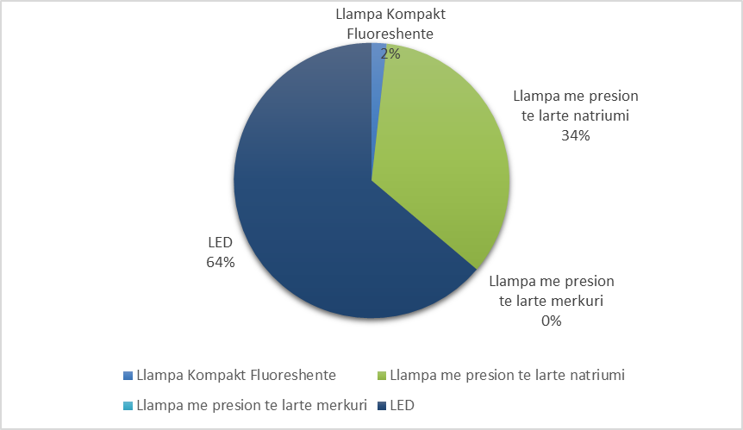
Chart 7 Types of public lighting lamps
Based on the data collected by the Department of Decoration, Lighting and Education, the consumption of electricity from street lighting for the last 4 years is as follows:
Table 48 Electricity consumption for street lighting
 | Electricity consumption (GWh)
 | 2019 | 2020 | 2021 | 2022
Street lightning | 0.4 | 0.4 | 0.4 | 0.3

From the data, it can be seen that over the last 2 years, electricity consumption has decreased, where for 2022, the electricity consumed was 0.3 GWh. This reduction in energy consumption is also related to the measures applied by the municipality of Roskovec during 2022 to save electricity. As for energy losses in the street lighting network, they are estimated to be 10%.
The following table provides data on the total costs for street lighting, including electricity costs, operation and maintenance and investment costs:
Table 49 Total costs for street lighting
Costs for public lighting | Value (Lekë/year)
Total energy costs for street lighting | 4,978,277
The cost of replacing the bulbs | 30,000
Other O&M expenses for street lighting | 1,754,958
Total cost for street lighting (energy + O&M + investments) | 3,129,278

Table 50 Public lighting rate according to customer categories
Customer category | Street lighting fee (LEK/year)
Families in urban areas | 800
Families in rural areas | 500
Small businesses in urban areas | 1000
Small businesses in rural areas | 1000
Large businesses in urban areas | 1000
Larg businesses in rural areas | 1000

Transportation sector
Road transport is the only mode of transport used within the borders of the municipality of Rosovec, for which the collection of data on fuel consumption has also been made. The data are provided only for diesel fuel, while for gasoline and liquid gas there is no information on the total consumed.
The road transport sector in the Municipality of Roskovec includes the fleet of vehicles owned by the municipality, public transport vehicles as well as private vehicles. The fleet of vehicles owned by Roskovec municipality includes 3 vehicles used by the administration, 1 fire engine vehicle, 4 vehicles used by the maintenance investment company, and 7 vehicles used by the cleaning, greening and cemetery maintenance company. In terms of public transport, there are a total of 21 buses in Roskovec municipality. In the table below, they gave data on the consumption of fuel (diesel) by vehicles owned by the municipality and by public transport for the last 4 years 2019, 2020, 2021 and 2022.
Table 51 Fuel consumption by the public transport sector
 | Number of vehicles | Diesel (litres) | GWh
 |  | 2022 | 2020
Vehicles owned by the municipality |  |  | 0.6
Administrator | 3 | 29,238 | 0.3
Firefightning | 1 | 4,057 | 0.0
Maintenance investment undertaking | 4 | 9,130 | 0.1
Cemetery Cleaning, Greening and Maintenance Enterprise. | 7 | 15,200 | 0.2
Public transport |  |  | 2.79
Bus | 21 | 260,430 | 2.79
Taxi | 11 | -
Transporti privat | 24,690 | 47,800,457 | 48
Total | 47 | 318,055 | 51

Interurban bus lines are not under the municipality's jurisdiction and no data on the consumption of waste materials from them have been provided. Also, the collection of data on fuel consumption by private vehicles that are used within the borders of Roskovec municipality has not been ensured. Currently, the condition of the vehicles in the use of the municipality is not very new and they have a considerable expense of fuel. Based on the table above, private transport has the highest fuel consumption. The calculation of the number of vehicles was carried out by referring to the number of families for the year 2022 and according to the methodology for calculating the road distance per km and fuel consumption per 100 km. Currently, there are no charging towers in Roskovec municipality that will serve to charge electric cars. Also, the municipality lacks a mobility plan which will better orient the development of mobility in the city..

Other sectors
1.3.1 Cleaning, collection and treatment services of urban waste
The waste management service (cleaning service) is provided by the municipality through the "Greening Cleaning and Cemetery Maintenance Enterprise". This enterprise together with the "Entrepreneurship of Institutions of Lighting, Road Maintenance and Education" are under the public services sector that handles the waste management service.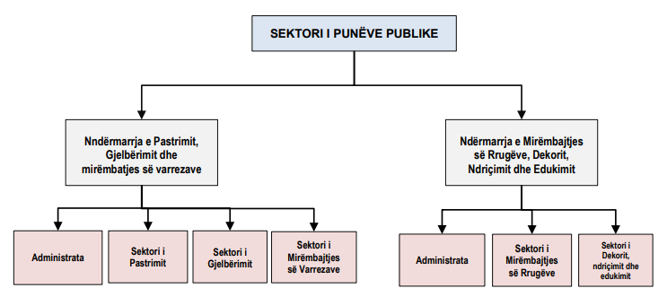
Figure 19 Organization of the Public Works Sector in Roskovec Municipality
The cleaning service is offered in all four AU, or in 94% of the territory. It covers the following services:
• Daily street sweeping service with hand brooms, on an area of about 251,625 m2
• Main street irrigation service, on an area of approximately 73,000 m2
• The service of collecting and transporting urban waste about 13.8 tons/day (from the collection points and around them) to the Energy Waste Treatment Plant in Fier.
• Inert, agricultural and bulky waste collection service.

The waste collection service consists of the collection of urban waste deposited by citizens, businesses and institutions in and around public containers and in some specific rural areas of the AU, where there are no containers, the service is offered door to door. It covers the disinfection of containers and the area around them, using lime and chlorine, as well as the transport of urban waste with a technological machine to the Marinza landfill. The mixed collection of waste in containers takes place 7 days a week in the city of Roskovec and 6 days a week in other UAs. Meanwhile, door-to-door collection service is offered 2 or 3 times a week, based on the situation on the ground.
In the entire territory of the municipality there are 169 1.1m3 containers with an average distance of 200m from each other in urban areas and about 400m in rural areas. The UA of Roskovec and Struma count the largest number of containers in their territories, followed by the other two administrative units, as shown in the table below.:
Table 52 Infrastructure for waste collection in Roskovec Municipality
Administrative Unit | No. of metal containers | Capacity (m³)
Roskovec | 62 | 1.1
Strumë | 58 | 1.1
Kuman | 25 | 1.1
Kurjan | 24 | 1.1
Total | 169

Their technical conditions are not very good, except for those purchased during 2019-2020. The waste collection and transportation service is offered in all administrative units of the municipality through a fleet of vehicles consisting of 1 technological vehicle (18 tons), two self-unloading trucks (5 and 7.5 tons), two 1 ton pickup trucks for rural areas and 1 tanker truck for washing the streets.

Table 53 Fleet of waste transport vehicles
Vehicle type | Year of manufacture | Year of purchase from the municipality | Capacity (ton) | Technical condition
Technology tools | 2006 | 2017 | 18 | Almost good
Self-discharge tool | 1996 | 2012 | 5 | Not good at all
Self-discharge tool | 1993 | 2010 | 7.5 | Not good at all
The pickup truck | 2011 | 2014 | 1 | Not good at all
Truck | 2012 | 2015 | 1 | Not good at all
Tank truck | 1998 | 2016 | 9 m³ | Almost good
Scrap technology machine | 2001 | 2021 | 1 m³ | Almost good

The total waste collection route is estimated to be 157 km and the route to the Waste-to-Energy Treatment Plant in Fier is about 34 km away. The municipality of Roskovec has a very weak infrastructure to properly carry out the collection and daily transport of waste. 169 containers do not cover the entire territory and in some cases the service is performed door to door.
Another issue that jeopardizes the quality and effectiveness of service delivery is self-loading trucks that are being widely used even in areas that are equipped with containers. Workers to ensure collection of waste from containers must empty the containers in the field and load the waste into the truck, using shovels or any other equipment they may find convenient.
The total amount of waste deposited in the Waste Treatment Plant for the year 2022 was 2,500 tons of waste. Referring to the data provided by the municipality of Roskovec, it turns out that the amount of waste that is recycled is 22 tons of cardboard and the waste that is composted is 240 tons of organic waste.
The total consumption of fuel (diesel) for trucks to collect and transport waste to the landfill is 17,000 liters/year. Table 54 Fuel consumption for the waste management service ve
Service area | No. of conteiners | Service frequency | Diesel (l/year ) | GWh
Urban and rural area | 169 | 7 days /week(urban)  6 days/week (AU) | 17,000 | 0.3
Cleaning service of streets and squares
The following table summarizes the technical data of the cleaning service in Roskovec Municipality:
Table 55 Street and square cleaning service
AU | Cleaning of the street |  | Street/neighbourhood
 | Time of the service offered | Surface (m²) | Time of the service offered | Surface (m²)
Roskovec | 1 April – October  (02:00 – 09:00) | 104,620 | May– September  (06:30- 08:30) | 73,000
Strume | November - March  (03:00 10:00)  During raining days  05:00 – 12:00 | 74,075 | N/A
Kuman |  | 43,330
Kurjan |  | 29,600
Total |  | 251,625

Waste treatment - Energy Treatment Plant in Fier
Starting from November 2021, the municipality will transfer the waste to the Energy Treatment Plant in Fier. The municipality of Roskovec, like the other municipalities of the waste area of Fier, is required to send urban solid waste to this Impaint with an entry fee of 10 euros/ton for waste treatment in landfill and up to 25-30 euros/ton for waste treatment in the energy treatment plant. The plant is located 25 km from the city of Roskovec (one way).

Financial and fiscal issues for the waste management system
Cleaning fees for different levels of customers, such as households, businesses and institutions, are calculated by Roskovec Municipality and approved annually by the Municipality Council in the annual fiscal package together with other local taxes and fees. According to the fiscal package approved for 2022, Roskovec Municipality applies these cleaning fees for the following categories:
Table 56 Cleaning fee according to the fiscal package approved in 2022
Customer category | Cleaning fee (LEK/year)
Families in urban areas | 1800
Families in rural areas | 1000
Small businesses in urban areas | 13500 - 45000
Small businesses in rural areas | 13500 - 45000
Large businesses in urban areas | 45000 - 120000
Large businesses in rural areas | 45000 - 60000
Institutions | 15000

Based on the data of the Roskovec municipality, the total revenue from the collection of cleaning fees (households, public institutions and businesses) for the year 2022 was ALL 15,298,527.

Water supply system in Roskovec Municipality
UK Roskovec sh.a was created in December 1996 and currently, since January 1, 2023, it has been included in UK Fier sha., operating in the water supply to the urban and rural areas of this municipality. The population in the area of jurisdiction of the company is 32,512 inhabitants, while the population in the area of service of the company for the year 2022 is 16,639 inhabitants. The active population with water consumption is 12,173 inhabitants, while the inactive population is 4,466 inhabitants. Continuity of water supply service duration is on average 5 hours/day.

Water resources

The sources of water supply are the existing boreholes and the systems work with mechanical lifting. The volume of water produced with mechanical lifting systems for the year 2022 is 850,000 m3 of water. Below are the characteristics of each of the water supply systems for the municipality of Roskovec.

Tabela 57 Vendndodhja e depove/rezervuarëve për furnizimin me ujë
No | Location of warehouse/reservoir | The name of the warehouse/tank | Area adm. that serves | Volumes and depositions | Number of population
 | NJA | U.K. Roskovec | Njësia | m3 | Nr
47 | Qyteti i Roskovecit | Vineyard Hill | Qyteti | 1300 | 3500
48 | Kurjan | The coast of Mec | Kurjan | 200 | 300
49 | Kurjan | Church | Kurjan | 100 | 200
50 | Kurjan | Kurjan | Kurjan | 200 | 300
51 | Cerven | Cervan | Cerven | 50 | 200
52 | Mbers | Mbers | Mbers | 50 | 200
53 | Vlosh | Vlosh | Vlosh | 50 | 200
54 | Luar | Luar | Luar | 100 | 400
55 | Vidhisht | Graveyard | Vidhisht | 250 | 600
56 | Kuman | Kuman | Kuman | 200 | 600
57 | Kuman (Marinëz) | Ward Hill | Kuman | 650 | 1500
58 | Strum | Strum | Strum | 200 | 1500
59 | Suk 1 | School field | Suk 1 | 100 | 3500
60 | Suk 2 | School field | Suk 2 | 100 | 3500
61 | Velmish | Velmish | Velmisht | 200 | 600
Due to the small reserves of underground water, the water supply of the city of Roskovec as well as the villages of this municipality is quite problematic. The water supply of the villages is mainly done from small local sources as well as from village wells and domestic wells dug with large diameter. Almost all the villages do not have a centralized water supply, except for some that are connected to the water supply of the city of Roskovec. Roskovec is supplied with water from wells in the Vidhishta area.
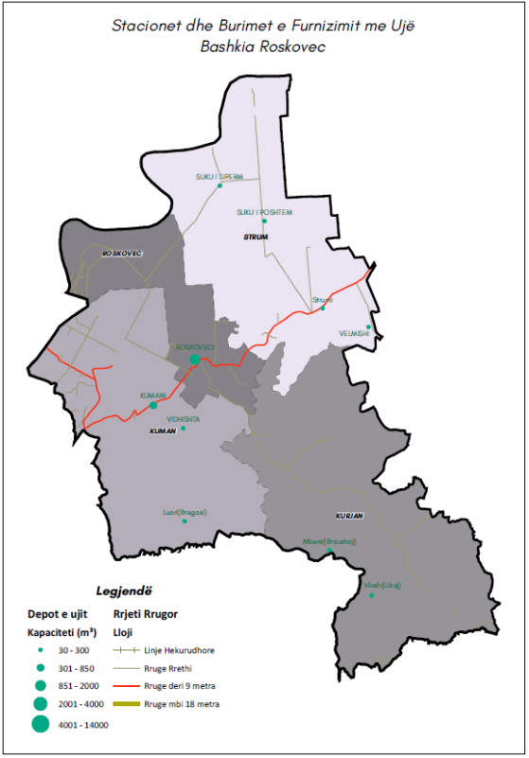
Table 58 Water stations and reservoirs for water supply of Roskovec
Main Existing and distribution network
The total length of the water supply pipeline network is 66.9 km, where the length of the transmission network pipelines is 16.2 km and the distribution network is 50.7 km.
Expenditure and use of energy for water supply
The total energy consumed by the water supply for the year 2022 is 620,000 kWh. The cost of electricity for the year 2022 for the water supply turns out to be 12,090,000 Lek. The total cost of operating the Roskovec aqueduct is 58,846,000 Lek, where the cost of electricity is 21% of the total operating costs.
The following table shows the main performance indicators in terms of water supply in the municipality of Roskovec. Table 59. Performance indicators for water supply system

Performance indicators | Vlerat | Unit
Water consumption per capita per day | 0.14 | m3/b/day
Total amount of water sold (m3) | 524,000 | m³
Energy consumed for the production and distribution of drinking water | 620,000 | kWh
The total amount of drinking water produced | 858,000 | m³
The specific energy consumed to produce and distribute drinking water | 0.72 | kWh/m³
Energy costs of the water company for water supply | 12,090,000 | ALL
Total costs of water supply operation | 58,846,000 | ALL
Total revenue billed by the water utility | 23,067,000 | ALL
Percentage of population with access to clean water | 73 | %

The fixed service fee is 100 lek/month/client. Based on ERRU decision No. 29, dated 30.06.2010 "On the approval of water fare for public consumption for JSC UK Roskovec", the volumetric fare for this service are:
Table 60 Water supply rates in Roskovec Municipality
Customer category | Water supply
Family customer | 52 lek/m³
Budget institutions | 105 lek/m³
Private entities | 125 lek/m³

1.3.1 Wastewater treatment/removal system

The current sewage system in the Roskovec Municipality is administered by the Roskovec Water and Sewerage Company SH.A. The population in the service area of the sewerage company is 62,383 inhabitants. The total population served by wastewater treatment is 65,073 inhabitants, with 62,693 inhabitants served by the sewer system and 2,380 inhabitants served by septic tanks.
The total length of sewerage pipes in Roskovec municipality is 41 km, where the length of concrete pipes is 14 km, while the length of polyethylene-plastic pipes is as follows:
The sewage system at the municipality level turns out to be more problematic than the water supply. According to the general local plan, for the municipality of Roskovec, the need for the construction of sewerage systems has been identified as follows, as well as the construction of the wastewater treatment plant for the urban center:
37 km. The number of connections to the sewage network for each of the customer categories is given in the table of ITUN wastewater treatment plant

1. KUZ network in the village of Suk (lower part)
2. KUZ network in the village of Suk (upper)
3. Network of KUZ village Vidhishte
4. KUZ network Kurjan village
5. KUZ network Mbërsi village
6. KUZ network Vlosh village
7. KUZ network Luar village
8. Completion of the KUZ network in the village of Jagodina
9. Completion of the Strum village KUZ network
10. Completion of the KUZ network in the village of Velmish
11. Completion of the KUZ network in the city of Roskovec
12. Completion of the Kuman village KUZ network
13. Completion of the KUZ network in the village of Arapaj
The total energy consumed by the sewage service for the year 2022 turns out to be 504,637 kWh. The total cost of electricity for 2022 is 39,087,000 Lek. The total cost of operating the wastewater service is 135,390,000 Lek, where the cost of electricity is 28% of the total operating costs.
The following table presents the main performance indicators in terms of the wastewater removal/treatment service in Roskovec municipality.
Table 61 Performance indicators for wastewater
Performance indicators | The Values | Unit
The total quantity of polluted water | 399,930 | m³
Total energy consumed for sewer service | 504,637 | kWh
Electricity costs of sewerage | 39,087,000 | ALL
Total sewer operating costs | 135,390,000 | ALL

6.5. Inventory of energy consumption and carbon emissions for the base year

Greenhouse gas emissions including all sources of emissions within the administrative boundaries for 2022 is in the amount of 20,458 tons of CO2. Categorization of emissions for each category is clearly shown in the table below. The information is divided into sub-categories in line with the guide of the convention of presidents, which will help to identify the main interventions supporting the decision-making process in the implementation of the plan. This analysis included fuel consumption in buildings, transport, waste and water supply as the largest sources of carbon emissions.
Public buildings account for about 0.3% of energy consumption or carbon emissions compared to other sectors. Residential buildings have a value of about 43.2% in relation to the total energy consumption within the territory of the municipality. Commercial buildings have a value of 2.3% of the weight of consumption, followed by street lighting with 0.4% of the weight. Transport has the highest weight value with approximately 52% of energy consumption in relation to the total value. Then there are the wastes with the value of 0.2% of weight, water supply and sewerage with the value of 1.1% and finally the irrigation sector (agriculture) with 0.3%.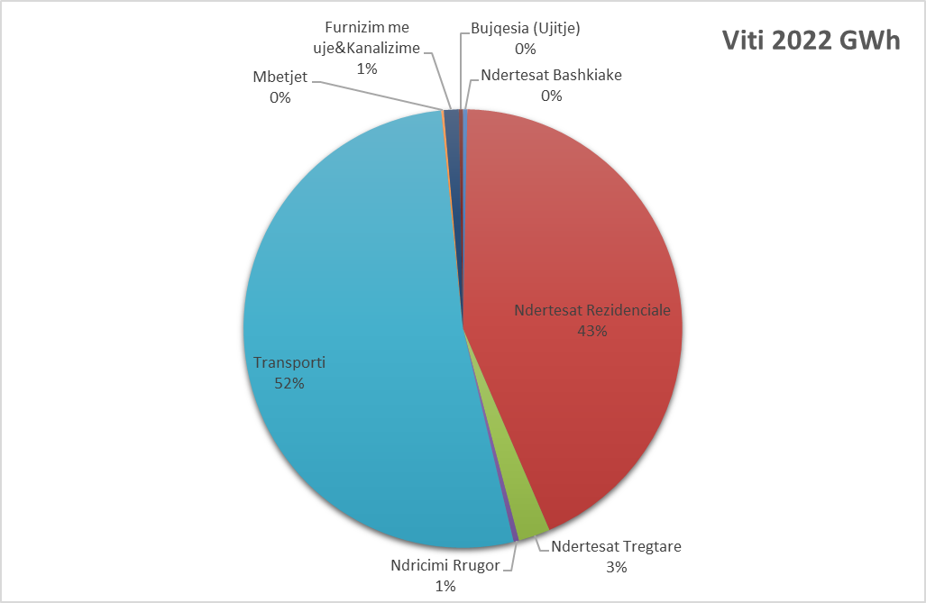
Chart 8 Categorization according to consumption for each category

Tabela 62 Informacioni mbi nivelin e konsumit të energjisë dhe emetimeve të karbonit
 | Year 2022
 | GWh | CO₂ (ton) | Weight
Buildings | 45.5 | 6,063 | 46%
Municipal buildings | 0.3 | 108 | 0.3%
Residential Buildings | 42 | 4,935 | 43.2%
Commercial Buildings | 2 | 872 | 2.3%
Street Lighting | 0 | 149 | 0.4%
Transportation | 51 | 13,825 | 52.1%
Vehicles owned by the municipality | 0.6 | 166,479 | 0.6%
Public transport | 3 | 752,382 | 2.8%
Private transport | 48 | 12,906,123 | 48.7%
Other sectors | 2 | 570 | 1.6%
Residues | 0.2 | 49 | 0.2%
Water supply & Sewerage | 1 | 409 | 1.1%
Agriculture (Irrigation) | 0.3 | 112 | 0.3%
Total | 98 | 20,458 | 100%
6. THE DEVELOPMENT OF THE SCENARIOS

7.1. Scenario I (without measures) and Scenario II (with measures) for energy demand
    - Description of projections
The population projection for 2030 was realized based on the average growth of Roskovec Municipality between 2010-2020. Based on the changes of the last 5 (five) years, it is seen that there is an increase of about 0.2% every year.
Below are the projections for each sector (scenario without measures):
- Building sector (public, residential, commercial buildings): In the projection obtained for the demand for energy in the construction sector it is with an increase of 1.2% every year. By 2040, the demand for energy will be in the value of 21%. This projection is based on the increase in the number of people and the increase in comfort (energy intensity). This value also includes the values of electricity, oil, and the use of wood.
- Transportation for the transport sector, the projection used over the years is estimated at 21%. This value is related to the increase in the number of vehicles, new roads as a result of the need for mobility.
- Waste, water supply and sewerage: The expansion of the water supply and sewerage network in more rural areas and the waste infrastructure will bring a demand for energy. Energy demand projections for these sectors also reach levels of around 21%.
In the scenario with measures (reduction of emissions with the value of about (34%-40%) is as follows:
- The construction sector (public, residential, commercial buildings): In the projection taken by taking into consideration the measures, it is estimated at a reduction of 0.5% during the first 3 years, accompanied by a reduction of 1.5%, in the following 2 years after that we have a reduction of energy consumption by 3% until 2040. The reduced amount until 2040 is 40% compared to the base year.
- Transport for the transport sector, the projection used over the years is predicted to be reduced by 41% until the base year compared to the base year.
- Waste, water supply and sewage: The expansion of the water supply and sewerage network in more rural areas and the waste infrastructure will bring a demand for energy. Proposing a number of measures would bring about a 40% reduction in energy consumption by 2040.

7.2. Building sector
    - Municipal buildings
From the evaluation of the information, in the scenario without measures, the level of demand for energy will increase until 2040. This increase will reach approximately 21% compared to the base year. This value will be accompanied by an increase in the level of carbon in the territory of the municipality. As seen in the base year (2022), the level of energy consumption is 0.32 GWh, this value will reach the value of 0.39 GWh in the year 2040. In the scenario with measures, the energy consumption will fall to the value of 0.21 GWh, to about 35%-40% compared to the base year. In the assessment of energy consumption, electricity and fuel consumption (wood) were taken into consideration. 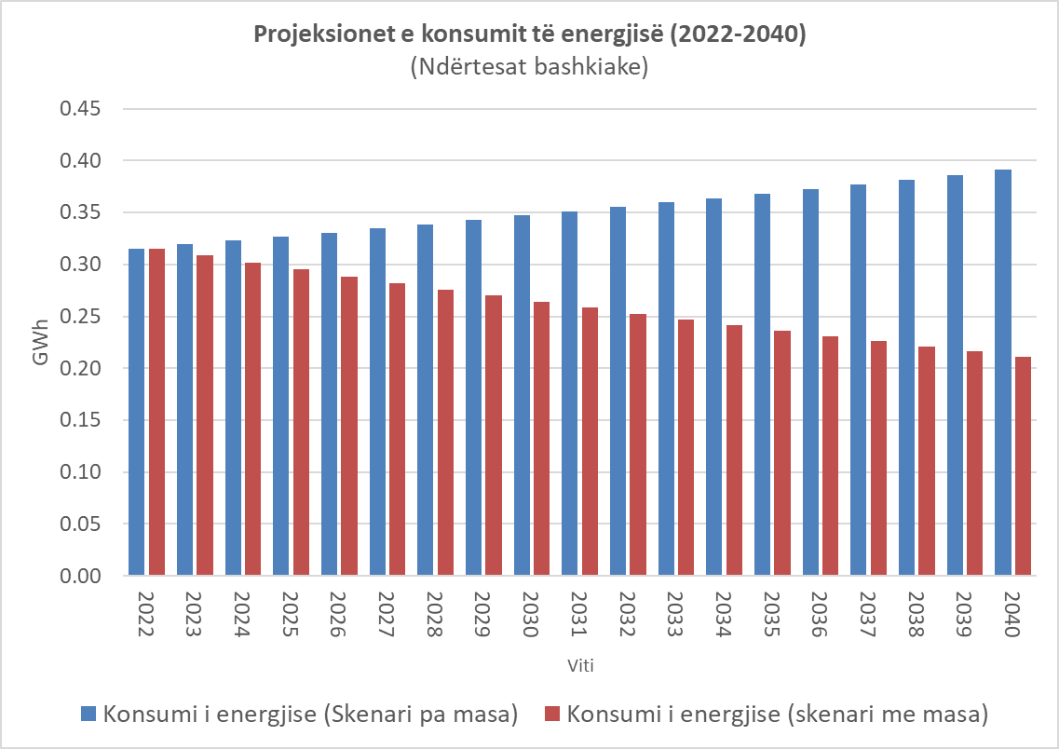
Chart 9 Energy consumption projections (2022-2040) for municipal buildings
    - Commercial buildings (businesses)
From the evaluation of the information for commercial buildings, in the scenario without measures, the level of demand for energy will increase until 2040. This increase will reach approximately 21% compared to the base year. This value will be accompanied by an increase in the level of carbon in the territory of the municipality. As seen in the base year (2022), the level of energy consumption is 3.19 GWh, this value will reach the value of 0.39 GWh. In the scenario with measures, the energy demand will fall to the value of 2.1 GWh, in about 35%-40% compared to the base year. In the commercial sector, only the consumption of electricity has been taken into consideration since the amount of fuel such as oil, wood and natural gas has not been collected. Despite this, the majority of energy consumption in businesses comes from electricity.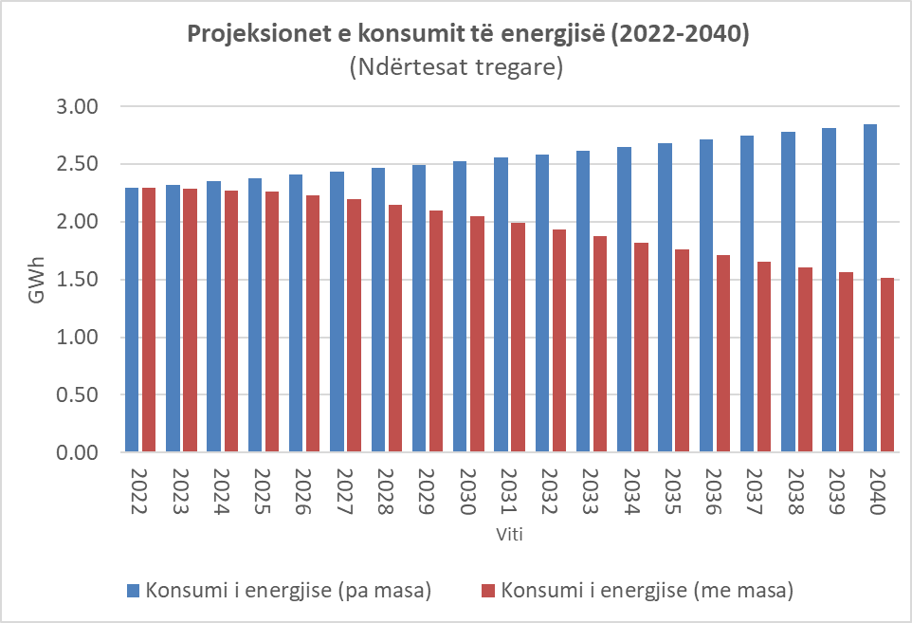

Graph 10 Projections of energy consumption (2022-2040) for municipal buildingsNdërtesat rezidenciale
From the evaluation of the information, in the scenario without measures, the level of demand for energy will increase until 2040. This increase will reach approximately 21% compared to the base year. This value will also be accompanied by an increase in the level of carbon in the municipality's territory. As seen in the base year (2022), the level of energy consumption for residential buildings is 29.36 GWh, this value would reach the value of 0.39 GWh in 2040 if no energy efficiency measure is taken into consideration. In scenario 2 two where the application of the measures is implemented, the energy consumption will reach the value of 19 GWh, at about 35%-40% compared to the base year. 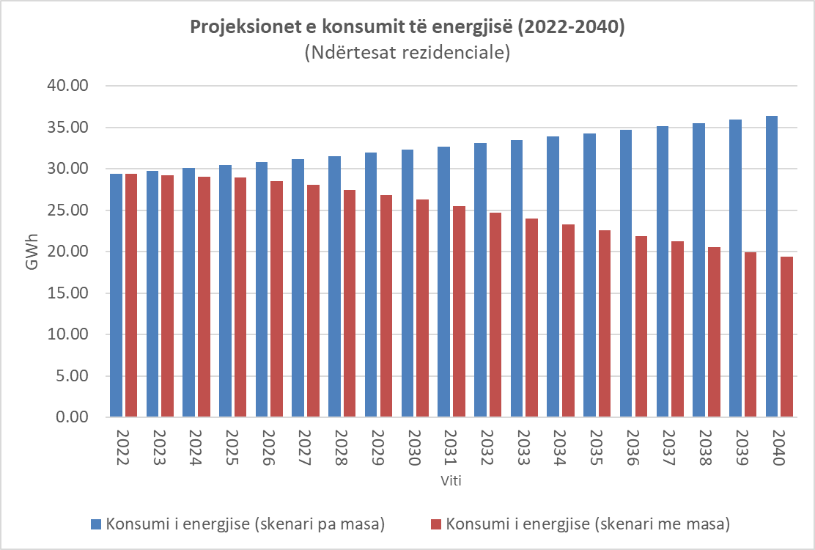
Chart 11 Energy consumption projections (2022-2040) for residential buildings
    - Public lighting
From the evaluation of the information, in the scenario without measures, the level of demand for energy will increase until 2040. This increase will reach approximately 21% compared to the base year. This value will be accompanied by an increase in the level of carbon in the territory of the municipality. As seen in the base year (2022), the level of energy consumption is 0.39 GWh, this value will reach the value of 0.48 GWh in 2040.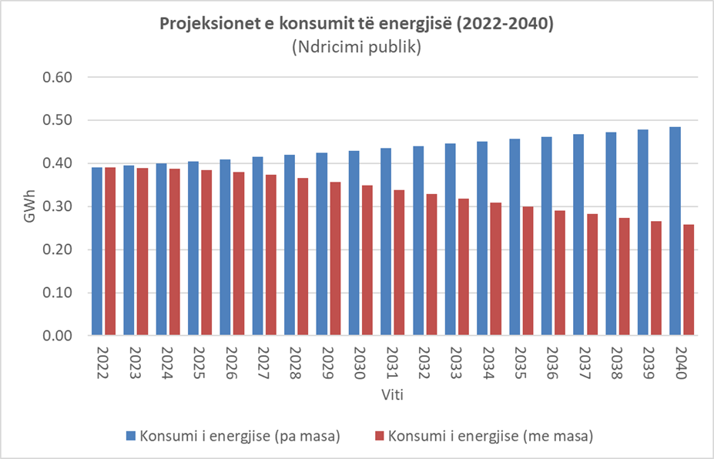

Graph 12 Projections of energy consumption (2022-2040) for public lighting

Transport
    - Transport (municipality administration, public and private)
In the transport analysis, several different types of transport were taken into consideration, such as the transport which is managed by the municipality, public and private transport. This methodology of calculation of transport including all categories is in line with the protocol of the convention of presidents. From the assessment carried out, the level of energy consumption for the year 2022 for transport (including all) is in the value of 51 GWh. The largest weight of consumption is carried by private transport with an energy consumption of about 47 GWh, followed by public transport with an energy consumption of 2.79 GWh and finally the consumption by cars in the management of the municipality administration which captures a value of about 0.62 GWh . Taking into consideration the increase in the demand for transport, the demand for energy in 2040 will reach the value of 63 GWh. In the scenario (with measures) the demand for energy will fall, where in 2040 this demand will be in the value of 33 GWh. The demand for energy for private transport will fall to 31.5 GWh, for public transport it will fall to 1.84 GWh and transport in administration management will reach the value of 0.41 GWh.
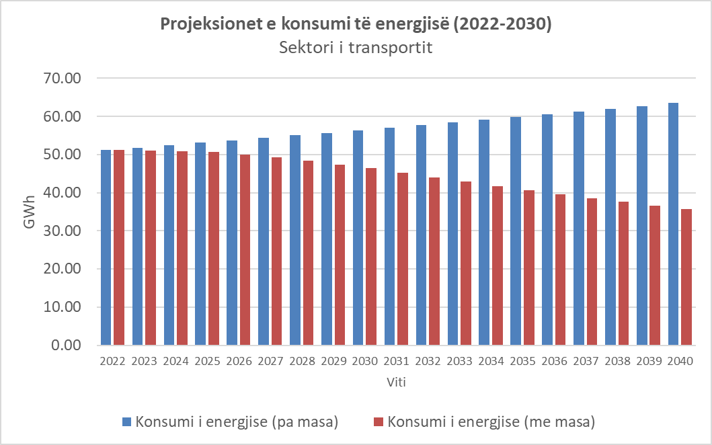
Graph 13 Energy consumption projections (2022-2040) for transport
From the collected information, there are a total of 15 tools in the management of the municipality (administration, fire department, cleaning company) with an energy consumption for the year 2022 of 0.6 GWh. Then, there are a total of 32 public vehicles (buses, taxis) with a total energy consumption of about 3 GWh and finally there is the consumption by privately owned cars that reach an annual consumption of about 48 GWh. The total amount of carbon emissions from transport amounts to 13,825 tonnes-CO2. Above is a reduction in energy consumption, this comes mainly from i) Identification of spaces within municipal buildings, parking areas and roads that have a wider access for electric cars and promoting the placement of charging stations for electric cars .

Other sector

7.4.1. Solid waste management

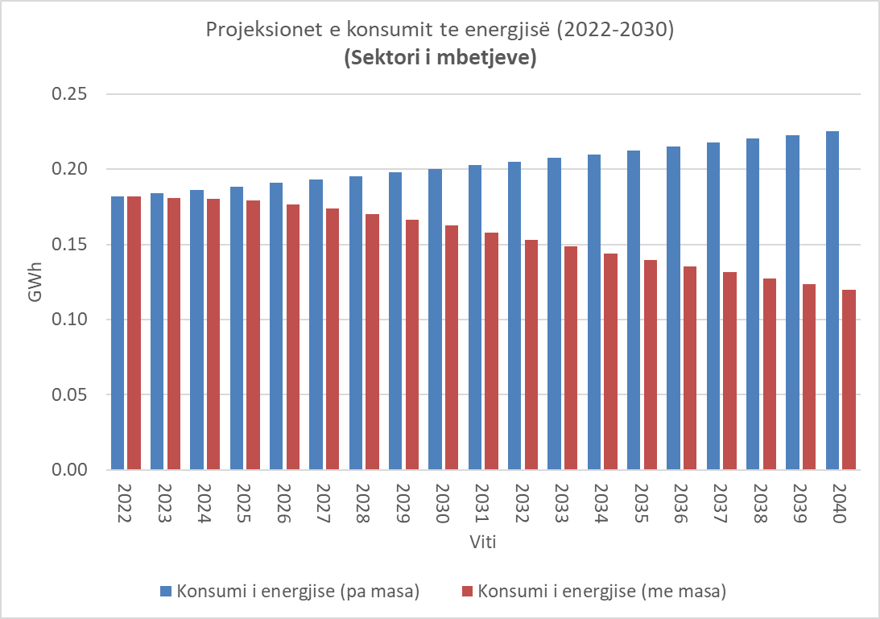
As explained in the paragraph above, in the evaluation of the demand for energy, the fuel, oil, was taken from the transportation of waste. From the performed calculations, the level of energy consumption in 2022 is at 0.18 GWh.

Grafiku 14 Projeksionet e konsumit të energjsë (2022-2040) për transportin
Throughout the year 2022, the amount of fuel used is about 17,000 liters of diesel. This quantity is the measures for reducing the demand for energy, this value will reach 0.12 GWh. The application of waste separation and recycling practices will reduce the frequency of collection and reduce energy consumption, equivalent to 0.18 GWh. According to the scenario without measures, the demand for energy will increase, where in 2040 it will reach the value of 0.23 GWh. The reason for the increase will come as a result of the expansion of service coverage and the amount of waste, which will be increasing. From the explanation in the chapter above, only a part of the service area is covered by the waste management company. In the projection, the amount of waste will continue to increase and the lack of a separation and recycling program will result in an increase in the demand for energy and of course the level of carbon emissions will increase. In the second scenario, where will they be applied
    - Water supply and sewerage
In the water supply and sewerage sector, all data on energy consumption for the year 2022 have been obtained. During the year 2022, the level of energy consumption for water supply is 0.8 GWh, while for sewerage this value goes to 0.4 GWh. Consumption from both services amounts to 1.08 GWh. According to projections, the demand for energy for water supply and sewage in 2040 will reach the value of 1.33 GWh. This increase comes as a result of the expansion of the water supply and sewerage system, increased demand for water and sewerage, and depreciation of pumps. In the second scenario, where a number of measures are taken into consideration, such as the use of solar panels for the water supply and sewerage system, the replacement of water and sewerage pumps, the demand for energy will decrease. In 2040, the demand for energy for both services will reach the value of 0.7 GWh. Energy demand will decrease by about 35-40% compared to the base year.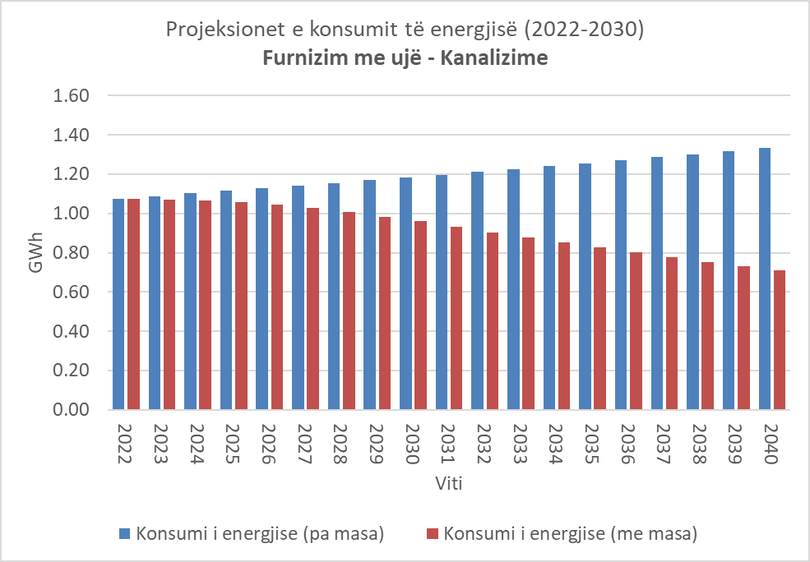

Chart 15 Energy consumption projections (2022-2040) for FUK
    - Irrigation
In the agricultural irrigation sector, all data on energy consumption for the year 2022 have been obtained. During the year 2022, the level of energy consumption for agricultural irrigation is 0.29 GWh. According to projections, the energy demand for water supply and sewage in 2040 will reach the value of 0.36 GWh. This increase comes as a result of the expansion of the irrigation system in the irrigation infrastructure, increased demand for water and climate change. In the second scenario, where a number of measures are taken into consideration, such as the use of solar panels for the irrigation system, the replacement of irrigation pumps, the use of intelligent technologies in agriculture, there will be a reduction in energy demand. In 2040, the demand for energy for the irrigation system will reach the value of 0.19 GWh. Energy demand will decrease by about 35-40% compared to the base year.

A very important element is the climate change factor. The irrigation sector is more vulnerable than other sectors and the impact of climate change will be very high. As explained above, energy consumption in the irrigation sector comes mainly from the energy consumption of pumps, some of which are depreciated and have a high energy consumption. This is a high cost for the citizens and for the municipality itself to cover these costs. In the case of not taking measures, the demand for water will be extremely high, which will increase the pressure on the water environment as well as the energy environment. The total demand for energy in 2040 will be 21% higher than that of the base year (2022). In order to achieve a normal energy demand, a number of measures regarding infrastructure to adapt to climate change must be considered..

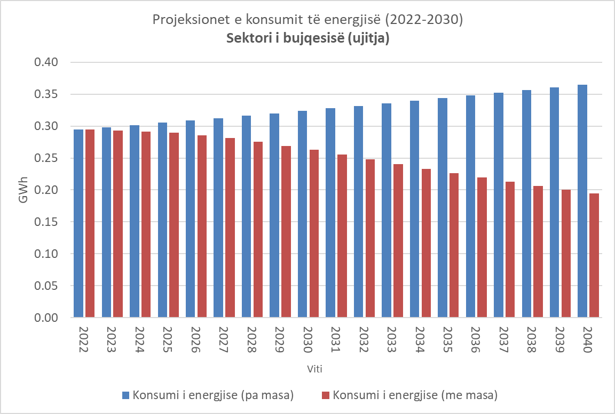
Chart 16 Energy consumption projections (2022-2040) for irrigation

7.7. Summary
    - Carbon emission level projections "with measures" and "without measures"
The graph below shows the level of carbon emissions for each sector. In 2022, the level of carbon emissions in the territory of Roskovec municipality is about 20,458 tons of CO2. The buildings sector (including municipal, commercial and institutional buildings) accounts for about 39% of the total value of emissions. In the buildings sector, municipal buildings account for about 108 tons-CO2, residential buildings about 5,216 tons-CO2, commercial buildings 1,211 tons-CO2 and street lighting 149 tons-CO2. The transport sector carries the highest weight of carbon emissions in the territory of Roskovec municipality. The level of carbon emissions in the base year (2022) reaches the value of 13,352 tons of CO2. Dividing them into categories, private transport is the source for the level of carbon emissions about 12,906-tons of CO2, public transport (buses, minibuses) about 570-tons of CO2 and finally is the level of carbon from vehicles in the management of the municipality. The level of emissions from these vehicles amounts to about 166 tons of CO2. The level of carbon emissions from other sectors such as waste, water supply and irrigation amounts to about 570 tons.
In taking the measures (see the objectives and action plans in the following chapters) the level of carbon emissions will decrease approximately to the value of 35-40% compared to the base year. The level of emissions in buildings reaches the value of 38.7% of the total emissions, where more specifically the level of emissions from municipal buildings will be 4407 tons of CO2, where municipal buildings number about 72 tons of CO2, residential buildings about 3439 tons of CO2, those indicator 798-ton CO2 and street lighting 98 ton-CO2. In the transport sector, the level of carbon emissions will reach the value of 33.76 tons-CO2 by 2040, for each sub-category the level of emissions varies. In relation to other sectors such as waste, water supply-sewerage and agriculture, the level of carbon emissions reaches the value of 1.02 tons-CO2. The table below shows the carbon level for each sector in the case of taking measures.

Table 63 Level of energy demand and carbon emissions in 2040
 | Year 2040
 | GWh | CO2 | Weight
Buildings | 22 | 4407 | 38.7%
Municipal buildings | 0.2 | 72 | 0.4%
Residential Buildings | 19.4 | 3439 | 34.1%
Commercial Buildings | 2.1 | 798 | 3.7%
Street Lighting | 0.3 | 98 | 0.5%
Transportation | 33.76 | 9115 | 59.5%
Vehicles owned by the municipality | 0.41 | 110 | 0.7%
Public transport | 1.84 | 496 | 3.2%
Private transport | 31.51 | 8509 | 55.6%
Other sectors | 1.02 | 376 | 1.8%
Residues | 0.12 | 32.4 | 0.2%
Water supply & Sewerage | 0.71 | 270 | 1.3%
Agriculture (Irrigation) | 0.19 | 73.8 | 0.3%
Total | 56.7 | 13,897 | 100%

Chart 17 Level of energy demand and carbon emissions in 2040

Chart 18 Level of energy demand and carbon emissions in 2040 without measures

- 6. PLAN OF MEASURES FOR CARBON REDUCTION (REDUCTION)

Municipal, residential and commercial buildings
The following section describes measures to help reduce the impacts of the construction sector of the municipality of Roskovec on climate change at the local and national level, mainly through measures aimed at reducing greenhouse gas emissions and efficient use of resources. In accordance with the categorization described above, the object of the measures will be municipal, residential and commercial buildings.
The objective of the measures: Improving the energy efficiency of existing buildings and those under construction by encouraging and promoting energy efficient techniques in buildings.
Number of actions: 8
Sectoral targets against the 2018 baseline

- Municipal buildings: ~ 40% emission reduction by 2030
- Residential buildings: ~ 40% emissions reduction by 2040
- Commercial buildings: ~ 40% emissions reduction by 2040
Energy consumption in buildings accounts for 40% of the municipality's total energy consumption (excluding industry) and carbon emissions. Because the building stock represents such a significant part of total emissions, achieving the reduction target is highly dependent on interventions in this sector.
There are several national strategic plans and regulations related to energy efficiency, which are described in the sections above. Regulations for building energy efficiency standards are set at national level. The National Climate and Energy Plan 2021-2030 which is coordinated by the Ministry of Energy and Infrastructure and includes the general reconstruction of the thermal envelope of existing residential and non-residential buildings and the reconstruction of the heating system and the improvement of thermal efficiency through specific interventions in separate elements of the building.
Although all new buildings are required to obtain an Energy Performance Certificate from 2021, the building stock as a whole is likely to have relatively poor energy performance, reflecting the rapid urbanization dynamics of recent decades. Therefore, in broad terms, these actions will aim to set high standards for new buildings while also taking steps to improve existing buildings.
Although the sector targets are listed above, it should be noted that the state of the building stock is probably the most important factor in developing appropriate emission reduction targets, however, there is limited data on this topic making assessment difficult. of the degree of improvement that can be achieved. The last detailed study undertaken of the building stock is a decade ago, which is now significantly out of date, especially considering the changes that have occurred as a result of urban transformation initiatives.
The measures proposed to address and reduce emissions related to the construction sector for the climate and energy plan are described below:

A1: The municipality commits to transform all municipal buildings into net-zero energy by 2030
1: The municipality's commitment to net zero energy in all existing buildings controlled by the municipality until 2030. A1.
The objective | Increasing energy efficiency in municipal buildings by reducing the level of carbon emissions and saving energy.
Description | In order to adapt to climate change and its impacts, the IBB will commit to making all new buildings controlled by municipalities net zero and encourage other organisations, businesses and institutions to do the same.
Context | Increasing national energy dependence on imports and the volatility of market prices are a major challenge facing the entire region.  There are a total of 34 objects under the administration of the municipality, where 2 are kindergartens and nurseries, 23 schools, 4 administrative objects and 4 other objects are sports centers. Approximately 60% of the building stock is modular and does not have an efficient energy saving system. This leads to energy loss and constitutes a high cost for citizens. The total area of the buildings is 11,000 m2. Currently, the public buildings sector (for the year 2022) has an energy consumption of around 0.32 GWh and the level of emissions is 108 tons-CO2. Municipal buildings comprise 0.4% in relation to 38.7% of the contribution of all buildings.
Steps for Implementation | 1. Creation of a working group to implement a strategy for the renovation of buildings in the municipality, accompanying it with a feasibility plan.  2. Development of the concept for the renovation of buildings as part of the strategy.  3. Conducting audit studies for priority buildings.  4. Presentation of projects to different donors.  5. Development and implementation of projects.  6. The objective to be met by implementing projects in stages. Sustainable low energy to be achieved between 2022-2027; almost zero buildings between 2027-2033 and then net zero energy buildings from 2030 onwards.
Deadline | 2023-2035
Expected impacts | - - Reduction of carbon emissions.  - - Reduction of energy consumption.  - - Increasing the comfort of citizens.
LIABILITY | Urban Planning Department, Roskovec Municipality
Potential emissions savings | In the case of mass application of energy efficiency the level of energy saving until 2040 will be approximately 10 GWh translated into 2022 ton-CO2.
Financing options | The municipal budget, IFNs, Ilbank, private banks, green bonds  Revenue/Savings Opportunities: Savings opportunities will come from reduced energy costs, reduced pressure on power grids and public health benefits
Impact measures | Annual emissions associated with new public sector buildings
Estimated cost | Investment costs (for about 60% of the building stock: €1.3 million  (6600 m2, 200 eur/m2 investment cost)  Costs for the development of feasibility studies, energy audits for all buildings in the municipality's administration. Total cost EUR 300,000.

A1.2. Replacement of all lighting stock with LED lamps
A1.2. Installation of energy efficient lamps
Objective | The lighting infrastructure will be expanded throughout the territory and sodium lamps will be replaced with LED lamps.
Context | Electricity consumption from public lighting accounts for about 0.5% of the total energy consumption in the territory of the municipality, and therefore represents a major source of carbon emissions. Also, the municipality spends about 19,860,220 Lek per year only for public lighting, which constitutes about 20% of the total expenditure of the municipality. The municipality has distributed about 904 lamps, where 311 lamps are high pressure sodium lamps, 16 of them are fluorescent and 577 are LED lamps. The total energy consumption from lighting is about 0.39 GWh and the level of carbon emissions is 149 ton-CO2.
Steps for implementation | 1. Development of the concept for changing the existing lamps.  2. Conducting audit studies for lamps  3. Presentation of projects to different donors.  4. Development and implementation of their technical projects.  5. The objective to be met by implementing projects in phases. By 2030, the lamps must be all LED. By 2040, the entire territory should be covered with lighting and with LED lamps.
Deadline | 2023 – 2030
Expected imact | The level of energy consumption until 2040 is expected to be in the value of 0.25 GWh and the level of CO2 will be reduced to the value of 98-ton CO2.
Liability | Services and Maintenance enterprise , Urban Planning
Estimated cost | Currently, only 311 high pressure sodium lamps are expected to be replaced. The estimated cost is 31,500 EUR.
Stakeholders | Municipality of Roskovec  Non-governmental organization  Private company  Financial institutions
Financing options | Municipal budget,different donors

A1.3 Installation of solar panels for electricity and hot water
A1.3.1 Installation of solar panels for electricity in municipal buildings
A1.3.2 Installation of hot water panels in schools, kindergartens and nurseries
Objective | Reduction of electricity consumption for lighting and heating and fuel (wood) used for heating. Promotion of initiatives such as the creation of energy communities with businesses, local communities and public institutions.
Context | The municipal buildings taken into consideration are schools, nurseries, kindergartens and administration buildings. Energy consumption for each category is shown below. The largest weight of consumption is carried by administration buildings with about 87% of the total, followed by 9-year schools with 8% of the total, secondary schools with about 3% and cultural institutions with 2%. At the end are the gardens and nurseries. The consumption of each category in GWh for the base year (2022) is shown below. Annual electricity consumption in kindergartens is 0.05 GWh, 9-year-old schools 0.085 GWh, secondary schools, 0.028 GWh, city administration buildings 0.914 GWh.  Besides electricity, oil, wood and natural gas are used for heating. The amount of oil used in 2022 is 5680 liters, the amount of wood is 34 m3 and natural gas about 3600 liters. These values translate into energy 0.3 GWh and 108 tons-CO2.
Steps for Implementation | 1. Development of the concept for the installation of solar panels for electricity and heating.  2. Development of the technical project/feasibility study for the installation of panels.  3. Presentation of projects to different donors.  4. Development and implementation of their technical projects.  5. The objective to be met by implementing projects in phases. By 2030, the lamps must be all LED. By 2040, the entire territory should be covered with lighting and with LED lamps.
Deadline | 2023 – 2030
Possible impacts | The level of energy consumption until 2040 is expected to be in the value of 0.21 GWh and the level of CO2 will be reduced to the value of 98-ton CO2.
Liability | Urban Planning Department, Roskovec Municipality.
Estimated cost | It is currently expected to install solar panels with installed power (20 kWp) in each building of the municipality. The total cost for all the buildings comes to the value of 700,000 EUR.  Installation of hot water for schools and nurseries at a value of around 200,000 EUR.
Stakeholders | Municipality of Roskovec  Non-governmental organization  Private company  Financial institutions
Financing options | The municipal budget, different donors

A1.4 Establishment of the working group for energy management in the municipality
A1.4.1 Building the capacities of the energy management group on monitoring the climate and energy plan.
Objective | Monitoring the climate and energy plan through a structured structure within the municipality and strengthening communication with central institutions (Energy Efficiency Agency), external consultants, donors.
Context | The municipality of Roskovec has an energy administrator who has been in office since 2021 in line with the law on energy efficiency. It is currently following the procedures for hiring an energy manager according to Decision No. 189, dated 04.05.2023. Regardless, the capacities in the municipality have opportunities to be improved and developed continuously to realize a monitoring of energy consumption in the municipality.
Steps for Implementation | 1. Development of several modules/curriculum for capacity development of the energy manager, working group.  2. Selection of a representative from each department (urban planning, finance, public services, communication). The working group is led by the mayor and coordinated by the energy manager.  3. Staff training by an external consultant.  4. Continuous monitoring of energy and carbon consumption according to the formats defined by the convention of mayors, and the Agency for Energy Efficiency.
Deadline | 2023 – 2028
Possible impacts | - - The capacities of the municipality's staff on energy management have increased.  - - Foreign funds for projects in the energy sector have been successfully received and implemented.  - - Continuous monitoring of energy and climate by the municipality staff in collaboration with an external consultant.
Estimated cost | Roskovec Municipality
Stakeholders | Estimated cost for the development of modules and training of municipal staff for energy management, monitoring and reporting of the energy plan. About 100 working days are expected, cost per working day in the amount of 150 euros. Total cost 15,000 EUR.  The external consultant will assist the municipality during the next 3 years in energy and climate monitoring (2023-2026). Meanwhile, the external consultant will facilitate the municipality in the continuous reporting to the Agency for Energy Efficiency every year. The annual cost for the assistance from the external consultant is EUR 5000.
Financing options | Municipality of Roskovec  External consultant for climate and energy
 | The municipal budget, various donors

A1.5 Increasing information in schools on energy efficiency, renewable energy
A1.5.1 Capacity building of the energy management group on climate and energy plan monitoring.
Objective | Initiation of a program to increase awareness and increase information among students on energy efficiency, energy
Context | The level of information and awareness of the younger generations on the efficient use of energy is still low and there is a need for promotional and incentive activities.
Steps for Implementation | 1. Development of several modules/curriculum for developing the capacities of students and pupils.  2. Training of mothers and teachers on energy efficiency, renewable energy, etc.
Deadline | 2023 – 2030
Possible impacts | - - Informing students about energy efficiency has increased.  - - Increasing teachers' capacities on energy efficiency.  - - Participation of students in local and international projects on green energy.
LIABILITY | Educational Directorate and Roskovec Municipality
Estimated cost | Estimated cost for developing modules and training municipal staff for energy management, energy plan monitoring and reporting. About 50 working days are expected, cost per working day in the amount of 150 euros. Total cost 7500 EUR. Every year, information sessions are planned with 3-5 schools with 5 different classes in each school. This activity will be repeated over the next 3 years.
Stakeholders | Municipality of Roskovec  Non-profit organizations, external experts
Financing options | The municipal budget, different donors

8.3. Commercial buildings and residential buildings
B 1.1: Financial support of businesses and citizens for increasing energy efficiency and the use of renew

able energies
Objective | Increasing energy efficiency in commercial buildings by promoting financial mechanisms at the local level.
Description | In order to reach the necessary target, the municipality will create a local fund for energy efficiency. This fund will be subject to businesses and residents who will be able to access the revolving energy fund. The source of funds will be mainly from the municipality, various donors
context | The commercial/business buildings sector contains about 3.7% of the weight in relation to 39% of the total consumption coming from the buildings sector. The level of carbon emissions for 2022 is estimated at 1,211t-on CO2 from commercial buildings only. Residential buildings contain the highest value of energy consumption with a value of about 34% in relation to 39% of the total. The level of carbon emissions for the year 2022 from residential buildings is 5,216-tons and the electricity consumption for this year is 29 GWh.
Steps for Implementation | 1. Creation of a working group to carry out the study of the feasibility and operation of the fund.  2. Setting up a "one-stop shop" for energy efficiency  2. Presentation of the fund model to different donors for the possibility of financing the fund.  3. Approval and operation of the fund.
Deadline | 2023-2040
Expected impacts | - Reduction of carbon emissions.  - Reduction of energy consumption.  - Financial facilities for investments.
Liability | Roskovec Municipality
Potential emissions savings | In the case of mass application of energy efficiency the level of energy savings from commercial buildings until 2040 will be approximately 1 GWh translated into 450 ton-CO2. As for residential buildings, the level of energy saving will be 10 GWh.
Financing options | Municipal budget, private banks, green bonds, revenue/savings opportunities: Savings opportunities will come from reduced energy costs.
Estimated cost | In order to calculate an accurate value for the working fund budget, a more in-depth feasibility study is needed which will accurately determine the value of the fund.

Transport
The following section describes the actions taken to help mitigate the impacts of the transport sector of Roskovec Municipality. In broad terms, this includes promoting the use of sustainable modes of transport and reducing emissions from existing modes of transport.
Sector Objective: Increase the sustainable modes of urban transportation systems by improving the efficiency of current modes to increase the quality of life for all citizens.
Number of actions: 1
Sectoral targets against 2022 baseline: 36% reduction by 2040
The transport sector represents the first largest source of emissions in Roskovec municipality with about 59%. The fleet of vehicles owned by the municipality make up 0.7% of emissions, then public transport services (buses, minibuses) make up 3.2% of transport emissions), while the majority is dominated by private vehicles. Currently Roskovec municipality does not have a proper mobility plan that will reduce carbon emissions from transport by 2030 and outline future projects related to the improvement of transport infrastructure. A survey conducted for UPİ 2030 shows that 21% of trips are made by private car while 35% use public transport. It should also be noted that 33% of transport in Roskovec municipality is done by pedestrians and 11% by service buses, and the rest by private cars.
C.1.1: Promotion of the use of electric vehicles in transport
C1.1: Promotion of the use of electric cars in municipal, private and public transport.
Objective | Promoting sustainable transport in harmony with the environment and local economic development.
Description | - • Parking with priority for electric vehicles.  - • Providing new and intelligent charging infrastructure for electric vehicles (EV).  - • Promote and encourage businesses to have charging stations.  - • Installation of charging stations for all municipal buildings and the municipal parking area.
context | Transport in Roskovec municipality is the main source of carbon emissions. During the year 2022, energy consumption by the transport sector was estimated at 51 GWh, holding 60% of the total energy consumption. From the collected information, there are a total of 15 tools in the management of the municipality (administration, fire brigade, cleaning company) with an energy consumption for the year 2022 of 0.6 GWh. After that, there are a total of 32 public vehicles (buses, taxis) with a total energy consumption of about 3 GWh and finally there is the consumption from privately owned cars that reach an annual consumption of about 48 GWh. The total amount of carbon emissions from transport amounts to 13,825 tonnes-CO2.
Steps for Implementation | Priority infrastructure for parking and charging electric vehicles:  1. Preparation of the concept for the development of sustainable transport in the municipality of Roskovec.  2. Development of the mobility plan for the Municipality of Roskovec.  3. Identification of spaces within municipal buildings, parking areas and roads that have a wider access for electric cars.  3. A feasibility study to assess the capacity of the network for the installation of charging infrastructure.  4.. To promote and encourage commercial buildings to have EV charging stations through business licenses granted by IBB.
Positively influenced environmental values | - Reduction of carbon emissions  - Increasing efficiency in transport  - Financial sustainability
Potential emissions savings | It is assumed that 30% of private cars will switch to electric vehicles by 2030  9,115 tCO2e in 2030
LIABILITY | Transport Department, Roskovec Municipality
Deadline | 2021 – 2035
Funding opportunities | Opsionet e financimit: Buxheti i bashkisë, financat private të kompanive (kompanitë tarifore, kompanitë e makinave etj.), fondi lokal qarkullues.
Estimated cost | 17,000 € për 50 pika të karikimit të shpejtë. 11,000 € për 50 pika të ngadalta të karikimit.  Panele diellore (3 cope * 10 KWp): 30,000 EUR  Kostot e projektimit/zhvillimit: 30,000 EUR

Residues
The following section describes the actions taken to help mitigate the impacts of the waste sector in the municipality of Roskovec. In broad terms, this includes promoting the separation of waste at source, fuel reduction from transport through a sustainable waste management model.
Objective of the Sector: Promoting sustainable practices in waste management to reduce carbon emissions and a clean environment for communities.
Number of actions: 1
Sectoral targets against the 2022 baseline: 36% reduction by 2040
The waste sector covers about 0.2% of the emissions in relation to the emissions coming from the sectors (1.8%). In this study, the energy aspect of waste management, which is mainly related to waste transportation, has been considered. The average daily amount of waste collected is about 13.8 tons/day of waste or 5,037-tons of waste/year. Based on the waste management plan, about 71% of the waste is organic, 7% is plastic, 3% is glass and 2% is carbon. A total of 169 containers are distributed. The municipality uses 1 technological vehicle with a 10-ton capacity and 2 self-unloading vehicles with a 5-ton and 1-ton capacity. The total waste collection route is estimated to be 157 km and the route to the Waste-to-Energy Treatment Plant in Fier is about 20-25 km away. From the information gathered, the amount of fuel is 17,000 liters translated into 0.18 GWh. This value translated into carbon emissions is 49-ton CO2.
D 1.1 Separation of waste at source with citizens
D 1.2 Selected collection of waste in schools
Objective | Promotion of good practices for waste segregation në burim
Description | - Extension of the waste service throughout the territory of the municipality.  -Door-to-door distribution of waste in rural areas.  - Reducing the frequency of waste collection by adding waste collection and waste recycling points.  - Replacement of existing cars with more efficient cars in relation to fuel consumption.  - Promotion of waste separation in schools.  - Setting up a circular economy laboratory to explore the transformation of organic waste.
Context | Currently, the separation of waste is not carried out in the neighborhoods of the city. Since 2022, the selection of cardboard waste and organic waste in the production of compost has begun. This practice is a model that should be translated and used for other types of waste such as plastic, paper, glass. Meanwhile, there is a lack of a waste separation and circular economy promotion program in schools. The total waste collection route is estimated to be 157 km and the route to the Waste-to-Energy Treatment Plant in Fier is about 20-25 km away. From the information gathered, the amount of fuel is 17,000 liters translated into 0.18 GWh. This value translated into carbon emissions is 49-ton CO2.
Steps for Implementation | Separation of waste in schools  1. Development of a concept for waste separation in city schools and promotion of circular economy.  2. Development of circular economy modules for teachers and school students.  3. Realization of a number of trainings for students and teachers on the circular economy.  4. Building the infrastructure for waste separation in schools according to their types.  Reducing the frequency of waste collection by adding waste collection and recycling points.  1. Study of waste collection routes and development of the best possible scenario (reference waste management plan of Roskovec Municipality).  2. Adding waste collection points and covering the entire territory.  3. Separation of waste at source and reduction of waste through recycling.  4. Replacement of current vehicles with high efficiency vehicles in terms of energy consumption.
Environmental values positively influenced | - Reduction of carbon emissions  - Increasing efficiency in transport  - Financial stability
Potential emissions savings | By applying the practices above, a reduction in carbon emissions of up to 40% is expected. The amount of emissions will be 31 tons in 2030 compared to 2022.
LIABILITY | Enterprise of Cleaning, Greening and Maintenance of Cemeteries
Timeline | 2023 – 2040
Funding opportunities | Financing options: Municipal budget, private company finance (tariff companies, car companies, etc.), local working capital.
Estimated cost | - Consultant for the development of the curriculum and development of the circular economy program for a period of 3 years. 50 working days per year are foreseen, plus a budget of 7,500 euros.  - Raising bins (approximately 20 bins for each school), 7000 euros in total for 3 schools during the first year.  - Replacement of 3 technology machines with 3 new machines: Total cost 180,000 EUR.

8.6. Water supply and sewerage
The following section describes the actions taken to help mitigate the impacts of the water supply - sewerage sector in the municipality of Roskovec. In broad terms, this includes replacing existing pumps with efficient pumps that consume less energy and using solar panels for water supply.

Sector Objective: Promoting sustainable practices in water supply and sanitation to reduce carbon emissions and water quality.
Number of actions: 1

Sectoral targets against 2022 baseline: 36% reduction by 2040
The water supply sector covers about 1.3% of the emissions in relation to the emissions coming from the sectors (1.8%). In this study, the energy aspect of water supply, which is directly related to the consumption of electricity from the pumps, has been considered. The amount of energy consumed throughout the year 2022 for the water supply system is about 0.6 GWh and the specific energy consumed is 0.72 kWh/m3.
While for the sewage system, this value is 0.4 GWh with a specific energy of 1.13 kWh/m3. The total amount of water sold for 2022 is 525,000 m3 while the total amount of drinking water produced is 858,000 m3. The energy costs of the water company for water supply for the year 2022 are estimated at 12,090,000 Lek. Currently, the water supply service covers only 70% of the territory of the municipality. The monthly cost for energy is approximately 50% of the total operating costs of the water supply, which is quite a significant amount. This cost is reflected in the rate for citizens. As for the sewerage system, the monthly cost of energy is about 8,890,000 Lek, which constitutes 19% of the total operating expenses of the sewerage system. In these circumstances, the efficient use of water by citizens, the replacement of outdated pumps with efficient ones, the reduction of losses and the use of solar panels for energy coverage are considered reasonable.
E 1.1 Use of solar panels for energy
E 1.2 Reduction of losses along the water supply
E 1.3 Replacement of inefficient pumps with efficient pumps
Objective | Improving energy efficiency in the water supply and sewage sector
Description | - The extent of the water supply and sewerage service throughout the territory of Roskovec municipality.  - Reduction of technical and non-technical losses along the water supply.  - Reducing energy demand through the use of solar panels.  - Reducing the frequency of waste collection by adding waste collection and waste recycling points.  - Replacement of existing cars with more efficient cars in relation to fuel consumption.  - Promoting the separation of waste in schools.  - Setting up a laboratory for the circular economy to explore the transformation of organic waste.
Context | Currently, the water supply service covers only 70% of the territory of the municipality. The monthly cost for energy is approximately 50% of the total operating costs of the water supply, which is quite a significant amount. This cost is reflected in the rate for citizens. As for the sewerage system, the monthly cost of energy is about 8,890,000 Lek, which constitutes 19% of the total operating expenses of the sewerage system. The energy consumption during the year 2022 was about 1.08 GWH and the level of carbon emissions 409 ton-CO2. Among others to be noted are the level of losses which should be reduced, the existing pumps are amortized and not efficient.
Steps for implementation | The use of solar panels for the pumping station  1. Development of a concept for placing solar panels for water supply and sewage.  2. Preparation of feasibility plan and technical project for solar panels.  3. Project implementation and monitoring of water and energy consumption.  Reduction of technical and non-technical water losses  1. Development of the concept for the rehabilitation of the water supply system.  2. Preparation of the technical plan and feasibility study.  3. Project implementation and monitoring of water and energy consumption.  Replacement of inefficient pumps with efficient pumps  1. Development of the concept for the replacement of inefficient pumps.  2. Preparation of the technical project and feasibility study.  3. Project implementation and monitoring of water and energy consumption.
Positively influenced environmental values | - Reduction of carbon emissions  - Increasing efficiency in water supply  - Financial stability
Potential emissions savings | By applying the practices above, a reduction in carbon emissions of up to 40% is expected. The amount of emissions will be reduced by 200 tonnes by 2040.
Liability | Aqueduct
Timeline | 2023 – 2030  2030-2040
Funding opportunities | Funding options: Government budget, foreign donors
Estimated costs | Consultant for the preparation of the feasibility and technical plan  Project implementation cost. In this comment there is no real cost as it requires a more in-depth study separately.

Agriculture (irrigation)

The following section describes the actions taken to help mitigate the impacts of the irrigation sector in the municipality of Roskovec. In broad terms, this includes replacing existing pumps with efficient pumps that consume less energy and using solar panels for irrigation..

Objective of the Sector: Encouraging sustainable practices in soil irrigation in agriculture for reducing carbon emissions and food security.
Number of action : 1
Sectoral targets against the 2022 baseline: 40% reduction by 2030
The agriculture and irrigation sector in particular constitutes a sector of great economic interest for the Municipality of Roskvec. There are 4 pumping stations for land irrigation in the Roskovec municipality. The pumping station in the Metushaj neighborhood which has an energy consumption of 84,137 kWh throughout the year 2022. The pumping station in the Arapaj neighborhood which has an energy consumption of 159,426 kWh throughout the year 2022. The Hoxhenjte pumping station which has a energy consumption 32,000 kWh. The pumping station in "Jagodina" which has a consumption of 18,000 kWh. The total energy consumption of the pumping stations is 0.3 GWh of energy per year and the level of carbon emissions is 112 ton-CO2. Throughout the year 2022, the monetary value of the expenditure in Lek for the Metushaj irrigation pump was 1,413,493 Lek, while for the station in Arapajk, the value was 1,541,480 ALL/ yearIn order to have a reduction in energy consumption and the carbon level, a preliminary evaluation of the placement of solar panels on irrigation pumps has been made possible. The installation capacities of irrigation pumps are expected to be in the values of 25-30 kWp and the energy production will be 95219 kWh per year for the station in Metushaj, translated into an annual saving of 821,287 lek per year. Whereas for the station in Arapajk, the savings from energy production will be 1,541,480 lek per year.
The implementation of these projects will bring about an improvement of food quality for the local communities in Roskovec municipality and mainly for the farmers involved in agriculture. It will also be proposed to establish an energy community which will be a support for communities in need through the use of energy between the community.
E 1.1 Use of solar panels for irrigation
Raising the energy community
Objective | Improving energy efficiency in the irrigation sector through the use of solar panels.
Description | - - Reduction of energy consumption by irrigation pumps through the use of solar panels.
Context | The agriculture sector is one of the sectors.
Steps for implemntation | Use of solar panels for existing pumps  There are three pumping stations for soil irrigation in the Roskovec municipality.  1. The pumping station in the Metushaj district, which has an energy consumption of 84,137 kWh throughout the year 2022.  2. The pumping station in the Arapaj district, which has an energy consumption of 159,426 kWh throughout the year 2022.  3. "Hoxhenjte" pump station, which has an energy consumption of 32,000 kWh.  4. The pumping station in "Jagodina" which has a consumption of 18,000 kWh.  The total energy consumption of the pumping stations is 0.3 GWh of energy per year and the level of carbon emissions is 112 ton-CO2.  Building the energy community  Energy communities are an innovation that has taken off in European countries. Their goal is to reduce the cost of energy through joint use.  Steps for setting up 2 energy communities in Roskovect Municipality:  1. Realization of the concept for building energy communities (2)  2. Community engagement and consensus among them  2. Investment realization and project monitoring.
Environmental values positively influenced | - Ulja e emetimevë të karbonit.  - Rritja e eficencës në sistemin e ujitjes.  - Qëndrueshmëri financiare.
Potential emissions savings | By applying the practices above, a reduction in carbon emissions of up to 40% is expected. The amount of emissions will be reduced by 40 percent in 2040.
LIABILITY | Directorate of Agriculture and Rural Development
Timeline | 2023 – 2027
Funding opportunities | Funding options: Municipal budget, foreign donors, local community.
Estimated cost | Consultant for the preparation of the feasibility and technical plan  Project implementation cost. In this comment there is no real cost as it requires a more in-depth study separately.

- PLAN OF MEASURES FOR CLIMATE ADAPTATION

In this chapter, the measures/actions that must be taken to adapt to climate change in the Municipality of Roskovec will be described. proposed are categorized according to each of the sectors based on the risk assessment of the measures carried out.

9.1. Water sector
G1.1 Rehabilitation of the infrastructure of the drainage network and the systemization of the rainwater network in the urban area
Objective | Improving urban wastewater and stormwater management
Description | - The collection of drainage and rainwater through separate channels will reduce the hydraulic load of the urban wastewater system.  - Rainwater collected in separate channels can be used for the needs of other sectors, e.g. for irrigation in agriculture in case of water shortage.
Context | Heavy rainfall can cause the combined sewage and stormwater system to overflow, causing flooding in urban areas and increasing the risk of pollution. Separate collection of rainwater can reduce the load on the sewer network and will reduce the risk of flooding.
Steps for implementation | - Vlerësimi aktual i kapacitetit të kanalizimeve të ujërave të ndotura;  - Identifikimi i zonave urbane të cilat janë të rrezikura nga përmbytjet nga rrjeti i kanalizmeve;  - Përcaktimi i projektit teknik për rehabilitimin e rrjetit të kullimit dhe ndarjen e ujërave të shiut;  - Zhvillimi i dokumentacionit për tenderit për këtë projekt;  - Përcaktimi i vlerës së investimit dhe implementimi i projektit;  - Monitorimi i sasisë së ujërave të shkarkuara në sistemin e kanalizimeve dhe ujërva të shiut të grumbulluara
Type of action | Investment project
Positively influenced environmental values | - Improving water quality  - Availability of water  - Water cycle management
Potential emissions savings | Indirect reduction of carbon emissions. The separation of rainwater from the sewer system will reduce the amount of wastewater that goes to be treated at the wastewater plant. This means that less energy will be needed to operate the treatment plant and less emissions from energy use.
Liability | The Roskovec Water and Sewerage Company
Timeline | 2025-2028
Funding opportunities | Roskovec Municipality budget, foreign donors.
Estimated costs | Consultant for the preparation of the feasibility and technical plan  Project implementation cost. At the moment there is no real cost as it requires a more in-depth study separately.

G1.2 Maintenance of embankments, cleaning of drainage channels and maintenance of dams
G1.3 Setting up an early warning system for flooding events from rivers, streams and flash floods, especially in urban areas
Objective | Reducing the risk of flooding in urban areas in Roskovec Municipality
Description | In the area of the Roskovec Municipality, there are no recorded floods from the Seman River in the last 30 years. Floods occur mainly in agricultural lands during heavy rains, and due to blockage of drains. Some floods that can bring significant damage from the possible destruction of the dams are: The destruction of the Allambrezi dam, the Kurjani, Strum and Cerven dams which would cause flooding in all four Administrative Units of Roskovec Municipality.
Context | Flooding problems are caused by the drainage channel of Hoxhara in the agricultural lands in the administrative units of Kuman, Roskovec and Strum. The Irrigation Canal that comes from the Kurjani Reservoir that serves as a high water canal must be maintained and cleaned regularly. While the Seman River has not caused any flooding after the construction of the embankments.
Steps for implementation | 1. Periodic cleaning of drainage canals, in particular, the Hoxhara drainage canal.  2. Maintenance of the left embankment of the Seman River and the dams mentioned above.  3. Periodic monitoring of the water level and the amount of precipitation  4. Development of a project for an early warning system for flood events.  5. Implementation of the early warning system and training of the population on the importance of this system in reducing the negative consequences of accidents.
Type of action | Investment policy/strategy and project
Positively influenced environmental values | - Adaptation to climate change
Potential emissions savings | No reduction in carbon emissions is foreseen.
Liability | Forestry, Irrigation and Drainage Sector, Roskovec Municipality
Timeline | 2024-2030
Funding opportunities | Roskovec Municipality budget, foreign donors.
Estimated cost | Cost for the implementation of the project for the early warning system. At the moment there is no real cost as it requires a more in-depth study separately.

9.2. Agriculture and forestry sector
I1.1 Development of Local Strategy for Forest Fire Management
Objective | Reducing and managing the risk of fires at the local level
Description | All relevant structures at the municipal level should use risk information in all its dimensions of vulnerability, capacity and exposure of communities, economy, environment and assets, to develop and implement disaster risk reduction policies. Based on the Local Risk Assessment document (approved February 2022), Roskovec municipality must develop a strategy for forest fire management.
Context | In the municipality of Roskovec, there has been an increase in the number of fire cases in the last two years, where in 2021 the largest number of fire cases was recorded (11 cases), where 10 cases of fires were in non-forest lands and 1 case in the forest, year 2022 (2 cases), and only 1 case of fires in 2011 and 2013. Roskovec municipality is expected to have consequences from climate change. These changes will make the municipality of Roskovec face drought and intense heat and are expected to increase the number of forest fires.
Steps for implementation | - Creation of a database regarding the frequency of fires, damage to assets and their economic bill.  - Improving the quality of data reported on local fires.  - Drafting of the strategy for the management of forest fires;  - Increasing the knowledge of the local government and relevant structures regarding forest fires through the exchange of experiences, lessons learned, good practices, training and education for reducing and managing the risk of forest fires.  - Implementation and monitoring of the local strategy for the management of forest fires
Type of the action | Policy/strategy
Positively influenced environmental values | Protection of the environment and biodiversity
Potential emissions savings | - - Reduction of carbon emissions caused by the burning of wood. It cannot be quantified at present.
Liability | Forestry, Irrigation and Drainage Sector, Roskovec Municipality
Timeline | 2024-2030
Funding opportunities | Roskovec Municipality budget, foreign donors.
Estimated cost | Consultant for the drafting of the Local Strategy for the Management of Forest Fires.  At the moment there is no real cost as it requires a more detailed study separately.

I1.2 Preparation of an action plan in case of periods of drought
Objective | Risk management in cases of periods of droughts and adaptation to them.
Description | Periods of drought will affect the agricultural sector by causing the degradation of the quality of agricultural land, the reduction of crop productivity.
Context | As a result of the predicted changes in temperature and changes in precipitation there will be more hot days and heat waves. This would cause periods of drought which will affect the agricultural sector and may cause forest fires in the municipality of Roskovec.
Steps for implementation | - 1. Development of an action plan on droughts in cooperation with relevant actors, including:  - Monitoring and management of the volume of water used for irrigation.  - Development of an early warning system for droughts.  - Adaptation of vegetation for areas that may be affected by droughts, using vegetation that requires less irrigation.  - Informing and educating farmers on the effects of droughts and measures to adapt to them.  2. Implementation and monitoring of the action plan for periods of drought.
Type of action | Policy/strategy
Positively influenced environmental values | -Adaptation to climate change
Potential emissions savings | No reduction in carbon emissions is anticipated.
Liability | Directorate of Agriculture and Rural Development, Roskovec Municipality
Timeline | 2028-2030
Funding opportunities | Roskovec Municipality budget, foreign donors.
Estimated cost | In this comment there is no real cost as it requires a more in-depth study separately.

Environment and biodiversity
J1.1 Conservation, protection and enhancement of existing biodiversity through wetland restoration and afforestation
Objective | Stopping the loss of natural habitats and biodiversity
CONTEXT | Climate change is recognized as a threat to the survival of ecosystems, such as Wetlands, which are sensitive to changes in the quantity and quality of their water supply and changes in hydrological regimes. Afforestation schemes will be beneficial due to carbon sequestration, while also helping to mitigate impacts such as soil erosion and degradation, landslides and floods.
Steps for implementation | 1. Carrying out a study on the identification of natural ecosystems in this municipality that are at risk from climate change.  2. Cooperation with stakeholders to offer projects for the preservation and protection of natural ecosystems.  3. Development of projects for the restoration of natural ecosystems and afforestation.
Action type | Investment project
Environmental values positively influenced | The protection of biodiversity
Potential emissions savings | Reduction of carbon emissions as a result of afforestation. It cannot be quantified at present.
LIABILITY | Directorate of Agriculture and Rural Development, Roskovec Municipality
Timeline | 2025-2030
Funding opportunities | Roskovec Municipality budget, foreign donors.
Estimated cost | At the moment there is no real cost as it requires a more in-depth study separately.

Health
- K1.1 Realization of awareness-raising activities on the effects of climate change on human health.
- K1.2 Identification of vulnerable groups to the effects of climate change on health.
Objective | Raising the awareness of the local population and vulnerable groups on the effects of climate change on human health.
Description | The awareness activities will focus on the impact on human health from the risks that are present but also the risks predicted in the future as a result of climate change such as Extreme heat, droughts, floods etj.
Context | The issues of climate change have been given special importance in recent years, due to the direct impact they have had on people's livelihoods and health. Often the information that climate changes have on human health is missing or not promoted in the groups that are most affected by them.
Steps for Implementation | 1. Identifying vulnerable groups to climate change.  2. Realization of awareness meetings with vulnerable groups on the effects of climate change on human health.  3. Preparation of informative materials (leaflets, brochures, awareness videos) on the effects of climate change on health  4. Distribution and promotion of informative materials at meetings, social media, etc.
Action game | Rritje e kapaciteteteve
LIABILITY | Bashkia Roskovec
Deadline | 2024-2026
Funding opportunities | Buxheti i Bashkisë Roskovec, projekte nga donatorë të huaj.
Estimeted costs | Cost for the realization of informative materials (brochures, leaflets, videos).

9.5. Civil protection and emergencies
L1.1 Strengthening capacities for fire risk management
Objective | Management of emergencies caused by fires
Description | All relevant fire structures should strengthen technical capacities to capitalize and consolidate existing knowledge related to fire management.
Context | The availability of fire fighting infrastructure and equipment is insufficient. There is a need for technical assistance in building forest fire management skills at the municipal level.
Steps for Implementation | 1. Setting up an early warning system to identify critical time periods of extreme fire risk before their occurrence.  2. In the absence of early warning systems, it is advisable to increase the number of fire watchers and watchtowers during the fire season.  3. Increasing the knowledge of the local government and relevant structures regarding forest fires through the exchange of experiences, lessons learned, good practices, training and education for reducing and managing the risk of forest fires.  4. Training firefighting structures at the local level with the main focus on fire management (including preparation, preparedness, response and recovery measures).
Action type | Increase of capacities
LIABILITY | Fire Protection and Rescue Service Sector, Roskovec Municipality
Deadline | 2025-2028
Funding opportunities | Roskovec Municipality budget, foreign donors.
Estimated cost | At the moment there is no real cost as it requires a more detailed study separately.

7. MONITORING AND REPORTING
10.2 Adaptation
In order to ensure that the climate change adaptation process for Roskovec municipality is effective and sustainable over time, it is important to regularly assess the progress of planned and implemented measures and check actual results against defined objectives.
Furthermore, it is important to consider whether it is necessary to adjust, add or remove some measures in view of the monitoring results.
Important elements of the monitoring and reporting process are the selection of appropriate indicators and the establishment of an internal process for collecting and evaluating information.
The following table provides the indicators that will be used to monitor and report the impact of climate change.
Table 64 Indicators related to the impact of climate change
Sector | Indicators related to impact
Buildings | Number or % of buildings (public/residential) damaged by extreme weather conditions/events
Transportation  Power  Water  Residues  Civil protection and emergencies | Number or % of transport/energy/water/waste/infrastructure damaged by extreme weather conditions/events
 | Number of days with interruption of public services (eg energy/water supply, health/civil protection/emergency services, transport, waste)
Health | Number of people injured/evacuated/displaced due to extreme weather events (eg heat or cold waves)
 | Number of deaths related to extreme weather events (eg heat or cold waves)
Environment and Biodiversity | % of areas affected by soil erosion/degradation
 | % of habitat losses from extreme weather events
Agriculture and Forestry | % of agricultural losses from extreme weather conditions/events (eg drought/water shortage, soil erosion)
 | % change in crop yield
 | Number of reported forest fires
Economy | Annual direct economic loss (eg in commercial/agricultural/industrial/tourism sectors) due to extreme weather events
 | Annual amounts of the budget for compensation due to extreme weather events

Mitigation (Reduction )
In order to monitor the implementation of the proposed climate change mitigation measures, it is necessary that data on the consumption of electricity and fuel consumed for each of the sectors be reported on an annual basis. For their reporting, the formats used for data collection for the base year will be used. The monitoring of data on the consumption of electricity and fuels will also indicate the monitoring of the objectives defined in this plan.
Table 65 Data monitoring
Sector | Necessary data | Frequency of data collection
Buildings
Municipal buildings | Consumption of all fuels and electricity | Annual
Residential Buildings | Consumption of all fuels and electricity | Annual
Commercial Buildings | Consumption of all fuels and electricity | Annual
Street Lighting | Electricity consumption | Annual
Transport |  | Annual
Vehicles owned by the municipality | Konsumi i të gjitha lëndëve djegëse | Annual
Public transport | Konsumi i të gjitha lëndëve djegëse | Annual
Private transport | Konsumi i të gjitha lëndëve djegëse | Annual
Other sectors |  | Annual
Residues | Sasia e mbetjeve  Sasia e të gjitha lënd%ve djegëse të përdorura | Annual
Water supply & Sewerage | Sasia e ujit të prodhuar dhe trajtuar  Sasia e të gjitha lënd%ve djegëse të përdorura | Annual
Agriculture (Irrigation) | Konsumi i të gjitha lëndëve djegëse dhe energjisë elektrike | Annual

Data monitoring on an annual basis and reporting within the obligations to the Convention of Mayors will be carried out by the working group engaged in the drafting of the Local Action Plan for Energy and Climate. The reporting format determined according to the methodology of the Convention of Chairs will be followed to report the analyzed data for the base year as well as the 2-year reports.

ANNEX 1 – FLOOD RISK MAPS
• Flood risk map with a return period of 1 time in 100 years in Roskovec Municipality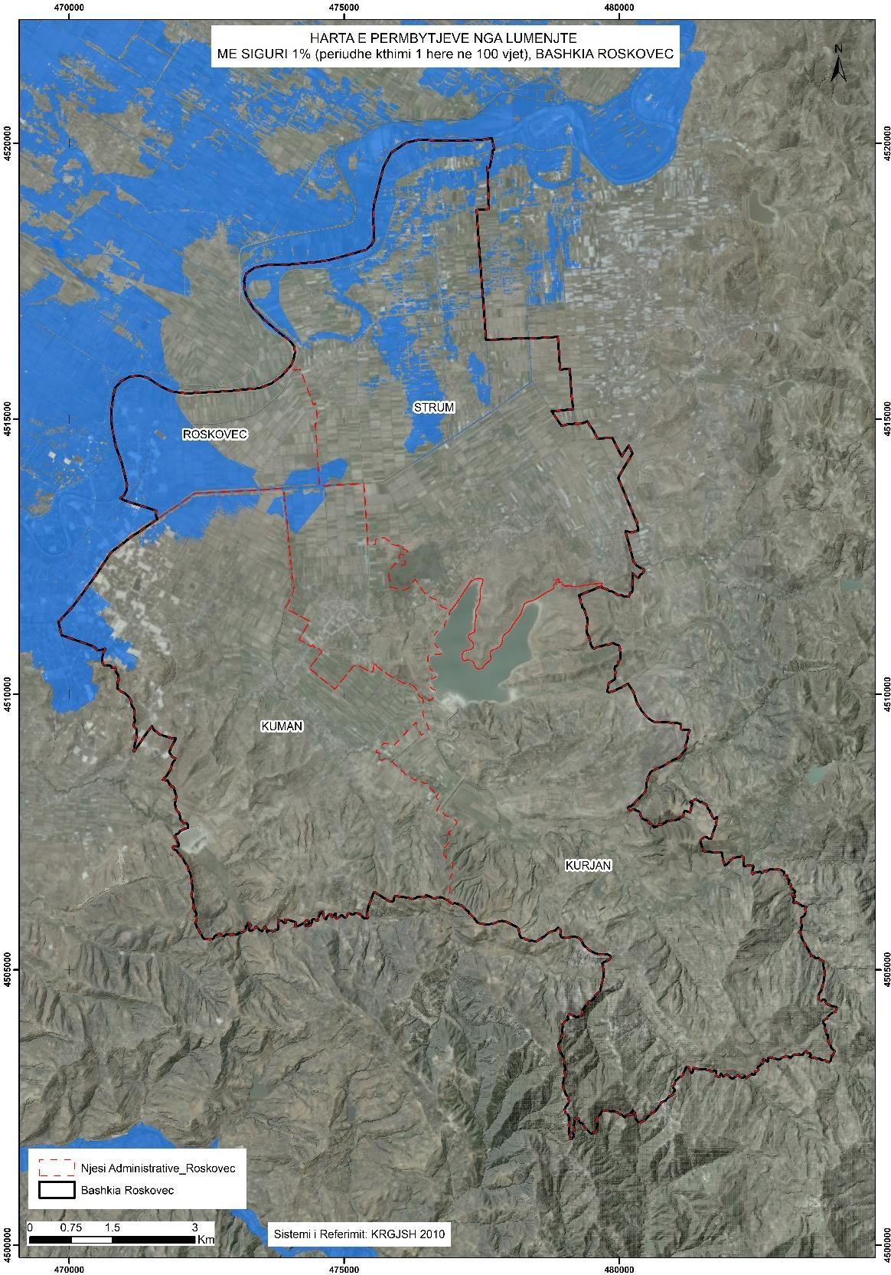
• Flood risk map from the possible destruction of dams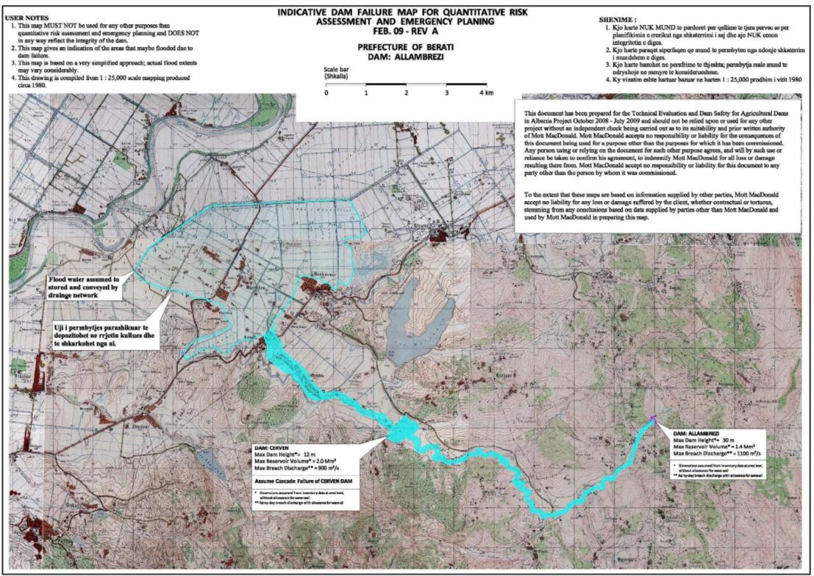
The flood from the destruction of the Allambrezi Dam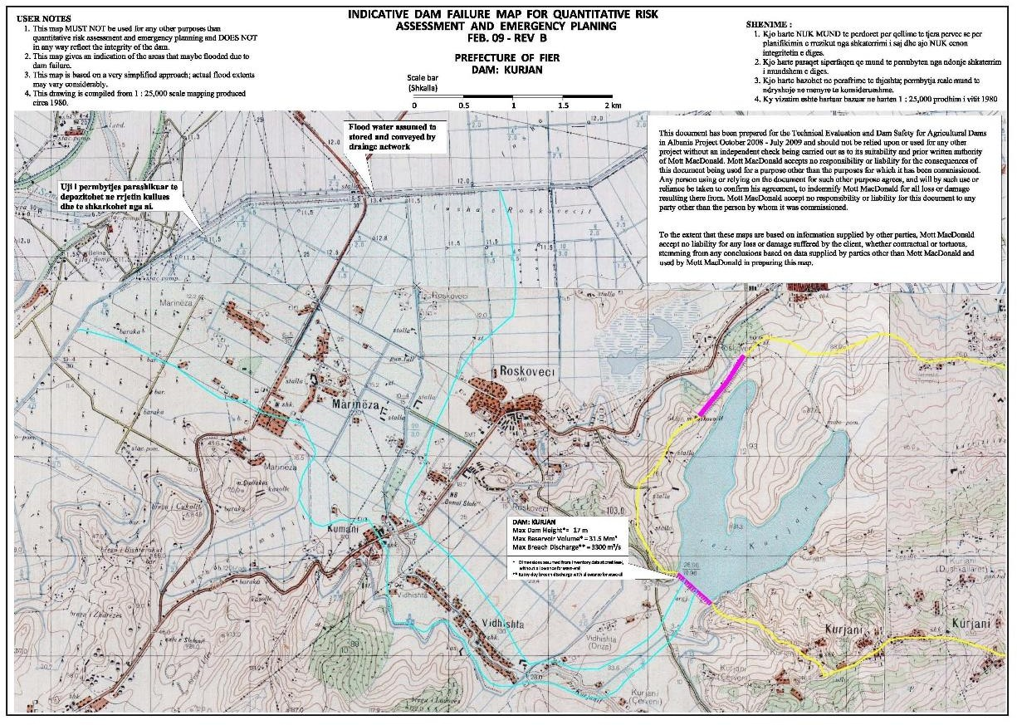
The Flood from the Destruction of the Kurjan Dam (Kurjan Reservoir)
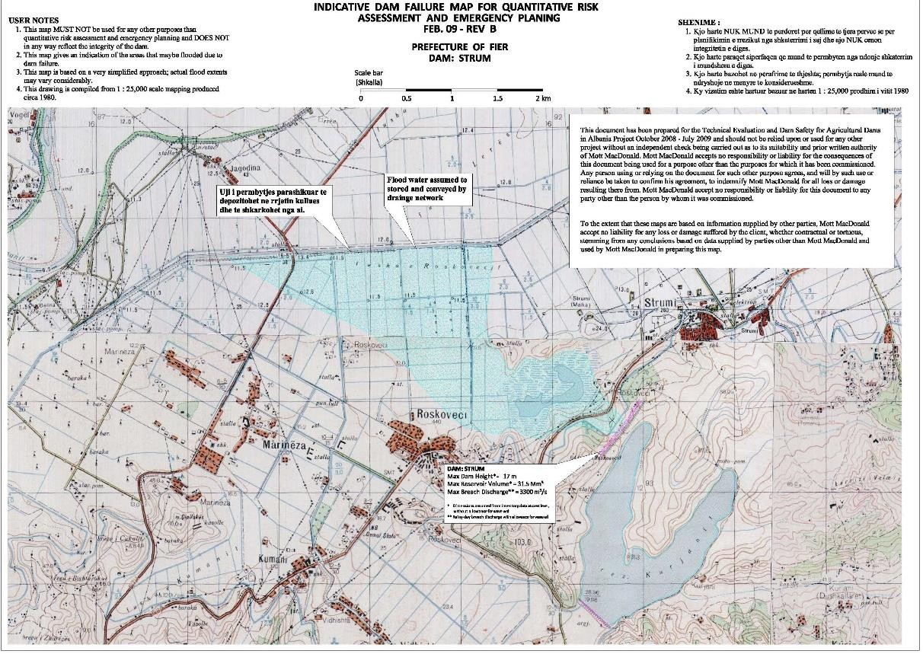
The Flood from the Destruction of the Strum Dam (Kurjani Reservoir)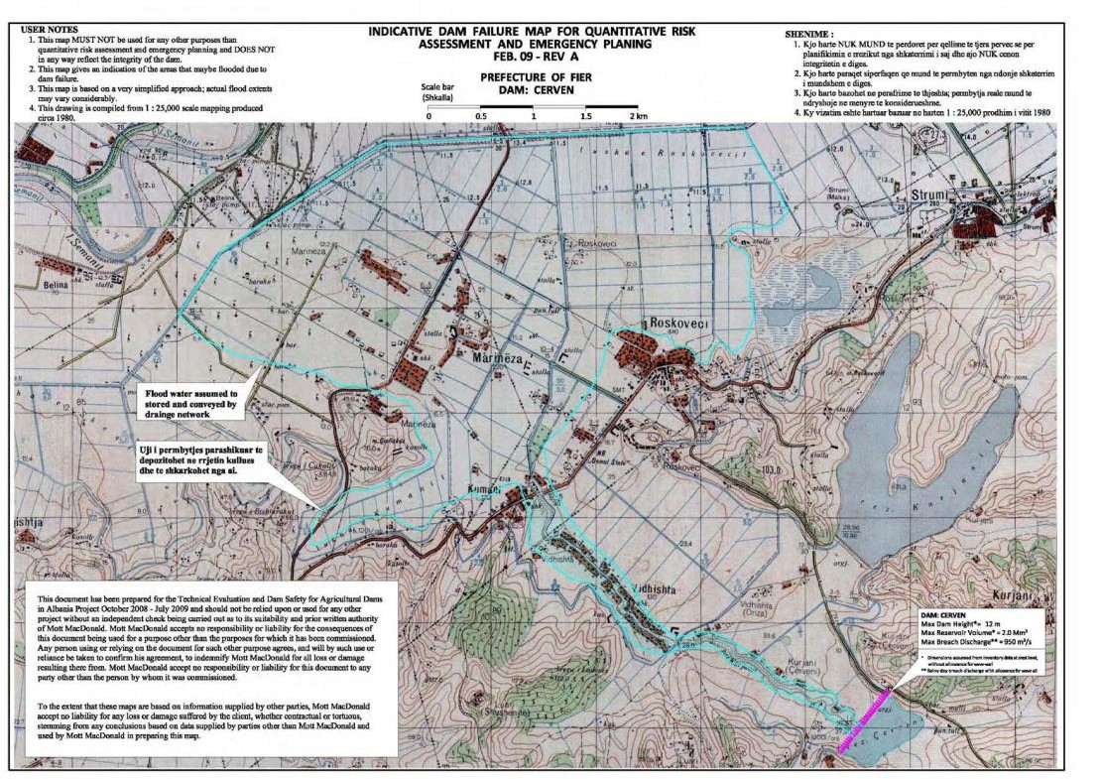
Përmbytja nga Shkatërimi i Digës Cerven

- ANNEX 2 – LANDSLIDE RISK MAPS
Map of the inventory of slides for Roskovec Municipality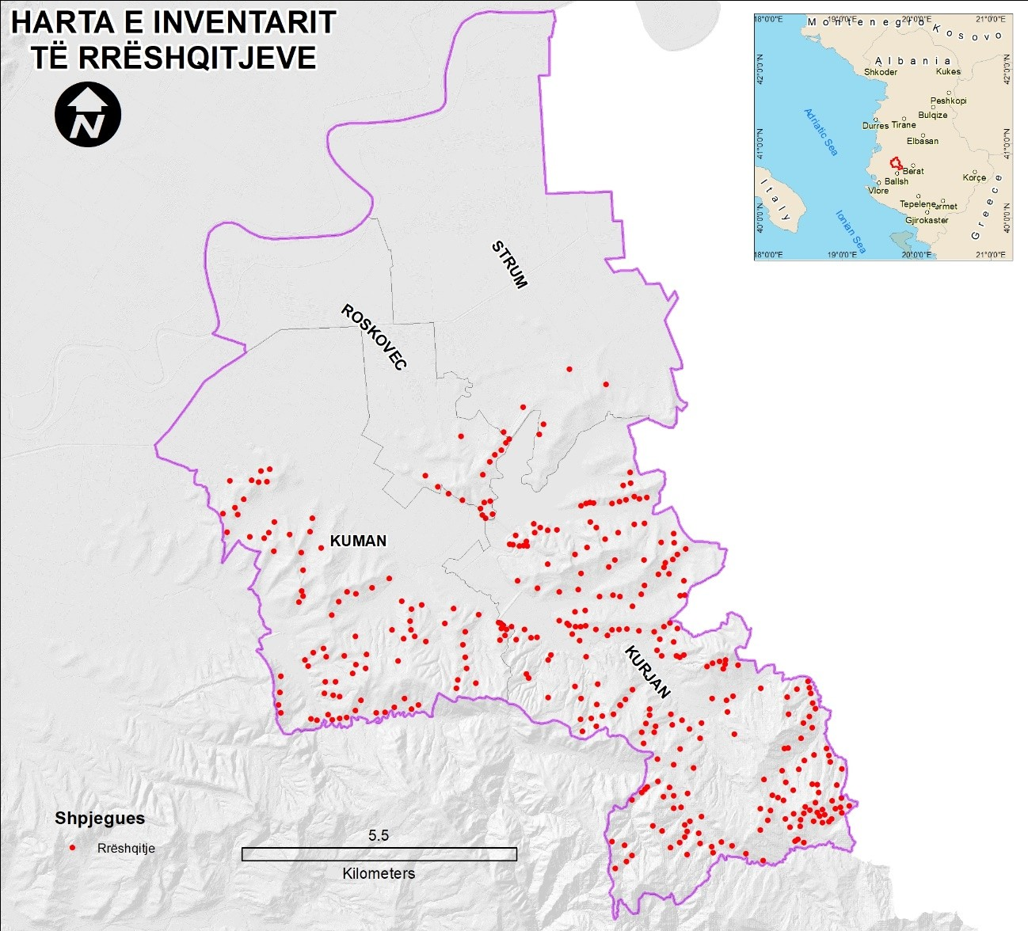

• Landslide susceptibility map for Roskovec Municipality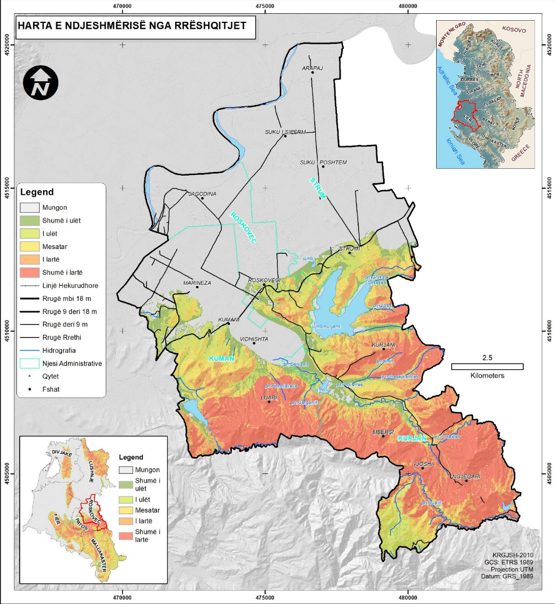

• Landslide Risk Map for Roskovec Municipality. Recurrence time 100 years
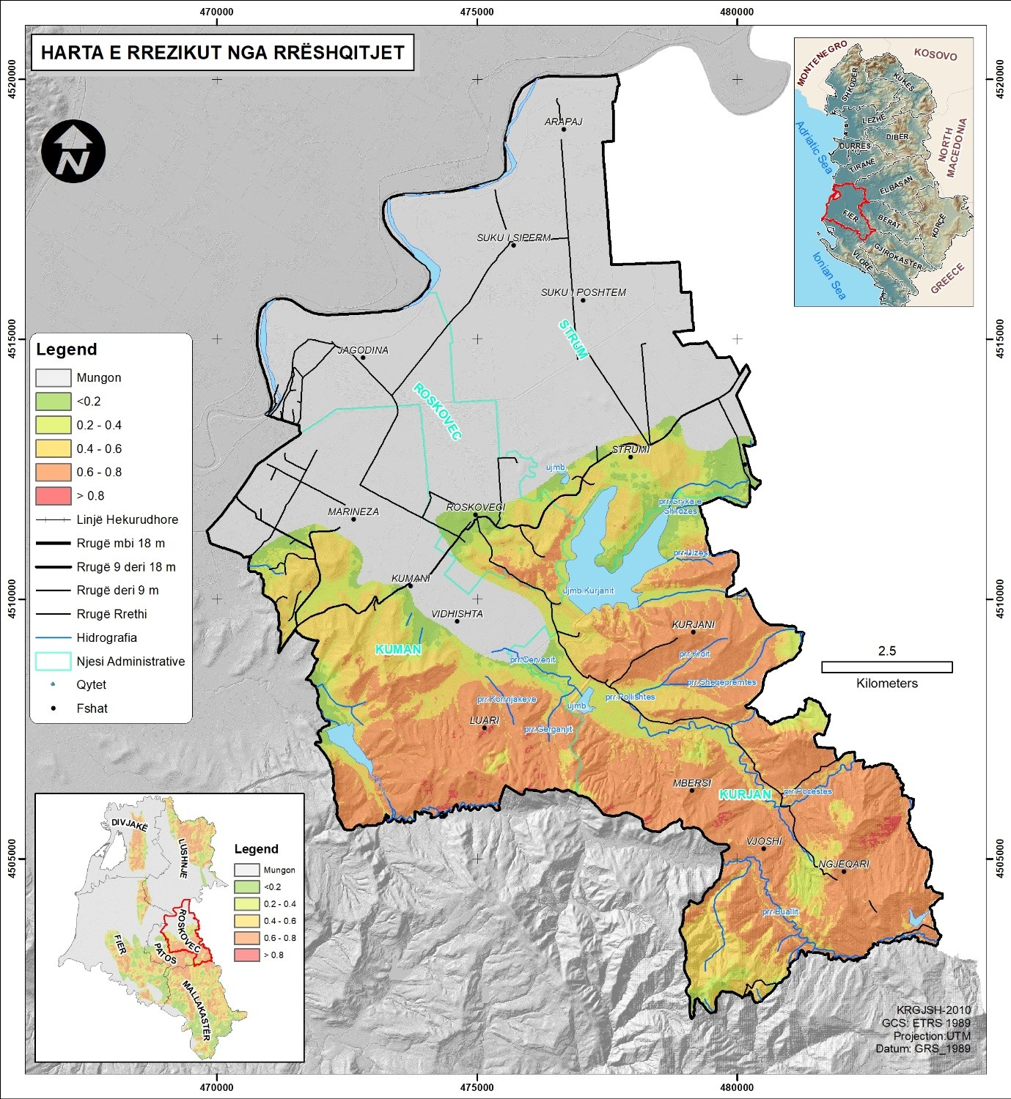

ANNEX 3 – MAP OF DANGER FROM FOREST FIRES
• Map of the risk of forest fires in the Roskovec municipality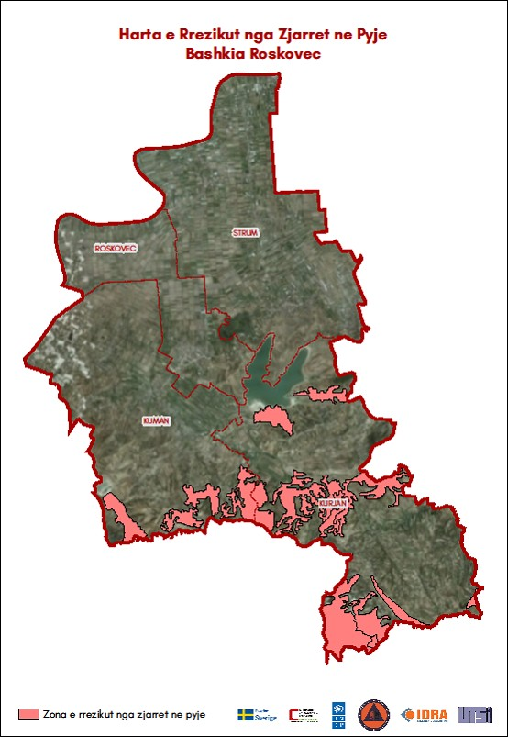

Draft Waste Management Plan, Municipality of Roskovec, 2022 Draft Waste Management Plan, Municipality of Roskovec, 2022
Third National Communication of the Republic of Albania under the United Nations Framework Convention on Climate Change
Raporti i Vlerësimi i Riskut në shkallë vendore, Bashkia Roskovec (Shkurt 2023)

